

**The Regulatory Assistance Project**

The E3-India Model

Technical model manual



E3-India model manual

info@camecon.com

www.camecon.com

Cambridge Econometrics

Cambridge, UK

June 2019

Cambridge Econometrics’ mission is to provide rigorous, accessible and relevant independent economic analysis to support strategic planners and policy-makers in business and government, doing work that we are interested in and can be proud of.

Cambridge Econometrics Limited is owned by a charitable body,

the Cambridge Trust for New Thinking in Economics.

[www.neweconomicthinking.org](http://www.neweconomicthinking.org)

Authorisation and Version History

|  |  |  |  |
| --- | --- | --- | --- |
| **Version** | **Date** | **Authorised for release by** | **Description** |
|  |  | Hector Pollitt | Full manual |

Contents

Page

1 Introduction and Background 5

2 Guide to Running E3-India 8

3 Model Inputs and Outputs 16

4 Model Validation 27

5 Functions in E3-India 34

6 A Detailed Description of E3-India 60

7 The FTT:Power model in E3-India 78

8 Example policy scenarios 82

9 The E3-India Test Scenarios 86

10 Top-Down and Bottom-Up Modelling Approaches 106

11 Linking E3-India to other models 109

12 Different Macroeconomic Modelling Approaches 111

13 Case studies 121

14 How the model solves 127

15 Frequently asked questions 130

16 References 133

Appendix A Model Classifications

Appendix B Model Assumption and Scenario inputs

# Introduction and Background

Introduction to E3-India

E3-India model is a new macro-econometric E3 (energy-environment-economy) model of India that can be used to assess policy at the level of the 32 states and territories. This introductory chapter describes briefly the model’s main functions, objectives and aims, outputs, and theoretical foundation.

## What is E3-India?

E3-India is an advanced software tool that can be used to assess energy-economy linkages in India. It is built on the existing structure offered by the global E3ME model[1] but accounts for detailed data and issues that are specific to India. As the model operates at state level, policies in individual states can be addressed and the distribution of impacts across India can be considered for national policy.

The E3-India model has the following dimensions:

* 32 Indian states and territories
* 39 economic sectors
* 21 users of 5 different energy carriers
* CO2 emissions from 8 sources
* annual projections out to 2035

See Appendix A for full classification.

## Aims of the model

The E3-India model was constructed with the following aims:

* The model represents best practice for sectoral policy simulations.
* Its development is transparent. Designed through a collaborative process it aims to capture local knowledge and expertise in India.
* The data used represent the best available data sources relevant to India.
* The parameters in the model reflect the behavioural characteristics of the states of India.
* The outputs of model simulations can be readily identified and explained.
* Use of the model is accessible and affordable to a broad base of prospective users over time.

## Policy questions that E3-India aims to address

As a general model of the economy, E3-India can be used to assess a wide range of fiscal and general macroeconomic policies. However, it has been designed to have a particular focus on the energy sector. Policies that the model can assess include:

* changes in the power sector energy mix, including the share of renewables in the mix
* policies to promote renewable uptake, such as Feed-in-Tariffs or direct subsidies
* direct regulation on energy efficiency
* energy and carbon pricing instruments

## What are the main outputs from the model?

E3-India produces a wide range of socio-economic outputs at state and national level, for example:

* employment and unemployment
* GDP and sectoral output
* investment
* international trade and trade between states
* household income (by income group) and consumption
* public balances
* prices and inflation

The model results also include a full set of energy balances (and prices), detailed power sector results by technologies, and energy-related emissions.

## How is the model being developed?

The modelling design centres on state actions, since much of energy policy and its implementation occurs at the state level.

In addition, the character of energy markets in India are unique by international standards. This requires the establishment of a model that captures attributes that are distinct from traditional economic textbooks.

The technical development of the model was carried out in Cambridge, UK, in collaboration with partners in India. Many of these partners are using the model already and it is available to other academic groups under licence.

## How does the model work?

E3-India is based on a series of econometric equations that are similar in design to those in the E3ME model (see www.e3me.com). Unlike the more common computable general equilibrium (CGE) approach to economic modelling, E3-India does not assume full employment or perfectly competitive markets; instead it estimates behaviour based on available historical data.

## Comparative advantages of E3-India

Compared to other macroeconomic models in operation currently across the world, E3-India has advantages in four important areas:

* Geographical coverage, with explicit representation of each state and territory in India.
* Sectoral disaggregation, which allows for representation of fairly complex scenarios at state level and the impact of any policy measure can be represented in a detailed way to show winners and losers.
* The econometric pedigree and empirical grounding of the model makes it better able to represent performance in the short to medium term, as well as providing long-term assessments without being too reliant on rigid assumptions.
* E3 linkages, and the hybrid nature of the model. A non-linear interaction between the economy, energy demand/supply and environmental emissions is an undoubtable advantage over other models.

## How does the model look?

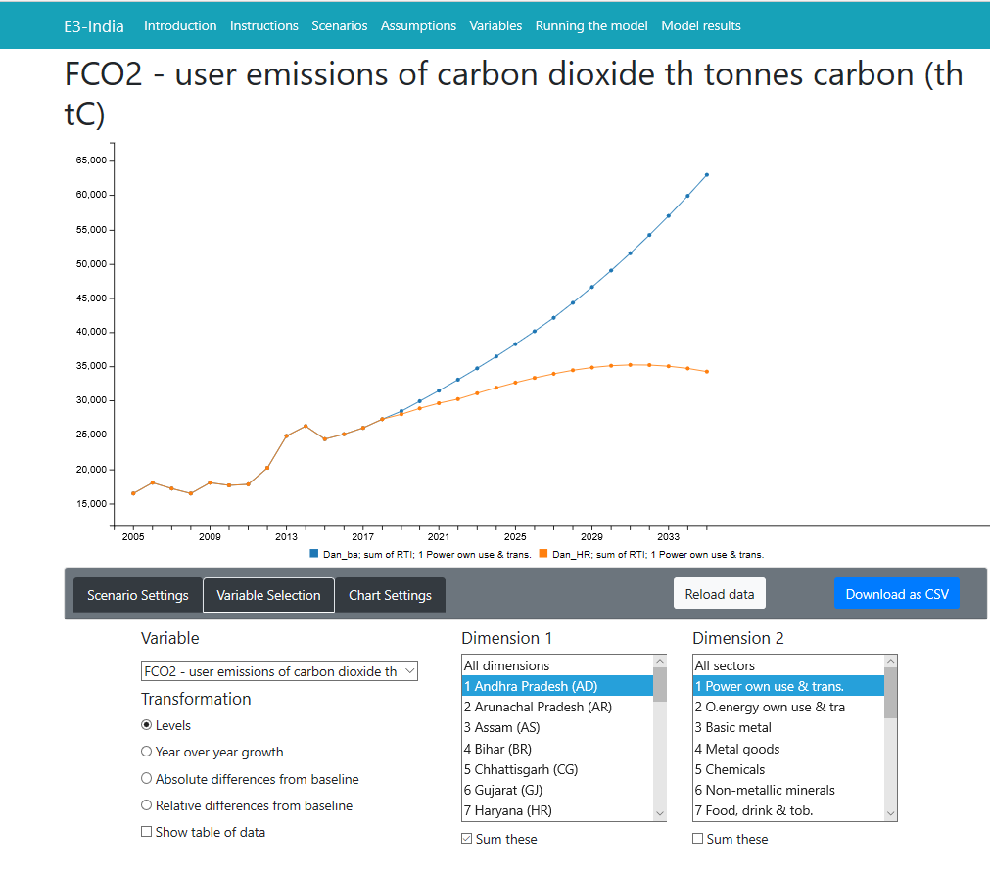

# Guide to Running E3-India

## Getting started

This chapter describes the steps required to install and run the model. We start with a general overview in this section and then describe how to run the model using the graphical interface. The model itself and the graphical interface come as a single package and are designed specifically to work together.

Installation

E3-India is set up to run on a PC running Windows version 8 or higher[2]. There are otherwise no specific computer requirements but the software works best in Google Chrome, and we highly recommend using Chrome as a platform for the software. The model has also been tested in Microsoft Edge but it does not operate in older versions of Internet Explorer. The model works in Windows but at present it does not work on Mac computers.

The Manager software is provided as part of a package for the E3-India model. It collates all E3-India model inputs into one place, enabling users to make changes directly to the input files or to load files that have been edited elsewhere (e.g. using other text editor software) and viewing the model results.

Getting started

To get started:

1. Download the software to the directory C:\E3-India on your local drive.
2. In the C:\E3-India\ directory, launch the shortcut *manager.exe* (full path C:\E3-India\Manager\).

This will launch the E3-India Model Manager software in your default internet browser. The link may be copied into another browser window, so it is not necessary to set Chrome as your default browser.

## The E3-India Manager interface

The Manager software collates all E3-India model inputs into one place, enabling users to make changes directly to the input files or to load files that have been edited elsewhere. It is also used for viewing the model results.

Figure 2.1 shows an image of the software on start-up.

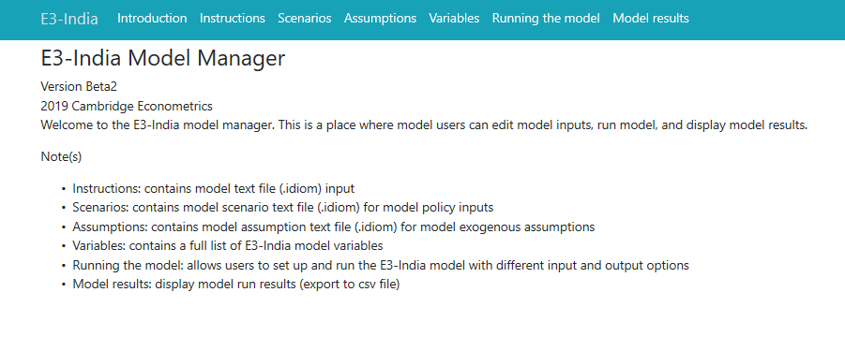

Figure .: Image of the software on start-up

The software contains seven main tabs, which are described in Table 2.1.

Many of the tabs link to other files that are installed on your local drive.

Table .: The main tabs in the Manager

| **Tab:** | **Description:** |
| --- | --- |
| Instructions  (original files in c:\e3-india\In\) | The instructions files include the commands to set up and run the model (see below). More complex scenarios can be assessed by modifying the instructions files. On installation, E3-India has a pre-loaded set of files. There are further options to modify, duplicate and delete files. |
| Scenarios  (original files in c:\e3-india\In\Scenario\) | The scenario files include a set of policy options that can be entered directly in the Manager. On installation, there is a baseline option and some test cases. Modifications can be made here. |
| Assumptions  (original files in c:\e3-india\In\Asns\) | The assumptions file includes a set of forward-looking assumptions that are necessary for the model to run. These assumptions can be modified here. |
| Variables | A list of the main E3-India variables for reference. |
| Running the model | Here the user can set up and run the model, entering the choice of scenario and assumption input files and choosing a name for the output file. |
| Model results | This tab allows the user to view and compare model results, and to produce charts and tables with the option to export model results for further analysis. |

There are three input files that are used every time the model is run:

* Instruction file: This file contains the code that sets up and operates the model. It offers a much wider range of options for potential scenarios but does require a basic knowledge of the IDIOM scripting language that is used. Advanced users typically work extensively with the instruction file.
* Scenario file: This contains a set of policy inputs, including carbon taxes and energy taxes, that can be modified easily without any programming.
* Assumptions file: This contains exogenous assumptions such as commodity prices, world growth rates, state tax rates and government spending. These can also be modified easily without any programming required.

A set of baseline inputs is provided: EnForecast.idiom (instruction file), Assumptions.idiom (assumption file) and BaseScen.idiom (scenario file).

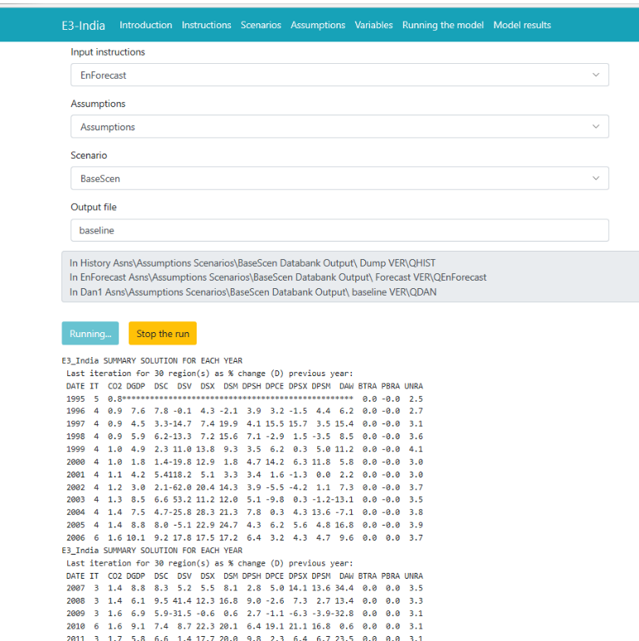

Figure .: Image of the model baseline using the provided inputs

*It is recommended not to delete the baseline input files, but to instead duplicate these files, make changes to the duplicates and save them under different names for scenario analysis.*

Running the model for the first time

It is recommended to have a set of baseline results first for comparison with future scenario results. To run the baseline:

1. Go to Running the model tab.
2. Select the default baseline inputs from the list: EnForecast.idiom (instruction file), Assumptions.idiom (assumption file) and BaseScen.idiom (scenario file).
3. Type in a name to be given to the output of this run e.g. ‘baseline’.
4. Click ‘run the model’ button and wait until it finishes.

Setting up scenarios

To set up and run scenarios after the baseline:

1. Go to the relevant tab to make the change (assumptions, scenarios or instructions)
2. Make a copy of the default input file by pressing the duplicate button and entering a new file name for it.
3. Make changes to the new file.
4. Click save once finished.
5. Follow step 1-4 of running the baseline above but make sure to select the relevant input files and provide a different name for results file.

Alternatively, steps 2 to 4 can be carried out outside the Manager by making a copy of the original input files and editing them manually using a standard text editor software package (e.g. Windows Notepad).

Note: output files are automatically saved to the C:\e3-india\output folder.

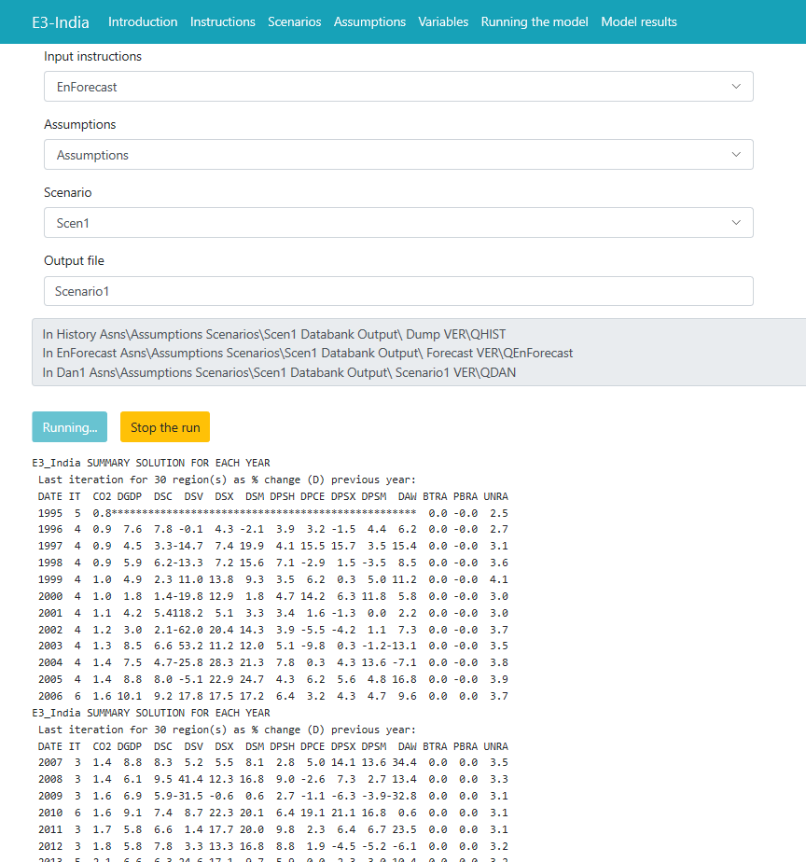

Figure .: Image of a model scenario

Every time the user runs the model, three run sequences are automatically called (see command lines below). These lines are the model executables. The model runs over history first (to e.g. generate lagged variables), the forecast period (from the EnForecast script) and in a separate routine to print out the results (from the Dan1 script).



Figure .: The three stages of running the model

The display box summarises key model variables as the model solves for each year of solution. It provides a quick overview of the model solution for all Indian states while the model is running. A full set of the model results can be accessed once the model has finished running.

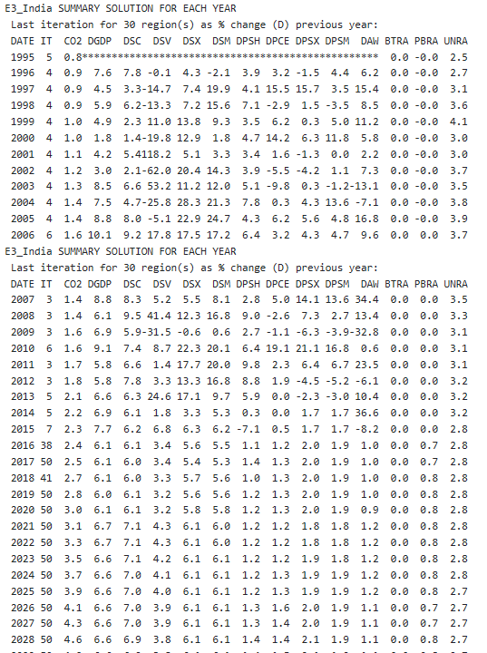

Figure .: Display when the model is running

Table .: The variables displayed while the model is running

|  |  |  |
| --- | --- | --- |
| **Code** | **Description** | **Unit** |
| CO2 | CO2 | CO2 equivalent billion tonnes of carbon |
| DGDP | GDP | Year on year growth |
| DSC | Consumption | Year on year growth |
| DSV | Investment | Year on year growth |
| DSX | Exports | Year on year growth |
| DSM | Import | Year on year growth |
| DPSH | Industrial prices | Year on year growth |
| DPCE | Consumer prices | Year on year growth |
| DPSX | Export prices | Year on year growth |
| DPSM | Import prices | Year on year growth |
| DAW | Average Wage Rates | Year on year growth |
| BTRA | Trade balance | Percent |
| PBRA | Public balance | Percent |
| UNRA | Unemployment rate | Rate |

Once the model finishes running, the output from the model run is saved in the C:\E3-India\Output folder. The output file is saved under a text (.mre) format which the Manager software translates into graphical format, allowing the user to inspect the model results in detail.

The Manager software automatically lists all the files with a .mre extension in the C:\E3-India\Output folder and users can select which sets of results to display.

To select the results to display go to the Model Results tab. If the latest model run does not appear in the list, refresh the page as you would normally do in the internet browser. Select the results from the model runs that you wish to inspect and click on the ‘Enable frontend’ button.

Figure .: Selecting sets of model results

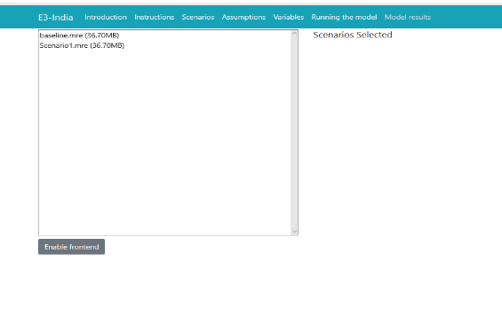

To view the model results, select the relevant scenario(s), variable and dimensions to display.

Figure .: Example of model output

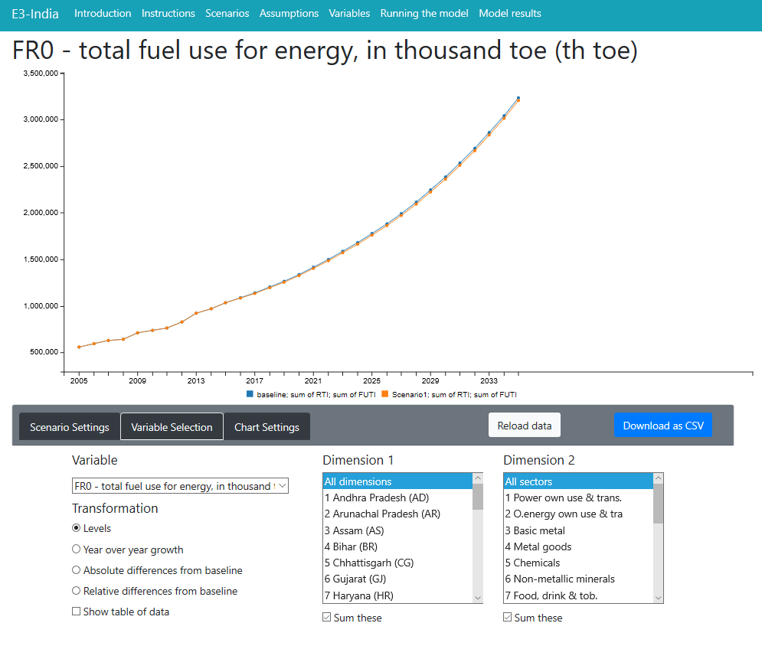

To compare scenario results against a baseline, select the baseline in the baseline drop down list (this can be any file). Choose the scenario, variable and dimensions to display.

Users can choose whether to view results in levels, absolute differences from baseline, relative difference from baseline, or year-on-year growth by selecting the relevant options in the bottom-left corner.

Additionally, users can select more than one sector or state to display simultaneously on the chart (by shift-clicking or control-clicking). There is an option to sum the dimensions selected, which is useful for checking aggregate results.

Figure .: Example of comparing results against baseline

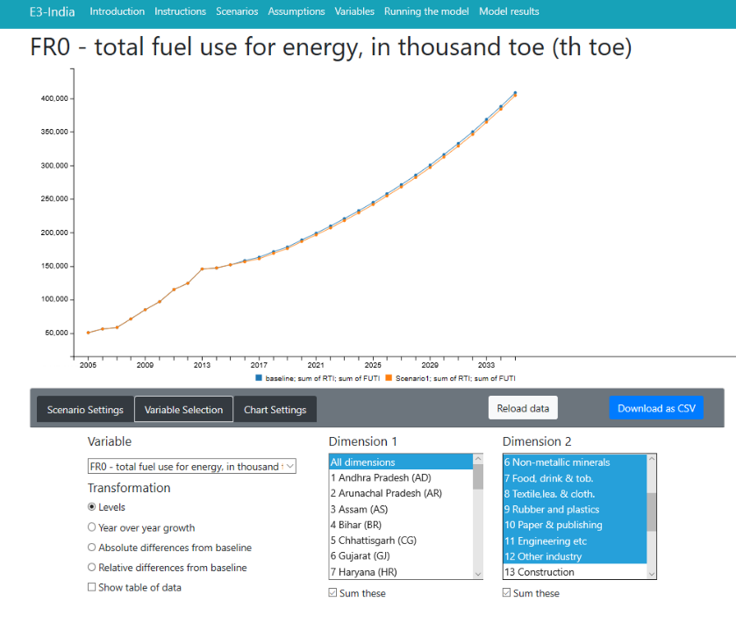

To export results, select ‘*Show a table of data’* and a table containing data will appear at the bottom of the page. Click ‘*download data as csv’* to export this table to .csv file. Alternatively, users can copy and paste the table to a spreadsheet package manually.

Users can browse through the full set of results from a model run. To rerun the model, return to the previous tabs. To look at the results from a different set of model runs, click on ‘*reload data’* button.

# Model Inputs and Outputs

## Introduction

This chapter describes E3-India’s main model inputs and outputs. The following sections describe the main inputs that the model relies on, including data and econometric parameters. The final part of this chapter describes the format of the main model outputs.

## Data inputs

Introduction to the model databanks

The data are the most important single input to E3-India. A lot of effort is put into ensuring that the model data are accurate and consistent to the maximum degree possible.

The following databanks are used to store the data:

* T – historical time-series data
* F – processed baseline forecast (see Section 4)
* X – cross-section data, including input-output tables and equation parameters
* E – energy balances, prices and emissions
* U – classification titles

One other databank is used for model operation:

* S – holds the calibration factors to match the baseline forecast (see section 4 of this chapter)

E3-India’s data requirements are extensive and specific. All data must be processed so that they are in the correct classifications and units. Gaps in the data must be filled (see below). All data processing is carried out using the [Oxmetrics software package](http://www.oxmetrics.net/pages/software.html).

Time-series economic data

It is a substantial exercise to create and maintain the time series of economic data. The main dimensions involved are:

* indicator
* states
* sector
* time period (annually from 1993)

In addition, indicators that are expressed in monetary units have constant and current price versions. Cambridge Econometrics therefore puts a large amount of resources into processing the time-series data.

The raw data are gathered from the sources described below and stored on the T databank. The model uses official sources as much as possible. It is often necessary to combine data sets to fill out gaps in the data and to estimate remaining missing values (see below).

The main indicators

A ‘V’ at the start of the name indicates a current price value; otherwise the indicator is expressed in constant prices (2011 rupees). The main indicators with full sectoral disaggregation are:

* QR/VQR – output (constant and current price bases)
* YVM/VYVM, YVF/VYVF – GVA at market prices and factor cost
* KR/VKR – investment
* CR/VCR – household expenditure (by product)
* GR/VGR – government final consumption (by category)
* QRX/VQRX – exports
* QRM/VQRM – imports
* YRE – employment
* YRLC – labour costs (current prices)

There are also time series for population (DPOP) and labour force (LGR), disaggregated by age and gender.

In addition, there are several macro-level time series that are used in the modelling. These include GDP, household incomes, tax and interest rates and the unemployment rate. They are also collected on an annual basis, starting from 1993.

Data sources for E3-India’s economic data

Table 3‑1 gives a summary of the data sources for economic variables used in the E3-India model. The majority of data are collected from original sources and processed by Indian national account data experts. Database construction was a major task.

The data must be consistent across states and in the same units. For monetary data, the rupee is used.

Table .: E3-India data sources for economic variables

|  |  |
| --- | --- |
| Variable | Source |
| Population | MOSPI Net State domestic product series  2001 Census of India - For State wise Rural and Urban Population  2011 Census of India - For State wise Rural and Urban Population |
| Unemployment and labour participation rates | NSSO Employment and Unemployment in India Surveys  NSSO Employment and Unemployment Situation in India Surveys  NSSO Household expenditure and Employment Situation in India Surveys |
| National Accounts and employment   * Total Inputs * Gross Value Added * Gross Fixed Capital Formation * Change in Stock * Profits * Employment * Compensation to Employees | **Agriculture**: “Statewise And Itemwise Estimates of Value of Output from Agriculture and Allied Sectors, Central Statistics Office, MOSPI, Government of India”  **Mining**: Indian Mineral Year Book 2012, Indian Bureau of Mines, Government of India.  **Services:**  **Manufacturing:** ASI Data |
| Consumer expenditure | NSSO Household Consumer Expenditure in India  NSSO Household Consumer Expenditure and Employment situation  NSSO Key Indicators of Household Consumer Expenditure in India  NSSO Level and Pattern of Consumer Expenditure  E3 India state rural and urban population  Level and Pattern of Consumer Expenditure in India, 1999-2000 NSS 55th Round (July 1999- June 2000)  Household Consumption of Various Goods and Services in India 2011-12 (NSS 68th Round) |
| Government spending | Reserve Bank of India State Finances: A Study of Budgets  India Ministry of Finance Union Budgets  E3 India Population  Own estimation using information from national total |
| External trade | Own estimation using information from national total  (share of trade in national accounts) |
| Total gross disposable income | Own estimation using information from national total  (ratio of gross disposable income and total wages and salaries in national accounts) |
| MOSPI – Indian Ministry of Statistics and Programme Implementation  NSSO – Indian National Sample survey reports | |

Values and price indices in E3-India

The general principle adopted in E3-India is that variables are defined in the currency unit appropriate for the use of the variable. This usually means that the units of measurement follow those in the data source. The principle of comparability is taken to imply that most current values are measured in millions of rupees and most constant values in millions of rupees at 2011 prices.

The price indices are calculated by dividing current by constant values in rupees.

Cross-sectional data

By cross-sectional data we mean data that are not usually available in time-series format. Historically, this has meant input-output tables. Other cross-sectional data include converters between model classifications that do not normally change over time.

Input-output tables in E3-India

There are no input-output data publicly available at state levels. However, state level input-output is crucial in the E3-India model as it is used to distinguish different economic characteristic between states and provide linkages between local industries. Our Indian national account expert spent great effort in putting together input-output flows information at state level from raw data sources. For full documentation on how the IO tables at state level were constructed, including sources, please see Appendix C.

Input-output flows are converted to coefficients by dividing the columns by industry output. These coefficients give the number of units of input required to produce one unit of output.

Energy and emissions data

State-level energy and emissions data for E3-India come from various sources. Where state-level data are not available, national data are used as proxies.

Table .: E3-India data sources for energy variables

|  |  |
| --- | --- |
| Variable | Source |
| Coal consumption | MOSPI Installed capacity, generation and consumption 2007-2013 |
| Oil consumption | Indian Petroleum and Natural Gas statistics (Ministry of Petroleum & Natural Gas) |
| Gas consumption | MOSPI Installed capacity, generation and consumption 2007-2013 |
| Electricity consumption | MOSPI Electricity sold to ultimate consumer: 2007-2013 |
| Biomass Consumption | MOSPI renewable generation capacity data |
| Energy Prices | IEA national fuel price |
| MOSPI – Indian Ministry of Statistics and Programme Implementation | |

Energy price data in E3-India

Energy price data

State-level energy prices for each fuel are also not available. Instead, energy prices for each state are assumed to match the national Indian prices obtained from the IEA Energy Statistics which provide prices (before and after taxes) in USD per tonne of oil equivalent by country and by fuel. Global fossil fuel price data for oil, coal and gas also come from the IEA.

CO2 emissions in E3-India

Time-series data for CO2 emissions, disaggregated by energy user, are calculated using national emission coefficients.

Correcting for missing data points

The team at Cambridge Econometrics has developed a software package to fill in gaps in any of the E3-India time series. The approach uses growth rates and shares between sectors and variables to estimate missing data points, both in cases of interpolation and extrapolation. Some time series have specific rules for filling gaps in the data, but the general procedures are described here.

The most straightforward case is when the growth rates of a variable are known and so the level can be estimated from these growth rates, as long as the initial level is known. Sharing is used when the time-series data of an aggregation of sectors are available but the individual time series is not. In this case, the sectoral time series can be calculated by sharing the total, using either actual or estimated shares.

In the case of extrapolation, it is often the case that aggregate data are available but sectoral data are not; for example, government expenditure is a good proxy for the total growth in education, health and defence spending. A special procedure has been put in place to estimate the growth in more disaggregated sectors so that the sum of these matches the known total, while the individual sectoral growth follows the characteristics of each sector. Interpolation is used when no external source is available, to estimate the path of change during an interval, at the beginning and end of which data are available.

Under different assumptions, time-series forecasts are created for each country and each aggregated variable: consumption, employment, GDP, trade and investment.

Naming conventions

E3-India’s software limits model variables to four character names. These characters are typically used to identify first the dimensions of the variable (excluding time, which is a dimension for all the variables) and then the indicator. In particular, Q indicates disaggregation by product, Y by industry, F by energy (fuel) user and R by region. If a variable name starts with P then it usually indicates a price. S and 0 can be used to identify sums.

These conventions are used in the data processing and in the model itself. Some examples of common variables names are provided below:

* QR: (Gross) output by product and by region
* YR: (Gross) output by industry and region
* YRE: Employment by industry and region
* YRW: Wage rates by industry and region
* YRVA: Gross value added by industry and region
* CR: Consumption by consumption category and region
* PCR: Consumption prices by category and region
* RSC: Total consumption by region
* PRSC: Aggregate consumer price by region
* KR: Investment by investment category and region
* FR0: Total energy consumption by energy user and region
* FRET: Electricity consumption by energy user and region
* FCO2: CO2 emissions by energy user and region
* RCO2: CO2 emissions by region

## Econometric parameters

The econometric techniques used to specify the functional form of the equations are the concepts of cointegration and error-correction methodology, particularly as promoted by Engle and Granger (1987) and Hendry et al (1984).

In brief, the process involves two stages. The first stage is a levels relationship, whereby an attempt is made to identify the existence of a cointegrating relationship between the chosen variables, selected on the basis of economic theory and a priori reasoning, e.g. for employment demand the list of variables contains real output, real wage costs, hours-worked, energy prices and the two measures of technological progress.

If a cointegrating relationship exists then the second stage regression is known as the error-correction representation, and involves a dynamic, first-difference, regression of all the variables from the first stage, along with lags of the dependent variable, lagged differences of the exogenous variables, and the error-correction term (the lagged residual from the first stage regression). Due to limitations of data size, however, only one lag of each variable is included in the second stage.

Stationarity tests on the residual from the levels equation are performed to check whether a cointegrating set is obtained. Due to the size of the model, the equations are estimated individually rather than through a cointegrating VAR. For both regressions, the estimation technique used is instrumental variables, principally because of the simultaneous nature of many of the relationships, e.g. wage, employment and price determination.

Software used

E3-India’s parameter estimation is carried out using a customised set of software routines based in the Ox programming language (Doornik, 2007). The main advantage of using this approach is that parameters for all sectors and countries may be estimated using an automated approach.

The estimation produces a full set of standard econometric diagnostics, including standard errors and tests for endogeneity.

Estimation results

A list of equation results can be made available on request and parameters are stored on the X databank. For each equation, the following information is given:

* summary of results
* full list of parameter results
* full list of standard deviations

## Baseline forecast

Overview

The E3-India model can be used for forming a set of projections but it is usually used only for policy analysis. Policy analysis is carried out in the form of a baseline with additional policy scenarios, with the differences in results between the scenarios and the baseline being attributed to the policy being assessed.

This section describes how the baseline is formed.

Role of the baseline

Usually results from E3-India scenarios are presented as (percentage) difference from base, so at first it may appear that the actual levels in the baseline are not important. However, analysis has shown that the values used in the baseline can be very important in determining the outcomes from the analysis. For example:

* If a scenario has a fixed emission target (e.g. 20% below 2005 levels) then the baseline determines the amount of work that must be done in the scenario to meet the target.
* If a scenario adds a fixed amount on to energy prices, then baseline energy prices determine the relative (percentage) impact of that increase.

It is therefore important to have a baseline that does not introduce bias into the scenario results. A common requirement of E3-India analysis is that the baseline is made to be consistent with official published forecasts. Since we do not have access to state-level economic and energy projections, the E3-India baseline is calibrated to national projections from the World Energy Outlook (IEA, 2015). State-level projections have been set to match.

Methodology for calibrating

The first stage in matching the E3-India projections to a published forecast is to process these figures into a suitable format. This means that the various dimensions of the model must be matched, including:

* geographical coverage (i.e. each state and territory)
* annual time periods
* sectoral coverage (including fuels and fuel users)
* National Accounts entries

CE uses the Ox software for carrying out this process, and saves the results on to the forecast databank, F.db1.

The next stage is to solve the model to match the results on the forecast databank. This is referred to as the ‘calibrated forecast’. In this forecast, the model solves its equations and compares differences in results to the figures that are saved on the databank. The model results are replaced with the databank values but, crucially, the differences are stored and saved to another databank, S.db1. These are referred to as ‘residuals’ although the meaning is slightly different to the definition used in econometric estimation.

Endogenous baseline and scenarios

The final stage is the ‘endogenous solution’ in which the model equations are solved but the residuals are added on to these results. In theory, the final outcome should be the same as for the calibrated forecast, although in practice there are calibration errors so it is not an exact match.

The key difference, however, is that inputs to the endogenous baseline may be changed in order to produce a different outcome (as opposed to the calibrated forecast where the model would still match databank values). The final outcome is thus a baseline forecast that matches the published projections, but which can also be used for comparison with scenarios.

Operational example

Consider an example for the aggregate consumption equation. If in the first year of forecast, E3-India predicts a value of 100bn rupees but the published forecast suggests 101bn rupees then the calibrated forecast will estimate a residual of 1.01 (i.e. 101/100).

If we then test a scenario in which consumption increases by 2% in this year, the model results will be 100bn rupees (endogenous baseline) and 102bn rupees (scenario). These will be adjusted (multiplied) by the residual to become 101bn rupees and 103.02bn rupees.

When these results are presented as percentage difference from base, the figure that is reported is still 2% (103.02/101), so the calibration does not affect directly the conclusions from the model results.

When are results influenced by calibration?

In this example, there is no impact on the results relative to baseline from the calibration exercise. This is typically true for any log-linear relationship within the model structure, as the calibration factors are cancelled out when calculating differences from base.

However, there are relationships in the model that are not log-linear, most commonly simple linear factors. These include the construction of energy prices but also identities for GDP and for (gross) output, and the calculation for unemployment (as labour supply minus demand).

For example, if the calibration results in higher trade ratios in a certain country, then the effects that trade impacts have on GDP will increase in the scenarios.

It is therefore important that the baseline provides a reasonable representation of reality, otherwise it is possible to introduce bias into the results.

## Other model data inputs

In the current version of the model there are two additional text files that are used as inputs (asides from the instruction file, see Chapter 2). These are the assumptions file and the scenario file, both of which can be modified by the model user.

The reason for having these inputs as text files rather than databank entries is that it allows easy manipulation, including through the Manager software (see Section 2.2). No programming expertise is therefore required to make the changes.

Assumptions file

The assumptions file contains basic economic information that is necessary for any model run. It consists mainly of exogenous model variables that are set by the model user.

The nature of the Fortran read commands means that the structure of the assumptions text files is very rigid, for example with the right number of white spaces (not tabs) and decimal places required for each entry.

The assumptions files cover the period 2000 to 2050 although historical values will get overwritten by the data stored on the model databanks and the last year of the model is 2035.

Commodity prices

At the top of the assumption file is a set of global commodity prices, with a focus on the energy groups that are covered by the model classifications. The figures are annual growth rates, in percentage terms.

Other world economies

Also at the top of the assumption file there is a set of twelve other countries’ GDP assumptions that form demand for Indian exports. The E3-India model assumes that rates of growth in the rest of the world are exogenous, matching the numbers in the assumptions file. The figures are annual growth rates, in percentage terms.

National and regional assumptions

This is followed by a set of assumptions that are specific to each state. They are:

* Market exchange rate (not used)
* Long-run interest rate (same as national rate)
* Short-run interest rate (same as national rate, only used for comparative purposes)
* Change in government final consumption, year on year
* % of government consumption spent on defence, education and health
* Standard VAT rate
* Aggregate rate of direct taxes
* Average indirect tax rates
* Ratio of benefits to wages (giving implicit rate)
* Employees’ social security rate
* Employers’ social security rate

Scenarios file

The scenario file contains a set of policy inputs that relate to basic model scenarios (see examples in Chapter 8). It can also be modified through the model Manager. Most of the policies in the scenario files are absent in the baseline. Policy inputs in the scenario file are categorised to three main groups: CO2 emissions policies, energy policies and options to recycle the revenue generated from market-based instruments.

CO2 emissions policies

The following CO2 emissions policies are available in the scenarios file:

* annual CO2 tax rate, rupees per tonne of carbon
* switches to include different energy users in the policies
* switches to include different fuel types in the policies

Energy policies

The following energy policies are available in the scenario file:

* annual energy tax rate, rupees per toe
* switches to include different users in policies
* switch to include different fuel types in policies
* households implied price of electricity subsidies

Revenue recycling options

The scenario file includes options to recycle automatically the revenues generated from carbon taxes and energy taxes (so that government balances remain unchanged). There are three options in the scenario file for how the revenues are recycled:

* to lower employers’ social security contributions, switch 0<X<1: 1=all, 0= none
* to lower income tax rates, switch 0<X<1: 1=all, 0=none
* to lower VAT rates, switch 0<X<1: 1=all, 0= none

These revenue recycling options do not differentiate sources of revenues. The model automatically sets the revenues to be recycled from the policies so that they are overall ‘revenue neutral’. Specific values for offsetting tax reductions can be entered through the assumption file discussed above.

## Model outputs

Overview

The model produces relatively few results automatically. It instead stores results internally so that they can be accessed separately. The separation of model solution, (1) writing the results year by year to a large file (the ‘dump’), and then (2) accessing this file to generate time series of results, is necessary because of software constraints and the logic of the model.

Because of the scale of the solution, the model does not hold all the time series of each variable, but only the current and past values necessary for the current year's solution; this reduces the storage requirements dramatically (one year plus lags instead of up to 50 years of values). At the completion of each year's solution, the solved values of most variables are written to the dump where they may be later accessed.

Data analysis files

The files that access the model results are called data analysis files. They are instruction files that are run after the model has finished solving (see Chapter 2).

The file produced contains matrix output. These files are designed as inputs to further processing, for example by other programming languages, or interpretation by the model manager software. They appear in the output directory with a ‘.MRE’ extension.

The data analysis files must start with a RESTART command with a year that matches the PUT ALL statement in the IDIOM instruction file (usually the first year of solution). A SELECT command then determines the output stream and format:

* SELECT OUTPUT 7 CARDS – MRE output

The syntax is then relatively straight forward. The VALUE command is followed by the variable name, start year and end year to give a table in time series format. The CHANGE command gives the equivalent output as annual growth rates. For variables with two dimensions (excluding time) it is necessary to say which column is required. So, for example, the command:

* VALUE CR(?:03) 2013 2020

would give a time series for household consumption in Assam (region 3) between 2013 and 2020. The following command will print out results for all states:

* VALA CR(?:01) 2013 2020

Other model outputs

The other model outputs are created for diagnostic purposes. A small text file (diagnostics.mre) is created automatically, which contains summary information about whether the model has solved and, if not, which equation caused the breakdown in solution. A longer ‘verification’ text file contains automatically generated outputs from the model, including warnings and possible non-convergences in the solution (see Section 12.1), which can be returned to Cambridge Econometrics to assist with problems in solution. The verification files are by convention given names that start with the letter Q and are stored in the verification folder in the output directory.

# Model Validation

## Introduction

Validation is an important part of the model-building process and especially so for a tool as large and complex as E3-India. There are several steps to the validation process:

* reviewing model data and the gaps in the data that have been filled out
* assessing the results of the econometric estimation
* validating the model as a system against the historical data
* running test scenarios and comparing results with expectations

Each of these steps is described in the following sections.

## Reviewing model data

Compiling the E3-India database was an extensive exercise that included many checking phases along the way. Standard checks were carried out on the time series, for example to identify breaks in the series.

The data as part of a system

The review of the data focused more on how the different series fit together, which is less easy to identify from simple plots of the data. Examples include cases where output appears to be different from the sum of its component parts. While the data would not be expected to match up exactly, large discrepancies could be the source of bias in the results.

The model itself provides a useful framework with which to carry out these tests, as it reports some of the key differences. Where large discrepancies were found, the team went back to assess the original data. For example, one instance of two states being entered in the wrong order was found.

External reviewing

The data in the E3-India database are also fully available to anyone who uses the model. Individuals with expertise on particular sectors or states are therefore able to further assess the data, and send any queries to the team. This part of the validation is especially important where gaps in the data have been estimated, as the software algorithms that are used may not always take into account local context.

## Assessing the results of the econometric estimation

Our estimation system is using the AIC to select the most appropriate set of significant parameters in each equation. The explanatory factors in each equation are selected based on the specification in the E3ME model. Outputs from the estimation include the usual R-squared tests and tests of significance. The more difficult bit to the evaluation is aggregating the tests over equations that are estimated for each state and sector, i.e. managing the amount of information that comes out of the estimation process.

We face two issues in the estimation – a lack of degrees of freedom, and a data set that covers a period of transition and change in India. The estimation results reflect both of these factors, although we anticipate that over time the time series for estimation will be extended to improve the basis for the estimation.

Restrictions on the estimated parameters

Three types of restrictions are placed on the coefficients that are estimated:

* Theoretical constraints – In a few cases restrictions are added to the equations for theoretical reasons, e.g. to ensure a one-to-one relationship.
* ‘Right sign’ – For example, price elasticities are not allowed to be positive.
* Model stability – Maximum values are set to ensure the model remains operable.

If the econometric estimation yields results that are overly constrained by these restrictions then it could be an indication of issues in the data.

Figure 4.1 shows an example of a set of estimation results, from the equations for employment (long-run part only, wages shown on an inverted scale). The chart shows that 525 equations were estimated (x axis); that is all sectors/states where there is employment. In around 50 cases no significant relationship between wage rates and employment was found, and in around 100 cases no significant relationship between output and employment was found.

At the other end of the scale, around 25 cases were found where the relationship between output and employment was greater than one (i.e. a 1% increase in output leads to more than a 1% increase in employment). For wages, slightly more instances were found.

However, for the large majority of equations estimated, a relationship between zero and one was found in both cases, giving impacts both in line with expectations and stable enough to use in modelling.

Figure .: Example estimation results (long-run employment equation)

Figure 4.2 shows the same distribution of estimation parameters, but for the short-run, differenced equation. Here there is a much wider variation in results, reflecting a wider range of short-run outcomes.

Between 100 and 200 of the equations show no significant impact in the short run. This finding is not unsurprising for employment equations, where there are often strong lagged effects, for example due to fixed contracts. At the top end of the scale, around 150 equations have short-run output-employment coefficients greater than one and there are 50 short-run wage-employment coefficients greater than one. We can also see the imposed maximum values (3 for output and 2 for employment), although relatively few equations hit these constraints.

Many of the equations that hit the constraints are for the energy sectors, where output and employment levels can be highly volatile. For this reason, a simpler specification is used in these sectors, effectively linking output and employment in a one-to-one relationship.

Overall, however, there is again a linear fit across most of the equation sets, indicating that the estimated parameters appear in line with expectations.

Figure .: Example of short-run estimation results

## Validating the model against historical data

While the analysis in the previous section considers some of the equations in isolation, this section looks at the system as a whole. The test that is carried out is to run the model over the historical period, and see how well its results match the actual data. If the equations do not fit the data well or are biased on some way then we would expect substantial divergence between the model results and the data.

The following figures are taken from the manager interface and show the results from the experiment. The blue lines show the model results and the orange lines actual data. Charts are shown for GDP, employment and CO2 emissions levels.

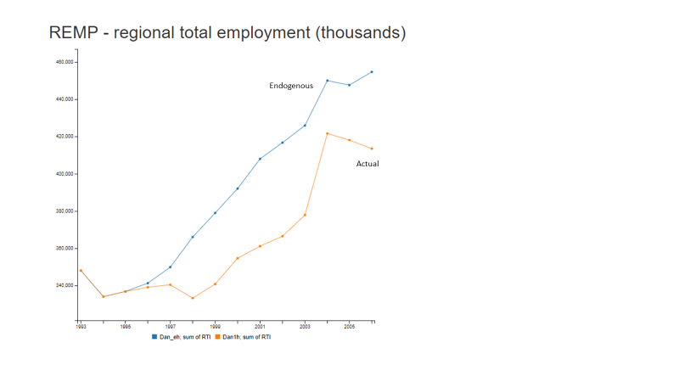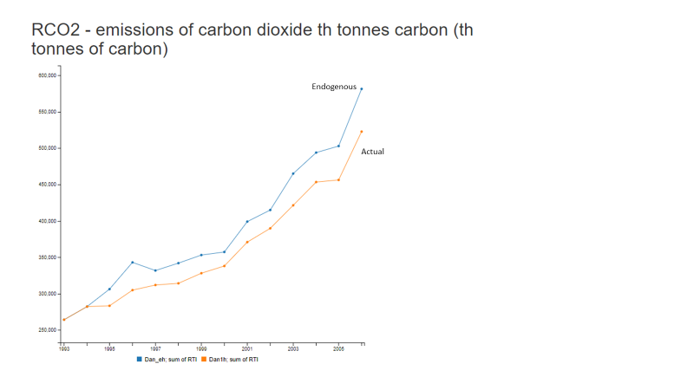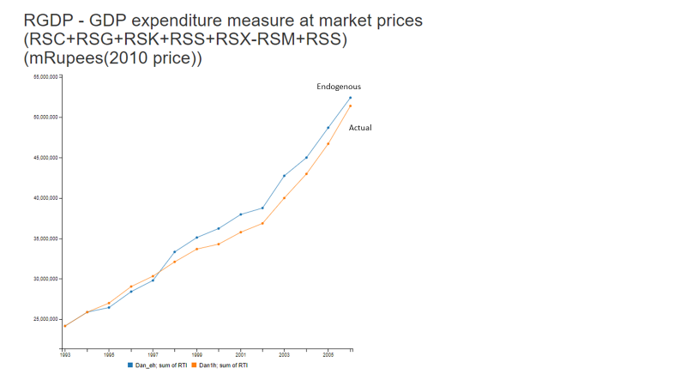

Figure .: Historical validation, national level

Solving the model over the historical period is a considerable exercise, as in general the model is designed to reproduce historical data rather than solve the equations. In some cases the discrepancies reported may reflect limitations in how the model solves historically rather than issues with model equations but this section reports results as they are.

Overall, the model matches GDP closely but the chart shows a bigger discrepancy for employment, led by differences in 1997-1999. The overall difference amounts to about 10%. For CO2, the model results are also consistently higher and again the difference is around 10%.

One important point to note for CO2, however, is that the power sector is not included in the historical analysis, as the FTT model cannot be run over history. FTT has its own structural validation, which is described in Mercure (2012).

In general, however, results are encouraging in that they show some differences (as expected) but no persistent bias. It is clear that there are some developments just before 2000 that the model has not accounted for as well as changes in other time periods but the general directions of the relationships are consistent.

Figure 4.4 shows the pattern across states in terms of absolute difference between model result and actual data. A few states stand out, which can usually be traced to individual equations but the results are generally consistent with those found at national level.

Figure .: Historical validation - GDP at state level

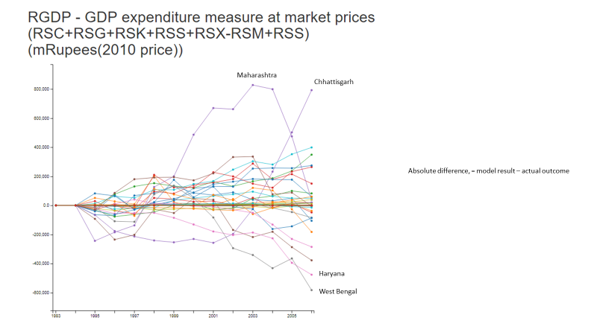

## Validating the model with residual corrections

The final test compares model results against actual data if we account for the errors in the individual equations. The errors, which are referred to as residuals, in the model interface are stored and added back into the endogenous model solution; this is the same mechanism that is used by the model to match baseline forecasts.

If the errors from the equations are large, then this approach could introduce bias into the modelling, but this would have been picked up in the tests in the previous section. This final test is more an assessment of the model’s mechanics; we would expect it to very closely match the actual data. However, the test is also important, because this is the closest approximation to how the model is used for analysis.

Figure 4.5 confirms that this is the case, with no difference at all in the GDP (and employment) results and only a very small difference in emissions.

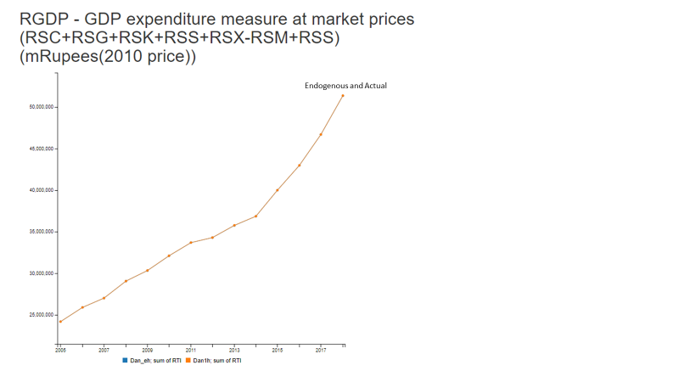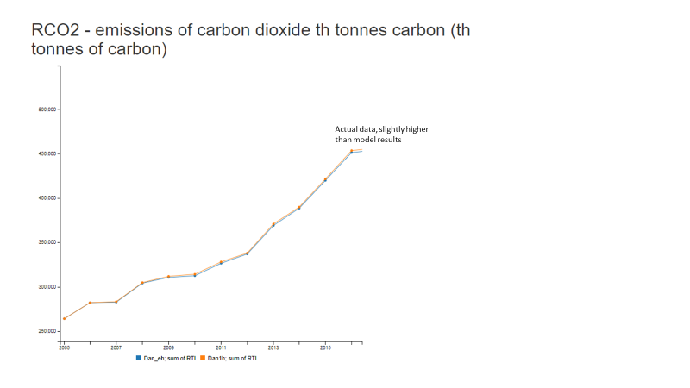

Figure .: Historical validation, including residual correction

Similar results were found at state level, with the discrepancies between model results and actual data being only a fraction of a percent. These small differences are likely due to rounding errors in the model solution process and not an indication of issues in the underlying data and equations.

## Running test scenarios

The final stage of the testing is for the model to be used as widely as possible by individuals with a range of expertise to consider a range of different policies. This part of the validation is still ongoing and we anticipate that some of the exercises will be added as case studies to Chapter 8 of this manual. Any issues that are uncovered in this process will be investigated by the modelling team.

## Summary

In conclusion, extensive testing has been carried out as part of the model validation and is still ongoing through an interactive process. Several issues, relating to both data and features of the model code, have been identified along the way and have been addressed.

The results presented in this chapter summarise the main findings of the validation. While there is still work to be done in some of the individual equations, we expect this to move forward over time as additional data become available. Longer time series should improve the accuracy of the parameter estimation and may allow for additional explanatory variables to be added to the equations, without reducing degrees of freedom too much.

The focus now is on developing additional test scenarios to continuously further model validation.

# Functions in E3-India

## Introduction

In common with other economic models, E3-India consists of a combination of accounting balances and behavioural relationships. This chapter describes both types of equation in the following sections, starting with the main accounting relationships.

The modelling approach for the behavioural relationships is econometric, meaning that the basis for determining the relationships is the historical time-series data. The estimation methods used are described in detail in Chapter 3, Section 3. The current version of E3-India includes 16 sets of econometric equations that cover energy consumption, several economic indicators, international trade and the labour market.

The following sections provide an overview of the equation specifications.

## Main macroeconomic identity relationships

In this section, we present the main accounting equations. The model follows the structure of the National Accounts, with disaggregation by sector in each state.

GDP, output and value added

The main measure of GDP is determined by demand-side factors in E3-India, following the definition shown below. This follows the standard accounting definition.

Table .: GDP identity

|  |  |
| --- | --- |
|  | |
| RGDP = RSC + RSK + RSG + RSX - RSM + RSS | |
| Definitions: | |
| RGDP | is GDP, m Rs at 2011 prices |
| RSC | is total consumer expenditure, m Rs at 2011 prices |
| RSK | is total investment (GFCF), m Rs at 2011 prices |
| RSG | is total final government expenditure, m Rs at 2011 prices |
| RSX | is total exports, m Rs at 2011 prices |
| RSM | is total imports, m Rs at 2011 prices |
| RSS | is total inventories, m Rs at 2011 prices |
|  |  |

Table .: Calculation of output

|  |  |
| --- | --- |
|  | |
| QR = QRY + QRC + QRK + QRG + QRX - QRM + QRR | |
| Definitions: | |
| QR | Is a vector of output (by product), m Rs at 2011 prices |
| QRY | is a vector of intermediate goods, m Rs at 2011 prices |
| QRC | is a vector of final consumer output goods, m Rs at 2011 prices |
| QRK | is a vector of final investment goods, m Rs at 2011 prices |
| QRG | is a vector of final government goods, m Rs at 2011 prices |
| QRX | is a vector of final exported goods, m Rs at 2011 prices |
| QRM | is a vector of final imported goods, m Rs at 2011 prices |
| QRR | is a residual value to balance accounts, m Rs at 2011 prices |
|  |  |

Output

While GDP provides a measure of net production at the whole-economy level, at the sectoral level we have (gross) output and gross value added. Output is equivalent to turnover in that it includes intermediate inputs to production, while value added does not include purchases from other sectors.

The measure of output is determined from the demand side, in a similar way to GDP but also including the intermediate demands, as shown below. Each variable in the box is defined by both state and sector.

A fundamental part of the national accounting structure is that supply and demand must match. In the demand-driven structure of E3-India this is imposed by ensuring that production matches the level of the goods demanded (if there are supply constraints that prevent this from happening then demand must be adjusted separately).

The basic relationship is presented below.

Table .: Balancing supply and demand

|  |  |
| --- | --- |
|  | |
| YR = QR | |
| Definitions: | |
| YR | is a vector of output (by industry), m Rs at 2011 prices |
| QR | is a vector of output (by product), m Rs at 2011 prices |
|  |  |

Value added

Value added is defined as the difference between output and material input costs. Value added itself is the sum of wages, company profits and production taxes.

GDP and value added are among the most important model results but there are other identity relationships that play an important role in determining these results. The key ones are presented in the following paragraphs, starting with the measures of consumer prices and inflation.

Table .: Calculating GVA

|  |  |
| --- | --- |
|  | |
| YRF = YR - YRQ - YRT | |
| Definitions: | |
| YRF | is a vector of value added, m Rs at 2011 prices |
| YR | is a vector of output (by industry), m Rs at 2011 prices |
| YRQ | is a vector of intermediate demands by industry, m Rs at 2011 prices |
| YRT | is a vector of taxes on products, m Rs at 2011 prices |
|  |  |

Consumer prices

Consumer prices are determined by converting industry prices to the relevant consumer products. For example, the prices of cars are determined by the output prices of the car industry, plus the contribution from transport and retail costs, plus the taxes on purchases of new cars.

The general structure of the relationships is shown below.

Table .: Consumer prices

|  |  |
| --- | --- |
|  | |
| PCR = (QCC * PQRD * CR) * ((1+CRTR) / CR) | |
| Definitions: | |
| PCR | is a vector of consumer prices, by product, m Rs at 2011 prices |
| QCC | is a matrix that converts industry production to consumer products |
| PQRD | is a vector of prices of industry sales to the domestic market, m Rs at 2011 prices |
| CR | is a vector of consumer products, m Rs at 2011 prices |
| CRTR | is a vector of indirect tax rates on consumer products |
|  |  |

The consumer price index

The aggregate consumer price index is obtained by taking the sum across all consumer products. Inflation is the annual change in the consumer price index.

Table .: The consumer price index

|  |  |
| --- | --- |
|  | |
| PRSC = sum (PCR * CR) / RSC | |
| Definitions: | |
| PRSC | is the aggregate consumer price index, 2011 = 1.0 |
| PCR | is a vector of consumer products’ prices, 2011 = 1.0 |
| CR | is a vector of expenditure on consumer products, m Rs at 2011 prices |
| RSC | is the sum of expenditure on consumer products, m Rs at 2011 prices |
|  |  |

Household real incomes

Real incomes are the main driver of consumption, which is the largest component of GDP. The level of real incomes is therefore a key model result. The variable is determined by summing wage and non-wage income in nominal terms, and converting to real terms.

Non-wage income includes rents from property and other financial and non-financial assets, plus remittances. It is very difficult to model and is held as a fixed differential to wage income (i.e. if wage income increases by 2% then it is assumed that non-wage income increases by 2% as well).

Table .: Calculating real incomes

|  |  |
| --- | --- |
|  | |
| RRPD = (sum (YRW * YRE) + RRI) / PRSC | |
| Definitions: | |
| RRPD | is a measure of real household income, m Rs at 2011 prices |
| YRW | is the average annual wage in each sector, th Rs |
| YRE | is the employment level in each sector, th people |
| RRI | is a measure of non-wage (‘residual’) income, m Rs |
| PRSC | is the aggregate consumer price index, 2011 = 1.0 |
|  |  |

The remainder of this chapter focuses on the econometric equations in the model.

## Summary specification of equations

Table 5.8 provides a list of the estimated equations. Table 5.9 summarises the variables that are used and units of measurement. A full list of model variables is available on request.

Dummy variables

The use of dummy variables in E3-India modelling is restricted by the limited degrees of freedom offered by the time-series data but there is an important case where a dummy variable is added to all the equation sets

The financial crisis in 2009 provoked many non-linear reactions. To reduce bias in our parameter estimates, a dummy variable for 2009 (zero before 2009, one from 2009 onwards) is included in all the equation sets.

To avoid excessive repetition, the dummy variable is not included in the formal definitions provided in the rest of this chapter, but it is an important part of the model estimation and solution.

Table .: The econometric functions

|  |  |  |
| --- | --- | --- |
|  | Short Name | Description |
| 1 | BFR0 | Aggregate Energy Demand |
| 2 | BFRC | Coal Demand |
| 3 | BFRO | Heavy Oil Demand |
| 4 | BFRG | Natural Gas Demand |
| 5 | BFRE | Electricity Demand |
| 6 | BRSC | Aggregate Consumption |
| 7 | BCR | Disaggregate Consumption |
| 8 | BKR | Industrial Investment |
| 9 | BQRM | Imports |
| 10 | BQRX | Exports |
| 11 | BYRE | Industrial Employment |
| 12 | BPYH | Industrial Prices |
| 13 | BPQX | Export Prices |
| 14 | BPQM | Import Prices |
| 15 | BYRW | Industrial Average Earnings |
| 16 | BLRP | Labour Participation Rate |

Table .: Summary of the econometric equations

|  |  |  |  |  |  |  |
| --- | --- | --- | --- | --- | --- | --- |
|  | **Endo var** | **V1** | **V2** | **V3** | **V4** | **Units** |
| 1 | FR0 | FRY | PREN | FRKE |  | th toe |
| 2-5 | FR(fuel) | FR0 | PFRF | FRKE |  | th toe |
| 6 | RSC | RRPD | RRLR | RUNR | PRSC | m Rs 2011 prices |
| 7 | CR | RRPD | PRCR | RRLR | PRSC | consumption ratio |
| 8 | KR | YR | PKR/PYR | RRLR |  | m Rs 2011 prices |
| 9 | QM0 | QRDI | PYH/PQM | YRKE |  | m Rs 2011 prices |
| 10 | QRX | QRDW | PQX | YRKE |  | m Rs 2011 prices |
| 11 | YRE | YR | LYLC | PQMA |  | thousands |
| 12 | PYH | YRUC | PQM | YRKE |  | index 20010=1.0 |
| 13 | PQRX | PQWE | EX | YRULT |  | index 20010=1.0 |
| 14 | PQM | PQWE | EX | YRUL |  | index 2011=1.0 |
| 15 | YRW | LYWE | YRWE | LYRP | RUNR | th Rs per year |
| 16 | LRP | RSQ | RWS/REMP | RUNR |  | rate [0,1] |

The names of variables and parameter sets closely follow the conventions for Fortran names, i.e. they are groups of capital letters and numbers beginning with a letter.

Table .: Understanding the function tables

|  |  |
| --- | --- |
| + - * and / | denote addition, subtraction, multiplication and division of scalars and of individual elements of vectors and matrices. |
| ( ) | are grouping brackets. |
| [ ] | enclose comments. |
| (.) | as a postscript on a name indicates that it denotes all the elements in a variable that is disaggregated. |
| (.,.) | as a postscript on a name again indicates all the elements in a disaggregated variable but across two dimensions (e.g. sector and region). |
| (^) | denotes that a disaggregated variable is converted to a diagonal matrix. |
| (.,.)' | denotes that the matrix variable is transposed. |
| (-1), (-2) etc. | as applied to a variable or a group of variables as a postscript, denote a one, two etc. period lag. |
| LN(V) | natural logarithm of variable V. |
| DLN(V) | change in LN(V). |
| MATP(M1(.,.),M2(.,.)) | matrix multiplication of variable matrices M1 and M2. |

Nearly all the variables and parameters are defined by state. In order to reduce the complexity of the notation, this regional dimension is omitted in the tables below. Therefore, all variables and parameters should be assumed to vary over the states of India unless otherwise stated.

## Aggregate energy demand

The original equation is based on work by Barker, Ekins and Johnstone (1995) and Hunt and Manning (1989). The work by Serletis (1992), and Bentzen and Engsted (1993) has also helped in forming the specification for the cointegrating equation. The version of the equation in the E3ME global model has been adapted for E3-India.

Overall structure

Since there are substitutable inputs between fuels, the total energy demand in relation to the output of the energy-using industries is likely to be more stable than the individual components. Even so, total energy demand is also subject to considerable variation, which reflects both technical progress in conservation, and changes in the cost of energy relative to other inputs. The aggregate energy equation considers the total energy used (summation of five carriers) in thousand tonnes of oil equivalent (th toe) by each energy user. The demand for energy is dependent on the economic 'activity' for that user (converted from the 39 economic sectors). This is chosen as gross economic output for most sectors, but household energy demand is a function of total consumers' expenditure. A restriction is imposed so that higher activity does not result in lower energy use (all other factors being equal).

The average price used in the equations weights the prices of individual energy carriers by their share in consumption by each user. Due to data limitations, the current energy demand equations do not allow for asymmetrical effects (i.e. rising energy prices leading to reductions in fuel demand, but falling prices not leading to an increase). Such asymmetrical price effects in aggregate energy demand equations have been the subject of other research (Gately, 1993; Walker and Wirl, 1993; Grubb, 1995, 2014). The idea is that because energy is used via capital stock with a long lifetime, and since technical change is progressive and is not generally reversed, when energy prices rise and energy savings are introduced, then when energy prices fall again, these savings are not reversed i.e. energy demand responds to rises in real prices, but not falls. This will be revisited in future.

Price elasticities

As described in Section 6.5, the long-run price elasticities are taken from the literature rather than estimated using the time-series data. The long-run price elasticity for transport is imposed at -0.45 for all states, following the research on long-run road transport demand (Franzen and Sterner, 1995) and (Johansson and Schipper, 1997, p. 289). CE’s internal research, using cross-sectional analysis of the E3ME data set has confirmed this result. Elasticities for other sectors are around -0.2.

Technology and capital stock

The measures of research and development expenditure capture the effect of new ways of decreasing energy demand (energy saving technical progress) and the elimination of inefficient technologies, such as energy saving techniques replacing the old inefficient use of energy. The variable FRKE is determined by converting the economic estimates for the technological progress indicators into the energy using categories.

The power sector

The power generation sector is solved using the bottom-up FTT model (see Section 6.6) rather than the estimated equations. The top-down approach offered by the econometric equations is not appropriate for this sector because:

* there is a small number of large plants, meaning estimated parameters give a poor performance
* the econometric approach is not well suited to the development of new renewable technologies

Table .: Aggregate energy demand equations

|  |  |  |  |  |  |
| --- | --- | --- | --- | --- | --- |
| *Co-integrating long-term equation:* | | | | | |
| LN(FR0(.)) | |  | | | [total energy used by energy user] |
|  | = | BFR0(.,7) | | |  |
|  | + | BFR0(,.8) * LN(FRY(.)) | | | [activity measure] |
|  | + | BFR0(.,9) * LN(PREN(.)) | | | [average price ratio] |
|  | + | BFR0(.,10) * LN(FRKE(.)) | | | [technology measure] |
|  | + | ECM | | | [error] |
|  |  |  | | |  |
| *Dynamic equation:* | | | | | |
| DLN(FR0(.)) | |  | | | [total energy used by energy user] |
|  | = | BFR0(.,1) | | |  |
|  | + | BFR0(.,2) * DLN(FRY(.)) | | | [activity measure] |
|  | + | BFR0(.,3) * DLN(PREN(.)) | | | [average price ratio] |
|  | + | BFR0(.,4) * DLN(FRKE(.)) | | | [technology measure] |
|  | + | BFR0(.,5) * DLN(FR0(-1)) | | | [lagged change in energy use] |
|  | + | BFR0(.,6) * ECM(-1) | | | [lagged error correction] |
|  |  |  | | |  |
| *Identity:* | | | | | |
| PREN | = | PFR0(.) / PRYR | | | [relative price ratio] |
|  |  |  | | |  |
| *Restrictions:* | | | | | |
| BFR0(.,3 .,4 .,9 .,10) <= 0 | | | | | [‘right sign’] |
| BFR0(.,2 .,8) >= 0 | | | | | [‘right sign’] |
| 0 > BFR0(.,6) > -1 | | | | | [‘right sign’] |
|  | | |  |  |  |
|  | | |  |  |  |
|  | | |  |  |  |
| *Definitions:* | | | | | |
| BFR0 | is a matrix of parameters | | | | |
| FR0 | is a matrix of total energy used by energy user, th toe | | | | |
| PFR0 | is a matrix of average energy prices by energy user, Rs/toe | | | | |
| PRYR | is a matrix of average producer prices in the economy as a whole, 2011 = 1.0 | | | | |
| FRY | is a matrix of activity by energy user, m Rs at 2011 prices | | | | |
| FRKE | is a matrix of technological progress by industry, converted to energy users | | | | |
|  |  | | | | |

## Disaggregate energy demand for coal, heavy fuel oil, gas and electricity

The specification is shown in Table 5.12.

The equations for disaggregated energy demand have been specified for four energy carriers[3]: coal, oils, gas and electricity. There is no reliable price data for biomass to form econometric relationships. Biomass in E3-India is therefore treated as a residual fuel and is set to move in line with total energy demand.

The four carriers that are modelled have the characteristic that in some industries they are highly substitutable inputs to the process of heat generation. The specification of the equations follows similar lines to the aggregate energy demand equations (see previous section). The equations contain the same technology variable, with the same restrictions imposed. Instead of using a measure of economic activity, total energy consumption by the sector is used.

The price term is a ratio of the price for the particular energy carrier in question to that of the aggregate energy price. The relative fuel prices have changed dramatically over the period of historical data, particularly towards the start and end of the time series.

Again, the power generation sector is solved using the FTT submodel, and does not use the estimated equation.

Table .: Disaggregate energy demand equations

|  |  |  |  |  |  |
| --- | --- | --- | --- | --- | --- |
| *Equations used for F = Coal (C), Heavy Fuel Oil (O), Natural Gas (G) and Electricity (E)* | | | | | |
| *Co-integrating long-term equation:* | | | | | |
| LN(FRF(.)) | | |  |  | [fuel used by energy user] |
|  | = | BFRF(.,7) | | |  |
|  | + | BFRF(.,8) * LN(FR0(.)) | | | [total energy used by energy user] |
|  | + | BFRF(.,9) * LN(PFRP(.)) | | | [price ratio] |
|  | + | BFRF(.,10) * LN(FRKE (.)) | | | [technology index] |
|  | + | ECM | | | [error] |
|  | | |  |  |  |
| *Dynamic equation:* | | | | | |
| DLN(FRF(.)) | | |  |  | [fuel used by energy user] |
|  | = | BFRF(.,1) | | |  |
|  | + | BFRF(.,2) * DLN(FR0(.)) | | | [total energy used by energy user] |
|  | + | BFRF(.,3) * DLN(PFRP(.)) | | | [price ratio] |
|  | + | BFRF(.,4) * DLN(FRKE (.)) | | | [technology index] |
|  | + | BFRF(.,5) * DLN(FRF(-1)) | | | [lagged change in energy use] |
|  | + | BFRF(.,6) * ECM(-1) | | | [lagged error correction] |
|  |  |  | | |  |
| *Identity:* | | | | | |
| PFRP | = | PFRF(.)/PFR0(.) | | | [price ratio] |
|  | | |  |  |  |
| *Restrictions:* | | | | | |
| BFRF(.,3 .,4 .,9 .,10) <= 0 | | | | | [‘right sign’] |
| BFRF(.,2 .,8) >= 0 | | | | | [‘right sign’] |
| 0 > BFRF(.,6) > -1 | | | | | [‘right sign’] |
|  | | |  |  |  |
| *Definitions:* | | | | | |
| BFRF | is a matrix of parameters | | | | |
| FRF | is a matrix of fuel used by energy user, th toe | | | | |
| FR0 | is a matrix of total energy used by energy user, th toe | | | | |
| PFRF | is a matrix of prices for energy carrier F, by energy user, Rs/toe | | | | |
| PFR0 | is a matrix of average energy prices by energy user, Rs/toe | | | | |
| FRKE | is a matrix of technological progress by industry, converted to energy users | | | | |
|  | | |  | | |

## Household consumption

Aggregate household consumption

The model equations for household consumption are split into two separate sets. The first set estimates total consumption volumes, while the second set allocates this consumption according to the available budget.

The equation specification is given in Table 5.13. It should be noted that the dependent variable and term for income are converted into per capita measures, although this is excluded from the table for conciseness. As consumption accounts for around 40-50% of final demand the equation is very important within the model structure as a whole.

Most studies have followed those of Hendry et al (1978) which have examined the dynamic links between consumption, income and wealth in an error correction model. In more recent studies, attention has focused more upon the role of wealth (housing wealth in particular) and financial liberalisation (Barrell and Davis, 2007; Carruth and Kerdrain, 2011); current data in India do not allow for this type of assessment but it could be added to the model in future.

The specification of the equation is similar to that used in the previous HERMES and E3ME models, which generalise the permanent income and the lifecycle theories in an error correction model. Indeed, the long-run elasticity of consumption in relation to income has been set equal to one to ensure the lifecycle theory is fulfilled (wealth effects are missing from the equations in E3-India due to data constraints).

These equations relate total consumption to regional personal disposable income, unemployment rates, inflation and interest rates. The unemployment rate is used as a proxy for the degree of uncertainty in the economy and has been found to have significant effects on short-term consumption levels. As unemployment data in India can be unreliable, inactive population (i.e. working age population minus those employed) is used as a proxy.

Table .: Aggregate consumption equations

|  |  |  |  |  |
| --- | --- | --- | --- | --- |
| *Co-integrating long-term equation:* | | | | |
| LN(RSC) | |  |  | [real consumers’ expenditure] |
|  | | = | BRSC(8) |  |
|  | | + | BRSC(9) * LN(RRPD) | [real gross disposable income] |
|  | | + | BRSC(10) * LN(RRLR) | [real rate of interest] |
|  | | + | ECM | [error] |
|  | |  |  |  |
| *Dynamic equation:* | | | | |
| DLN(RSC) | |  |  | [real consumers’ expenditure] |
|  | | = | BRSC(1) |  |
|  | | + | BRSC(2) * DLN(RRPD) | [real gross disposable income] |
|  | | + | BRSC(3) * DLN(RRLR) | [real rate of interest] |
|  | | + | BRSC(4) * LN(RUNR) | [unemployment rate] |
|  | | + | BRSC(5) * DLN(RPSC) | [consumer price inflation] |
|  | | + | BRSC(6) * DLN(RSC(-1)) | [lagged change in consumers’ expenditure] |
|  | | + | BRSC(7) * ECM(-1) | [lagged error correction] |
|  | |  |  |  |
| *Identities:* | | | | |
| RRLR | | = | 1 + (RLR–DLN(PRSC))/100 | [real rate of interest] |
| RRPD | | = | (RGDI / PRSC) | [real gross disposable income] |
|  | |  |  |  |
|  | |  |  |  |
| *Restrictions:* | | | | |
| BRSC(9) = 1 | | | | [‘life cycle hypothesis’] |
| BRSC(2) >= 0 | | | | [‘right sign’] |
| BRSC(3, 4, 5, 10) <= 0 | | | | [‘right sign’] |
| 0 > BRSC(7) > -1 | | | | [‘right sign’] |
|  | |  |  |  |
| *Definitions* | | | | |
| BRSC | is a matrix of parameters | | | |
| RSC | is a vector of total consumers’ expenditure, m Rs at 2011 prices | | | |
| RGDI | is a matrix of gross disposable income, m Rs at current prices | | | |
| RLR | is a matrix of long-run nominal interest rates | | | |
| RUNR | is a vector of unemployment rates, measured as a percentage of the labour force | | | |
| PRSC | is a vector of consumer price deflator, 2011=1.0 | | | |
| RPSC | is a vector of consumer price inflation, in percentage terms | | | |
|  |  | | | |

Disaggregate consumption

The specification is shown in Table 5.14

Both the long-term and dynamic equations have a similar specification to the aggregation consumption equations, but include the relative prices of each consumption category.

Table .: Disaggregate consumption equations

|  |  |  |  |  |  |  |  |
| --- | --- | --- | --- | --- | --- | --- | --- |
| *Co-integrating long-term equation:* | | | | | | | |
| LN(SHAR(.)) | | | | | | | [consumers’ budget share, logistic form] |
|  | = | | BCR(.,8) | | | |  |
|  | + | | BCR(.,9) * LN(RRPD) | | | | [real gross disposable income] |
|  | + | | BCR(.,10) * LN(PRCR(.)) | | | | [relative price of consumption] |
|  | + | | BCR(.,11) * LN(RRLR) | | | | [real rate of interest] |
|  | + | | BCR(.,12) * LN(PRSC) | | | | [consumer price deflator] |
|  | + | | ECM | | | | [error] |
|  | |  | | |  | |  |
| *Dynamic equation:* | | | | | | | |
| DLN(SHAR(.)) | | | | | | | [consumers’ budget share, logistic form] |
|  | = | | BCR(.,1) | | | |  |
|  | + | | BCR(.,2) * DLN(RRPD) | | | | [real gross disposable income] |
|  | + | | BCR(.,3) * DLN(PRCR(.)) | | | | [relative price of consumption] |
|  | + | | BCR(.,4) * DLN(RRLR) | | | | [real rate of interest] |
|  | + | | BCR(.,5) * DLN(PRSC) | | | | [consumer price deflator] |
|  | + | | BCR(.,6) * DLN(SHAR)(-1) | | | | [lagged change in consumers’ budget share] |
|  | + | | BCR(.,7) * ECM(-1) | | | | [lagged error correction] |
|  | | | |  | |  |  |
| *Identities:* | | | | | | | |
| SHAR | = | | (VCR(.)/VCRT) /  (1-(VCR(.)/VCRT)) | | | | [consumers’ budget share, logistic form] |
| RRPD | = | | (RGDI/RPSC)/RPOP | | | | [real gross disposable income] |
| PRCR | = | | VCR(.)/CR(.)/PRSC | | | | [real price of consumption] |
| RRLR | = | | 1+(RLR-DLN(PRSC))/100 | | | | [real rate of interest] |
|  | | | |  | |  |  |
| *Restriction:* | | | | | | | |
| 0 > BCR(.,7) > -1 | | | | | | | [‘right sign’] |
|  | | | | | | |  |
| *Definitions:* | | | | | | | |
| BCR | is a matrix of parameters | | | | | | |
| CR | is a matrix of consumers’ expenditure by commodity, m Rs at 2011 prices | | | | | | |
| VCR | is a matrix of consumers’ expenditure by commodity, m Rs at current prices | | | | | | |
| VCRT | is a vector of total consumers’ expenditure, m Rs at current prices | | | | | | |
| RGDI | is a matrix of gross disposable income, in m Rs at current prices | | | | | | |
| RLR | is a matrix of long-run nominal interest rates | | | | | | |
| PRSC | is a vector of total consumer price deflator, in percentage terms | | | | | | |
| RPSC | is a vector of consumer price inflation, in percentage terms | | | | | | |
|  |  | | | | | | |

## Industrial investment

Industrial investment

Investment (see Table 5.15) is a very important and very volatile component of final demand, so its treatment in the model is of central importance to model simulation and forecasting performance. Ideally, the treatment of investment in a sectoral model such as E3-India should disaggregate by asset (e.g. vehicles, plant and machinery, and buildings) as well as by investing industry, but this has not proved possible due to data limitations.

The specification of the investment equations in E3-India has built upon earlier work in the E3ME model and published in Barker and Peterson (1987). The theory behind the choice of variables that explain the long-run path of investment is a mix between the neoclassical tradition, whereby factor demands are explained solely in terms of other factor prices, and the accelerator model, which recognises the importance of output as a determining influence. For the dynamic representation, the real rate of interest is also added.

E3-India is bound by the investment-savings national accounts identity but the representation of capital markets in E3-India does not assume a fixed stock of money, as is typically the case in CGE models. Endogenous money is an important feature of the model, with banks creating money whenever they see a profitable lending opportunity (Pollitt and Mercure, 2017).

Table .: Investment equations

|  |  |  |  |  |  |  |  |  |
| --- | --- | --- | --- | --- | --- | --- | --- | --- |
| *Co-integrating long-term equation:* | | | | | | | | |
| LN(KR(.)) | | | | | | | | [investment] |
|  | | = | BKR(.,7) | | | | |  |
|  | | + | BKR(.,8) * LN(YR(.)) | | | | | [real output] |
|  | | + | BKR(.,9) * LN(PKR(.)/PYR(.)) | | | | | [relative price of investment] |
|  | | + | ECM | | | | | [error] |
|  | |  |  | | | | |  |
| *Dynamic equation:* | | | | | | | | |
| DLN(KR(.)) | | | | | | | | [change in investment] |
|  | | = | BKR(.,1) | | |  | | |
|  | | + | BKR(.,2) * DLN(YR(.)) | | | | | [real output] |
|  | | + | BKR(.,3) * DLN(PKR(.)/PYR(.)) | | | | | [relative price of investment] |
|  | | + | BKR(.,4) * LN(RRLR) | | | | | [real rate of interest] |
|  | | + | BKR(.,5) * DLN(KR)(-1) | | | | | [lagged change in investment] |
|  | | + | BKR(.,6) * ECM(-1) | | | | | [lagged error correction] |
|  | | | |  |  | | |  |
| *Identities:* | | | | | | | | |
| RRLR | | = | 1 + (RLR – DLN(PRSC)) / 100 | | | | | [real rate of interest] |
|  | | | |  |  | |  | |
| *Restrictions:* | | | | | | | | |
| BKR(.,2 .,8) >= 0 | | | | | | | | [‘right sign’] |
| BKR(.,3 .,4 .,9) <= 0 | | | | | | | | [‘right sign’] |
| 0 > BKR(.,6) > -1 | | | | | | | | [‘right sign’] |
|  | | | | | | |  | |
| *Definitions:* | | | | | | | | |
| BKR | is a matrix of parameters | | | | | | | |
| KR | is a matrix of investment expenditure by industry, m Rs at 2011 prices | | | | | | | |
| YR | is a matrix of gross industry output by industry, m Rs at 2011 prices | | | | | | | |
| PKR | is a matrix of industry investment price by industry, 2011=1.0 | | | | | | | |
| PRSC | is a vector of consumer price deflator, 2011=1.0 | | | | | | | |
| RLR | is a vector of long-run nominal interest rates | | | | | | | |
| PYR | is a matrix of industry output price by industry, 2011=1.0, Rs | | | | | | | |
|  |  | | | | | | | |

## The international trade equations

Trade is an important feature in the E3-India model for two main reasons. Firstly, globalisation has meant that international trade has accounted for an increasing share of total production (expected to increase further in the future, even with slower future trade growth). Secondly, exports and imports represent the linkage between India and the rest of the world, so effects moving from one India to another country, or from another country to India, are transmitted via this area of the model.

In a sub-national model, trade represents a major issue in assessing regional economic impacts. Demand in each state can be met either by production within that state, production in another state, or production in another country. With no available data on trade between the states, it is necessary to impose assumptions on the rates of production in the states with relation to developments in neighbouring states.

The approach can be summarised as:

* International exports are estimated at state level, based on the production prices within each state.
* International imports are estimated at national level and applied to the states, based on estimates of current and baseline future state-level imports.
* Trade between states is estimated using production shares that could be varied in response to changes in prices within each state.

International Imports

In the import equations, activity is modelled by sales to the domestic market, the relative price of sales to the domestic market and the technical progress variable.

International export volumes

In the E3-India model, exports are explained as a function of the demand of the rest of world for Indian production, export prices and the technology variable. The technology variable is included to allow for the effects of innovations on trade performance.

The formal specification of the import and export equations is shown in Table 5.16 and Table 5.17.

Table .: International export volume equations

|  |  |  |  |  |  |  |
| --- | --- | --- | --- | --- | --- | --- |
| *Co-integrating long-term equation:* | | | | | | |
| LN(QRX(.)) | | | | | | [export volume] |
|  | | = | BQRX(.,7) | | |  |
|  | | + | BQRX(.,8) * LN(QRDW(.)) | | | [rest of the world demand] |
|  | | + | BQRX(.,9) * LN(PQRX(.)) | | | [exports price] |
|  | | + | BQRX(.,10) * LN(YRKE(.)) | | | [technological progress] |
|  | | + | ECM | | | [error] |
|  | | | |  |  |  |
| *Dynamic equation:* | | | | | | |
| DLN(QRX(.)) | | | | | | [change in internal export volume] |
|  | | = | BQRX(.,1) | | |  |
|  | | + | BQRX(.,2) * DLN(QRDW (.)) | | | [rest of the world demand] |
|  | | + | BQRX(.,3) * DLN(PQRX(.)) | | | [exports price] |
|  | | + | BQRX(.,4) * DLN(YRKE(.)) | | | [technological progress] |
|  | | + | BQRX(.,5) * DLN(QRX)(-1) | | | [lagged change in export volume] |
|  | | + | BQRX(.,6) * ECM(-1) | | | [lagged error correction] |
|  | |  |  | | |  |
| *Restrictions:* | | | | | | |
| BQRX(.,2 .,4 .,8 .,10) >= 0 | | | | | | [‘right sign’] |
| BQRX(.,3 .,9) <= 0 | | | | | | [‘right sign’] |
| 0 > BQRX(.,6) > -1 | | | | | | [‘right sign’] |
|  | | | | | |  |
| *Definitions:* | | | | | | |
| BQRX | is a matrix of parameters | | | | | |
| PQRX | is a matrix of export prices by industry, 2011=1.0 | | | | | |
| QRDW | is a matrix of production in the rest of the world, m Rs at 2011 prices | | | | | |
| QRX | is a matrix of exports by industry, m Rs at 2011 prices | | | | | |
| YRKE | is a matrix of technological progress by industry | | | | | |
|  | | | |  | | |

Table .: International import volume equations

|  |  |  |  |  |  |  |
| --- | --- | --- | --- | --- | --- | --- |
| *Co-integrating long-term equation:* | | | | | | |
| LN(QM0(.)) | | | | | | [import volume] |
|  | | = | BQRM(.,7) | | |  |
|  | | + | BQRM(.,8) * LN(QRDI(.)) | | | [home sales] |
|  | | + | BQRM(.,9) * LN(PYH(.)/PQRM(.)) | | | [relative price] |
|  | | + | BQRM(.,10) * LN(YRKE(.)) | | | [technological progress] |
|  | | + | ECM | | | [error] |
|  | | | |  |  |  |
| *Dynamic equation:* | | | | | | |
| DLN(QM0(.)) | | | | | | [change in internal import volume] |
|  | | = | BQRM(.,1) | | |  |
|  | | + | BQRM(.,2) * DLN(QRDI(.)) | | | [home sales] |
|  | | + | BQRM(.,3) * DLN(PYH(.)/PQRM(.)) | | | [relative price] |
|  | | + | BQRM(.,4) * DLN(YRKE(.)) | | | [technological progress] |
|  | | + | BQRM(.,5) * DLN(QRM)(-1) | | | [lagged change in import volume] |
|  | | + | BQRM(.,6) * ECM(-1) | | | [lagged error correction] |
|  | |  |  | | |  |
| *Identity:* | | | | | | |
| QRDI | | = | QR(.) + QRM(.) | | | [home sales] |
| PYH | | = | (VQR(.) - VQRX(.)) / (QR(.) - QRX(.)) | | | [price home sales by home producers] |
|  | |  |  | | |  |
| *Restrictions:* | | | | | | |
| BQRM(.,2 .,3 .,8 .,9) >= 0 | | | | | | [‘right sign’] |
| BQRM(.,4 .,10) <= 0 | | | | | | [‘right sign’] |
| 0 > BQRM(.,6) > -1 | | | | | | [‘right sign’] |
|  | | | | | |  |
| *Definitions:* | | | | | | |
| BQRM | is a matrix of parameters | | | | | |
| PQM | is a vector of import prices by industry, 2011=1.0 | | | | | |
| QR | is a vector of gross output by industry (here, aggregated over states), m Rs at 2011 prices | | | | | |
| QM0 | is a vector of imports to India by industry, m Rs at 2011 prices | | | | | |
| QRX | is a matrix of exports by industry (here, aggregated over states), m Rs at 2011 prices | | | | | |
| YRKE | is a matrix of technological progress by industry (here, aggregated over states) | | | | | |
| V- | indicates a current price version of the variable | | | | | |
|  | | | |  | | |

## Export and import prices

The basic model of trade prices used in E3-India assumes that each sector operates in oligopolistic markets and is small in relation to the total Indian and global markets. Certain commodities, e.g. crude mineral oil, have prices treated exogenously, but the majority are treated in the following manner. Following from the assumption on market structure, prices are set by producers as mark-ups on costs, i.e. unit costs of production. Aside from this, the same variables are used for both import and export prices, within a general log-log functional form.

Alongside the unit cost variable, there is a price term included in each regression to deal with developments outside India.

Restrictions are imposed to force price homogeneity on the long-term equations, again in much the same manner as for the trade volume equations.

Table .: Export price equations

|  |  |  |  |  |  |  |  |  |  |
| --- | --- | --- | --- | --- | --- | --- | --- | --- | --- |
| *Co-integrating long-term equation:* | | | | | | | | | |
| LN(PQRX(.)) | | | | | | | | | [export price] |
|  | | = | | | BPQX(.,6) | | |  | | |
|  | | + | | | BPQX(.,7) * LN(PQWE(.)*EX) | | | | [world commodity prices] |
|  | | + | | | BPQX(.,8) * LN(YRULT(.)) | | | | [unit labour and tax costs] |
|  | | + | | | ECM | | | | [error] |
|  | | | | | |  |  | |  |
| *Dynamic equation:* | | | | | | | | | |
| DLN(PQRX(.)) | | | | | | | | | [change in export prices] |
|  | | = | | | BPQX(.,1) | | | |  |
|  | | + | | | BPQX(.,2) * DLN(PQWE(.)*EX) | | | | [world commodity prices] |
|  | | + | | | BPQX(.,3) * DLN(YRULT(.)) | | | | [unit labour and tax costs] |
|  | | + | | | BPQX(.,4) * DLN(PQRX)(-1) | | | | [lagged change in export prices] |
|  | | + | | | BPQX(.,5) * ECM(-1) | | | | [lagged error correction] |
|  | |  | | |  | | | |  |
| *Identities:* | | | | | | | | | |
| PQWE | | = | | QMC(.) * PM | | | | | [world commodity price index] |
| YRULT | | = | | (YRLC(.) + YRT(.)) / QR(.) | | | | | [unit labour and tax costs] |
|  | | |  | | |  |  | |  |
| *Restrictions:* | | | | | | | | | |
| BPQM(.,7) = 1 – BPQM(.,9) | | | | | | | | | [price homogeneity] |
| BPQX( .,2 .,3 .,7 .,8) >=0 | | | | | | | | | [‘right sign’] |
| 0 > BPQX(.,5) > -1 | | | | | | | | | [‘right sign’] |
|  | | | | | | | | |  |
| *Definitions:* | | | | | | | | | |
| BPQX | is a matrix of parameters | | | | | | | | |
| EX | is a vector of exchange rates, Rs per $, 2011=1.0 | | | | | | | | |
| QMC | is a converter matrix between industries and the world commodity classification | | | | | | | | |
| PM | is a vector of commodity prices (in Rs) for 7 commodities, 2011=1.0 | | | | | | | | |
| YRLC | is a matrix of employer labour costs by industry, Rs at current prices | | | | | | | | |
| YRT | is a matrix of tax costs, by industry, m Rs at current prices | | | | | | | | |
| QR | is a matrix of gross output by industry, m Rs at 2011 prices | | | | | | | | |
|  |  | | | | | | | | |

Table .: Import price equations

|  |  |  |  |  |  |  |  |  |  |
| --- | --- | --- | --- | --- | --- | --- | --- | --- | --- |
| *Co-integrating long-term equation:* | | | | | | | | | |
| LN(PQM(.)) | | | | | | | | | [import price] |
|  | | = | | | BPQM(.,7) | | |  | | |
|  | | + | | | BPQM(.,8) * LN(PQWE(.)*EX) | | | | [world commodity prices] |
|  | | + | | | BPQM(.,9) * LN(YRULT(.)) | | | | [unit labour and tax costs] |
|  | | + | | | ECM | | | | [error] |
|  | | | | | |  |  | |  |
| *Dynamic equation:* | | | | | | | | | |
| DLN(PQM(.)) | | | | | | | | | [change in export prices] |
|  | | = | | | BPQM(.,1) | | | |  |
|  | | + | | | BPQM(.,2) * DLN(PQWE(.)*EX) | | | | [world commodity prices] |
|  | | + | | | BPQM(.,4) * DLN(YRULT(.)) | | | | [unit labour and tax costs] |
|  | | + | | | BPQM(.,5) * DLN(PQRX)(-1) | | | | [lagged change in export prices] |
|  | | + | | | BPQM(.,6) * ECM(-1) | | | | [lagged error correction] |
|  | |  | | |  | | | |  |
| *Identities:* | | | | | | | | | |
| PQWE | | = | | QMC(.) * PM | | | | | [world commodity price index] |
| YRULT | | = | | (YRLC(.) + YRT(.)) / QR(.) | | | | | [unit labour and tax costs] |
|  | | |  | | |  |  | |  |
| *Restrictions:* | | | | | | | | | |
| BPQM(.,8) = 1 – BPQM(.,9) | | | | | | | | | [price homogeneity] |
| BPQM( .,2 .,4 .,8 .,9) >=0 | | | | | | | | | [‘right sign’] |
| 0 > BPQM(.,6) > -1 | | | | | | | | | [‘right sign’] |
|  | | | | | | | | |  |
| *Definitions:* | | | | | | | | | |
| BPQM | is a matrix of parameters | | | | | | | | |
| PQM | is a vector of imports to India, by industry, m Rs at 2005 prices | | | | | | | | |
| EX | is a vector of exchange rates, Rs per $, 2005=1.0 | | | | | | | | |
| QMC | is a converter matrix between industry and world commodity classifications | | | | | | | | |
| PM | is a vector of commodity prices (in Rs) for 7 commodities, 2005=1.0 | | | | | | | | |
| YRLC | is a matrix of employer labour costs by industry (here, aggregated over states), Rs at current prices | | | | | | | | |
| YRT | is a matrix of tax costs, by industry (here, aggregated over states), m Rs at current prices | | | | | | | | |
| QR | is a matrix of gross output by industry (here, aggregated over states), m Rs at 2005 prices | | | | | | | | |
| PQRX | is a matrix of export prices for 56 industries (here, aggregated over states), 2005=1.0, local currency | | | | | | | | |
|  |  | | | | | | | | |

## Domestic industry prices

The following model of industry price formation was developed from Lee (1988), having previously been derived from Layard et al (1991). The original empirical results were presented in E3ME working paper no. 43 (Barker and Gardiner, 1994).

The basis for price setting is a measure of unit costs, which is formed by summing labour material and taxation costs, and dividing this by sectoral output. Each industry is assumed to produce a homogenous product but does not necessarily operate in a fully competitive market place. The degree to which cost increases are passed on in final product prices is determined by the level of competition in the sector.

Although import prices are included in unit costs, depending on the import content of production, import prices are added separately in the equation to allow for the effects of international competition on domestic price formation. In the long-term relationship, homogeneity is imposed between higher domestic and import cost effects, so that their combined impact is unitary. The equations also include the technology indices, as a higher quality product may command a higher price.

Some sectors have a specific treatment of price and do not use the estimated equations, instead using a simpler relationship:

* The electricity sector – based on long-run ‘levelised’ costs, or could be modelled as part of a regulated system.
* Government sectors – these are assumed to move in line with aggregate consumer price inflation.
* Regulated sectors – these are also assumed to move in line with aggregate consumer price inflation.

Table .: The Domestic Industry Prices Equations

|  |  |  |  |
| --- | --- | --- | --- |
| *Co-integrating long-term equation:* | | | |
| LN(PYH(.)) | | | [price of home sales by home producers] |
|  | = | BPYH(.,7) |  |
|  | + | BPYH(.,8) * LN(YRUC(.)) | [unit costs] |
|  | + | BPYH(.,9) * LN(PQRM(.)) | [import price] |
|  | + | BPYH(.,10) * LN(YRKE(.)) | [technological progress] |
|  | + | ECM | [error] |
|  |  |  |  |
| *Dynamic equation:* | | | |
| DLN(PYH(.)) | | | [change in price of home sales by home producers] |
|  | = | BPYH(.,1) |  |
|  | + | BPYH(.,2) * DLN(YRUC(.)) | [unit costs] |
|  | + | BPYH(.,3) * DLN(PQRM(.)) | [import price] |
|  | + | BPYH(.,4) * DLN(YRKE(.)) | [technological progress] |
|  | + | BPYH(.,5) * DLN(PYH)(-1) | [lagged change in price] |
|  | + | BPYH(.,6) * ECM(-1) | [lagged error correction] |
|  |  |  |  |
| *Identities:* | | | |
| PYH | = | (VQR(.) - VQRX(.)) / (QR(.) - QRX(.)) | [price of home sales by home producers] |
| YRUC | = | YRUM(.,) + YRUL(.) + YRUT(.) | [unit costs] |
| YRUL | = | YRLC(.) / YR(.) | [unit labour cost] |
| YRUT | = | YRT(.) / YR(.) | [unit tax cost] |
| YRUM | = | (BQRY(.)*YR(.))* PQRD(.) | [unit material cost] |
|  |  |  |  |
| *Restrictions:* | | | |
| BPYH(.,2 .,3 .,8 .,9) >= 0 | | | [‘right sign’] |
| BPYH(.,8) + BPYH(.,9) = 1 | | | [long-run cost pass-through] |
| 0 > BPYH(.,6) > -1 | | | [‘right sign’] |
|  | | |  |
|  | | |  |
| *Definitions:* | | | |
| BPYH | is a matrix of parameters | | |
| PQRM | is a matrix of import prices by industry, m Rs at 2011 prices | | |
| YRKE | is a matrix of technological progress by industry | | |
| YRLC | is a matrix of labour costs by industry, m Rs at current prices | | |
| YRT | is a matrix of net taxes by industry, m Rs at current prices | | |
| YR | is a matrix of gross industry output by industry, m Rs at 2011 prices | | |
| QR | is a matrix of gross output by product, m Rs at 2011 prices | | |
| QRX | is a matrix of exports by industry, m Rs at 2011 prices | | |
| BQRY | is a matrix of input-output relationships | | |
| PQRD | is a matrix of prices of sales to domestic markets, 2011 = 1.0 | | |
| V- | indicates a current price version of the variable | | |
|  |  | | |

## Industrial employment

In the econometric representation in E3-India, employment is determined as a function of real output and real wage costs. This is shown in Table 5.21.

The chosen model follows the work of Lee, Pesaran and Pierse (1990) but also incorporates insights from the work on growth theory developed by Scott (1989). A detailed methodological description with empirical results is contained in E3ME working papers no. 28 (Gardiner, 1994) and no. 43 (Barker and Gardiner, 1994). This includes a formal representation of the theoretical optimisation problem for firms to minimise costs for a given level of output.

Table .: Employment equations

|  |  |  |  |  |  |  |  |
| --- | --- | --- | --- | --- | --- | --- | --- |
| *Co-integrating long-term equation:* | | | | | | | |
| LN(YRE(.)) | | | | | | | [total employment] |
|  | = | BYRE(.,6) | | | | |  |
|  | + | BYRE(.,7) * LN(YR(.)) | | | | | [real output] |
|  | + | BYRE(.,8) * LN(LYLC(.)) | | | | | [real wage costs] |
|  | + | ECM | | | | | [error] |
|  | | |  |  | |  | |
| *Dynamic equation:* | | | | | | | |
| DLN(YRE(.)) | | | | | | | [change in total employment] |
|  | = | BYRE(,.1) | | |  | | |
|  | + | *BYRE*(,.2) * DLN(YR(.)) | | | | | [real output] |
|  | + | BYRE(,.3) * DLN(LYLC(.)) | | | | | [real wage costs] |
|  | + | BYRE(,.4) * DLN(YRE)(-1) | | | | | [lagged change in employment] |
|  | + | BYRE(,.5) * ECM(-1) | | | | | [lagged error correction] |
|  | | |  |  | |  | |
| *Identity:* | | | | | | | |
| LYLC | = | (YRLC(.)/PYR(.)) / YREE(.) | | | | | [real labour costs] |
|  | | |  |  | |  | |
| *Restrictions:* | | | | | | | |
| BYRE(.,2 .,7) >= 0 | | | | | | | [‘right sign’] |
| BYRE(.,3 .,8) <= 0 | | | | | | | [‘right sign’] |
| 0 > BYRE(.,5) > -1 | | | | | | | [‘right sign’] |
|  | | | | | | |  |
|  | | | | | | |  |
|  | | | | | | |  |
| *Definitions:* | | | | | | | |
| BYRE | is a matrix of parameters | | | | | | |
| YRE | is a matrix of total employment by industry, in thousands of persons | | | | | | |
| YR | is a matrix of gross output by industry, m Rs at 2011 prices | | | | | | |
| YRLC | is a matrix of employer labour costs (wages plus imputed social security contributions) by industry, Rs at current prices | | | | | | |
| PYR | is a matrix of output prices by industry, 2011=1.0 | | | | | | |
| YREE | is a matrix of wage and salary earners, in thousands of persons | | | | | | |
|  |  | | | | | | |

## Industrial average earnings

The specification is given in Table 5.22.

The starting point for the equation formation of wage rates used in E3-India is the approach adopted by Lee and Pesaran (1993), which is general enough to accommodate differing degrees of market power on both sides of the labour market. More information is provided in Barker and Gardiner (1996).

The treatment of wage determination is based on a theory of the wage-setting decisions made by a utility-maximising union, where the union derives utility (as the representative of its members) from higher real consumption wages (relative to the fallback level and from higher levels of employment (again relative to a fallback level, which is taken to be proportional to a simple average of employment levels in the last two years in the empirical work). The wage rate is set by unions choosing wage rates to maximise utility subject to the labour-demand constraint imposed by profit-maximising firms. The form of the equation is relatively straightforward: real wages in a sector rise, with weights, if there are internal, sector-specific shocks which cause revenue per worker to rise (e.g. productivity innovations in the sector), or if employment levels are rising; and real wages are also influenced by external effects, including changes in the real wage that can be obtained in the remainder of the economy, changes in incomes received if unemployed, and changes in the unemployment rate itself.

The empirical evidence on the wage equation (surveyed by Layard, Nickell and Jackman, 1991) strongly suggests that, in the long-term, bargaining takes place over real pay, and this is imposed in all the equations presented below. However, in the dynamic equation for the change in wage rates, a response of real rates is allowed and tested by introducing the change in consumer prices. In addition, it has been assumed that long-run price homogeneity holds, so that the long-run economy-wide real product wage rates grow at the same rate as economy-wide labour productivity.

The specification allows for external industry effects on an industry's wage rates, effects of inflation and general economy-wide effects of the unemployment. The parameter on the price index is imposed at unity in all equations, implying that the explanation given is of the real consumer wage.

Table .: The Industrial Average Earnings Equations

|  |  |  |  |  |
| --- | --- | --- | --- | --- |
| *Co-integrating long-term equation:* | | | | |
| LN(YRW(.)) | | | | [gross nominal average earnings] |
|  | | = | BYRW(.,8) |  |
|  | | + | BYRW(.,9) * LN(YRWE(.)) | [external industry wage rates] |
|  | | + | BYRW(.,10) * LN(PRSC(.)) | [consumer price deflator] |
|  | | + | BYRW(.,11) * DLN(LYRP(.)) | [productivity] |
|  | | + | BYRW(.,12) * LN(RUNR(.,)) | [unemployment rate] |
|  | | + | ECM | [error] |
|  | |  |  |  |
| *Dynamic equation:* | | | | |
| DLN(YRW(.)) | | | | [change in gross earnings] |
|  | | = | BYRW(.,1) |  |
|  | | + | BYRW(.,2) * DLN(LYRWE(.)) | [external industry wage rates] |
|  | | + | BYRW(.,3) * DLN(LYRP(.)) | [productivity] |
|  | | + | BYRW(.,4) * DLN(PRSC(.)) | [consumer price deflator] |
|  | | + | BYRW(.,5) * DLN(RUNR(.)) | [unemployment rate] |
|  | | + | BYRW(.,6) * DLN(YRW)(-1) | [lagged change in wage rates] |
|  | | + | BYRW(.,7) * ECM(-1) | [lagged error correction] |
|  | |  |  |  |
| *Identities:* | | | | |
| YRWE(.) | | = | SUM OVER I, J (I, J = all other industries and regions)  (LN(YRW(I)) * YRLC(I) / SUM(YRLC(I))) | [external industry wage rates] |
|  | |  |  |  |
| *Restrictions:* | | | | |
| BYRW(.,10) = 1 | | | | [long-run in real terms] |
| BYRW(.,2 .,3 .,4 .,9 .,11) >= 0 | | | | [‘right sign’] |
| BYRW(.,5 .,12) <= 0 | | | | [‘right sign’] |
| 0 > BYRW(.,7) > -1 | | | | [‘right sign’] |
|  | | | |  |
| *Definitions:* | | | | |
| BYRW | is a matrix of parameters | | | |
| YRW | is a matrix of nominal average earnings (contractual wage) by industry, Rs per person-year | | | |
| YRLC | is a matrix of nominal employer costs (wages and salaries plus employers’ and imputed social security contributions) by industry, Rs at current prices | | | |
| LYRP | Is a matrix of labour productivity (output per worker) | | | |
| PRSC | is a vector of the consumer price deflator, 2005 = 1.0 | | | |
| RUNR | is a vector of the standardised unemployment rate | | | |
|  |  | | | |

## Labour participation rate

The theoretical model for labour force participation rates (see Table 5.23) stems from a paper by Briscoe and Wilson (1992). The standard analysis of participation in the labour force is based around the idea of a reservation wage, such that if the market wage is greater than an individual's reservation wage, they will actively seek employment, and vice versa. It should be noted here that this type of model assumes an excess demand for labour.

Specifically, labour participation rates in E3-India are modelled as a positive function of industry output and average wages. Moreover, they are also negatively related to the evolution of unemployment.

Table .: The Participation Rate Equations

|  |  |  |  |  |
| --- | --- | --- | --- | --- |
| Co-integrating long-term equation: | | | | |
| LN(LRP/(1-LRP)) | | | [participation rate, logistic form] | |
|  | = | BLRP(.,6) |  | |
|  | + | BLRP(.,7) * LN(RSQ(.,)) | [industry output] | |
|  | + | BLRP(.,8) * LN(RWS(.,)/(REMP(.,))) | [average wages] | |
|  | + | BLRP(.,9) * LN(RUNR(.,)) | [unemployment rate] | |
|  | + | ECM | [error] | |
|  |  |  |  | |
| Dynamic equation: | | | | |
| DLN(LRP/(1-LRP)) | | | [participation rate, logistic form] | |
|  | = | BLRP(.,1) |  | |
|  | + | BLRP(.,2) * DLN(RSQ(.,)) | [industry output] | |
|  | + | BLRP(.,3) * DLN(RWS(.,)/(REMP(.,))) | [average wages] | |
|  | + | BLRP(.,4) * DLN(RUNR(.,)) | [unemployment rate] | |
|  | + | BLRP(.,5) * ECM(-1) | [lagged error correction] | |
|  |  |  |  | |
| Identities: | | | | |
| LRP | = | LABF / POP | [participation rate] | |
|  |  |  |  | |
| Restrictions: | | | | |
| BLRP(.,2 .,3 .,7 .,8) >= 0 | | | [‘right sign’] | |
| BLRP(.,4 .,9) <= 0 | | | [‘right sign’] | |
| 0 > BLRP(.,5) > - 1 | | | [‘right sign’] | |
|  | | | |  |
| Definitions: | | | | |
| BLRP | is a matrix of parameters | | | |
| LRP | is a vector of labour force participation rates by gender and age group | | | |
| LABF | is a matrix of labour force by gender, in thousands of persons | | | |
| POP | is a matrix of population of working age by gender, in thousands of persons | | | |
| RSQ | is a vector of total gross industry output, m Rs at 2011 prices | | | |
| RWS | is a vector of total wages, m Rs at current prices | | | |
| RUNR | is a vector of the standardised unemployment rate | | | |
| REMP | is a vector of total employment, in thousands of persons | | | |
|  |  | | | |

# A Detailed Description of E3-India

## Introduction and underlying theory

Introduction

The following account of E3-India starts with a brief discussion of the theory behind the model. We then move on to the basic model structure before describing in more detail the main modules (the 3 E’s, economy, energy and environment). The final two sections in this chapter describe the model’s technological progress indicators and compare E3-India to other common modelling approaches.

The theoretical background

The effects of economic interactions between individuals, households, firms and other economic agents are visible after a time lag, and the effects persist into future generations, although many of the effects soon become so small as to be negligible. But there are many actors and the effects, both beneficial and damaging, accumulate in economic and physical stocks. The effects are transmitted through the environment (for example through greenhouse gas emissions contributing to global warming), through the economy and the price and money system (via the markets for labour and commodities), and through transport and information networks. The markets transmit effects in three main ways: through the level of activity creating demand for inputs of materials, fuels and labour; through wages and prices affecting incomes; and through incomes leading in turn to further demands for goods and services. These interdependencies suggest that an E3 model should be comprehensive (i.e. covering the whole economy), and include a full set of linkages between different parts of the economic and energy systems.

The economic and energy systems have the following characteristics: economies and diseconomies of scale in both production and consumption; markets with different degrees of competition; the prevalence of institutional behaviour whose aim may be maximisation, but may also be the satisfaction of more restricted objectives; and rapid and uneven changes in technology and consumer preferences, certainly within the time scale of greenhouse gas mitigation policy. Labour markets in particular may be characterised by long-term unemployment. An E3 model capable of representing these features must therefore be flexible, capable of embodying a variety of behaviours and of simulating a dynamic system. This approach can be contrasted with that adopted by general equilibrium models: they typically assume constant returns to scale; perfect competition in all markets; maximisation of social welfare measured by total discounted private consumption; no involuntary unemployment; and exogenous technical progress following a constant time trend (see Section 6.8 and Barker, 1998, for a more detailed discussion).

## Basic model structure

The E3-India model comprises:

* the accounting framework of the economy, coupled with balances for energy demands and environmental emission flows
* detailed historical data sets, with time series covering the period since 1993, and sectoral disaggregation
* an econometric specification of behavioural relationships in which short-term deviations move towards long-term trends
* the software to hold together these other component parts

Figure 6.1 shows how the three components (modules) of the model (energy, environment and economy) fit together.

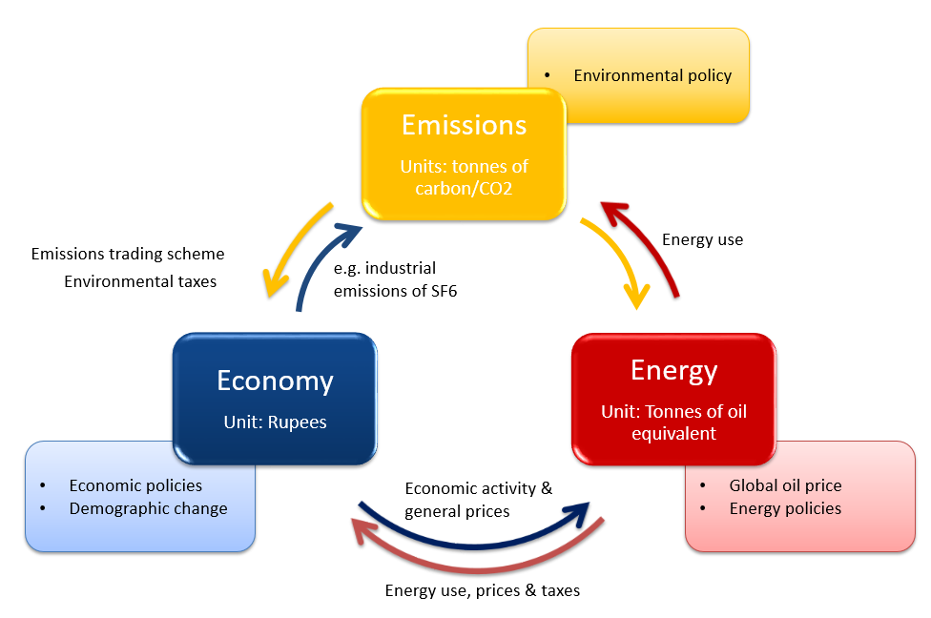Figure .: E3-India as an E3 Model

The three modules

Each component is shown in its own box with its own units of account and sources of data. Each data set has been constructed by statistical offices to conform to accounting conventions. Exogenous factors coming from outside the modelling framework are shown on the outside edge of the chart as inputs into each component. For the economic module, these include demographic factors and economic policy (including tax rates, growth in government expenditures, interest rates and exchange rates). For the energy system, the outside factors are the world oil prices and energy policy (including regulation of energy industries). For the environment component, exogenous factors include policies such as carbon taxes. The linkages between the components of the model are shown explicitly by the arrows that indicate which values are transmitted between components.

The economy module provides measures of economic activity and general price levels to the energy module; the energy module then determines levels and prices of energy consumption, which is passed to the emissions module and is also fed back to the economic module.

## E3-India’s economic module

Figure 6.2 shows how E3-India’s economic module is solved for each state. The arrows show flows of money. Most of the economic variables shown in the chart are solved at the sectoral level. The whole system is solved simultaneously for all industries and all states, although single-state solutions are also possible.

Figure .: E3-India’s basic economic structure

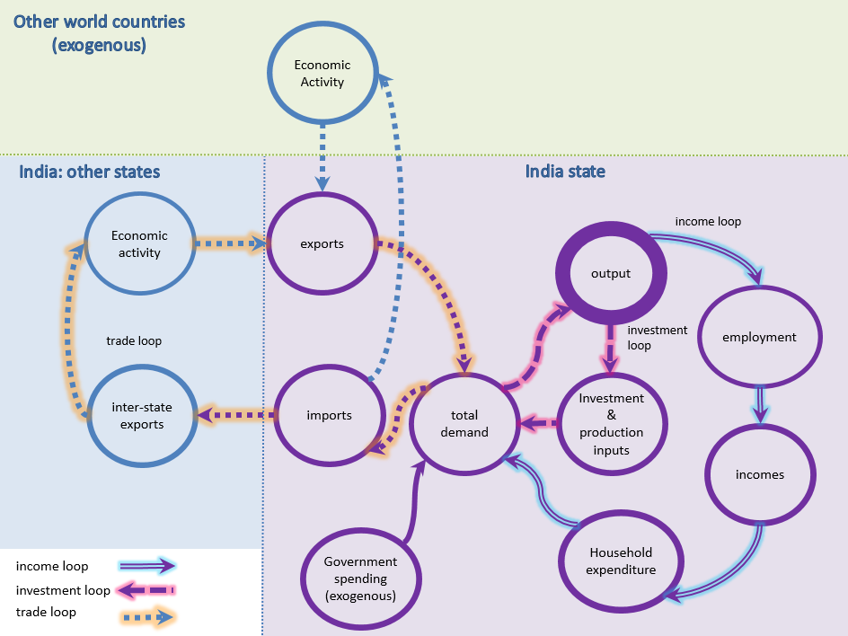

The loops of interdependency

As the figure suggests, output and employment are determined by levels of demand, unless there are constraints on available supply. The figure shows three loops or circuits of economic interdependence, which are described below. In addition, there is an interdependency between the sectors that is not shown in the figure. The full set of loops comprises:

* Interdependency between sectors: If one sector increases output it will buy more inputs from its suppliers who will in turn purchase from their own suppliers. This is similar to a Type I multiplier.
* The income loop: If a sector increases output it may also increase employment, leading to higher incomes and additional consumer spending. This in turn feeds back into the economy, as given by a Type II multiplier.
* The investment loop: When firms increase output (and expect higher levels of future output) they will also increase production capacity by investing. This creates demand for the production of the sectors that produce investment goods (e.g. construction, engineering) and their supply chains.
* The trade loop: Some of the increase in demand described above will be met by imported goods and services (within India and outside India). This leads to higher demand and production levels in other states. Hence there is also a loop between states. Economic activities outside India are treated as exogenous in E3-India.

Calculation of each component of demand

We now turn to how the model calculates results for each of the main indicators in the figure above. There is a mixture of accounting and behavioural relationships involved.

Formal equation definitions are provided in Chapter 5.

Intermediate demand

Intermediate demand (the sum of demand from other production sectors) is determined by the input-output relationships in the model. When one sector increases its production, it requires more inputs to do so. The sectors in its supply chain thus see an increase in demand for their products.

Household consumption

Estimating household consumption is a two-stage process. Total consumer spending by region is derived from functions estimated from time-series data. These equations relate consumption to regional personal disposable income, unemployment rates, inflation and interest rates. Share equations for each of the 16 consumption categories are then estimated. In the model solution, disaggregate consumption is always scaled to be consistent with the total.

Government consumption

Government consumption is given by assumption, split into the main different components of spending. It is therefore exogenous in the simulations and will not change unless explicitly requested by the modeller. It is possible to change the assumptions about levels of government spending in the Manager software.

Investment

Gross Fixed Capital Formation is determined through econometric equations estimated on time-series data. Expectations of future output are a key determinant of investment, but investment is also affected by relative prices and interest rates.

Unfortunately, due to data limitations investment is not disaggregated by asset in E3-India. Stock building is treated as exogenous in the model.

Inter-state and international trade

In a sub-national model, trade represents a major issue in assessing regional economic impacts. Demand in each state can be met either by production within that state, production in another state in India, or production in another country. With no available data on trade between the states, it is necessary to impose assumptions on the rates of production in the states with relation to developments in neighbouring states.

The approach can be summarised as:

* International exports are estimated at state level, based on the production prices within each state.
* International imports are estimated at national level and applied to the states, based on estimates of current and baseline future state-level imports.
* Trade between states is estimated using production shares (export) and domestic demand shares (import).

The treatment of international trade is described in more detail in Section 5.8.

Output and determination of supply

Total product output, in gross terms, is determined by summing intermediate demand and the components of final demand described above. This gives a measure of total demand for domestic production.

It is assumed that, subject to certain constraints, domestic supply increases to match demand (see Figure 6.3 for how this is implemented within the National Accounts structure). The most obvious constraint is the labour market (see below); if there is not enough available labour then production levels cannot increase. However, full employment is an unusual position for the labour market to be in and thus the supply constraint is therefore unlikely to be an issue.

The relationship between prices and quantities is discussed later in this section.

Figure .: Determination of supply and demand

national accounts

The labour market and incomes

Treatment of the labour market is another area that distinguishes E3-India from other macroeconomic models. E3-India includes econometric equation sets for employment (as a headcount, see Section 5.11, wage rates (Section 5.12) and participation rates (Section 5.13). Employment and wage rates are disaggregated by economic sector while participation rates are disaggregated by gender.

The labour force is determined by multiplying labour market participation rates by population. Unemployment (including both voluntary and involuntary unemployment) is determined by taking the difference between the labour force and employment.

Labour market interactions

There are important interactions between the labour market equations. They are summarised below:

Employment = F (Economic output, Wage rates, …)

Wage rages = F (Labour productivity, Unemployment, …)

Participation rates = F (Economic output, Wage rates, Unemployment, …)

Labour supply = Participation rate * Population

Unemployment = Labour supply – Employment

The full specification for the econometric equations is given in Chapter 5.

Analysis of skills

E3-India does not include measures of skills demand and supply explicitly, but the model results for sectoral employment and labour supply may be used to derive both of these. Nevertheless, it is important to be aware of the limitation in skills treatment within the main model structure. If a modelled scenario shows an increase in employment it is implicitly assumed that workers with the necessary skills are available. For studying large changes in employment, a supplementary bottom-up analysis is required to test feasibility of the model results.

Incomes

Due to limitations in available time-series data, E3-India adopts a representative household for each region[4]. Household income is determined as:

Income = Wages – Taxes + Benefits + Other income

The taxes currently distinguished are standard income taxes and employees’ social security payments (employers’ social security payments are not included in wages). A single benefit rate is used for each region.

‘Other income’ includes factors such as dividend payments, property rent and remittances. At present, it is not possible to derive data for these financial flows and so they are held constant in relation to wages.

Household income, once converted to real terms, is an important component in the model’s consumption equations, with a one-to-one relationship assumed in the long run.

Price formation

So far, the discussion has largely focused on real production (apart from wage rates). However, for each real variable there is an associated price, which influences quantities consumed. For example, each category of household expenditure has a price variable attached to it, which influences consumption patterns within the model.

Aside from wages, there are three econometric price equations in the model (see Chapter 5):

* domestic production prices
* import prices
* export prices

These are influenced by unit costs (derived by summing wage costs, material costs and taxes), competing prices and technology (see Figure 6.4). Each one is estimated at the sectoral level.

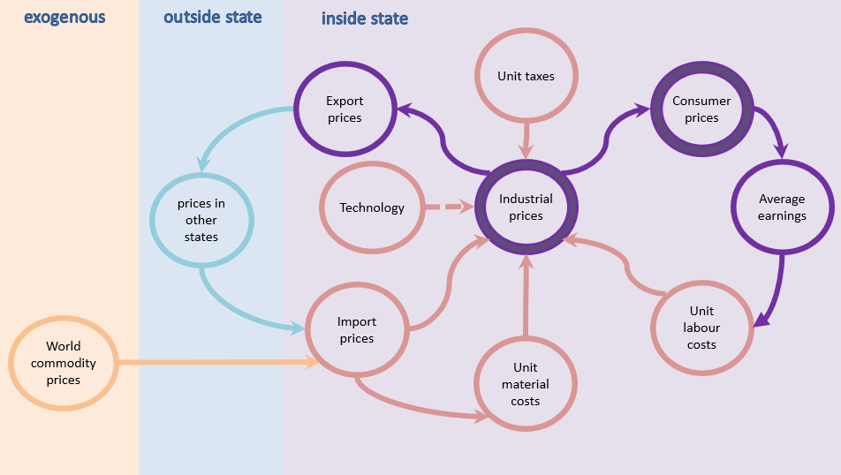Figure .: E3-India’s basic price formation structure

One of the key price variables in the model is the price of domestic consumption. It is also determined by sector, by taking a weighted average of domestic and import prices, subtracting off the export component. This price is then used to determine the prices for final consumption goods; for example, if the car industry increases prices, this will be reflected in the price consumers pay for cars.

Aggregate deflators, including the Consumer Price Index, are derived by taking the average of prices across all products and sectors.

Social indicators

In quantitative modelling, the assessment of social impacts is often largely ignored. This is partly due to a lack of quantitative indicators but also that it often does not fit well into the basic structure of most macroeconomic models.

Like other models, E3-India can provide less coverage of social factors than economic factors (see above) and environmental impacts (see next two sections) but social factors are not ignored completely. The main social indicators in the model are:

* sectoral employment and working hours
* sectoral wage rates
* unemployment
* an estimate of (real) income distribution when looking at issue of electricity price subsidies

The labour market indicators are discussed above, so the remainder of this section focuses on the estimates of distributional impacts.

Distributional income

There is no explicit modelling of the distribution of income in E3-India, except when looking at the issue of electricity price subsidies.

The model has an option to adjust electricity price subsidies by household group (five income quintiles and a rural/urban split), which enables users to adjust the subsidy rates and then assess the distributional impacts of electricity price policies (although without feedback to the rest of the model). The distributional impacts among households are calculated from state-level data on different electricity tariffs, average electricity consumption and income distribution by household group.

Demographic variables

Population projections are treated as exogenous in E3-India, apart from migration between Indian states. Aside from the endogenous treatment of migration, state population projections follow the overall population trends for India published by the UN (World Population Prospects).

Inter-state migration is modelled using a simplified concept of spatial transactions. The decision to migrate between states is determined by economic distance, i.e. pair-wise differences in GDP growth rates, weighted by physical distance between the states.

## The financial system

E3-India tracks financial balances across the main institutional sectors in the model:

* State government
* National government
* Households
* Industry
* Banking sector
* Other Indian states
* Rest of World

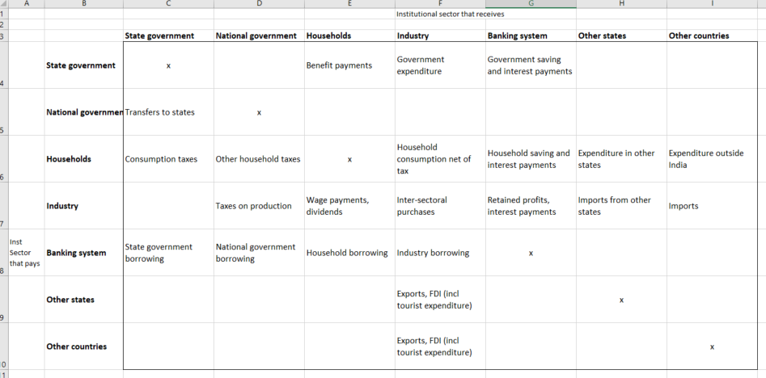 A ‘flow of funds’ representation is provided in Figure 6.5.

Figure .: The financial balances

Government balances

Government receipts include taxes on household incomes and expenditure, taxes on industrial production and any borrowing from the banking system. Government expenditures include payments to households (mostly in the form of benefits), final demand of industries (public administration, education, health) and the saving of any government surplus.

The model distinguishes between state governments and the national government. Only consumption taxes are collected at state level; all other taxes are collected centrally and then distributed to the states. All expenditure is assumed to be made by the states.

In the model, the state government balance is therefore:

RBEN + PRSG*RSG = RITX + TRAN + RNGB

Where:

* RBEN is total transfers to households
* PRSG*RSG is total government final demand (PRSG converts real to nominal terms)
* RITX is consumption tax receipts
* TRAN is the value of the transfer from the national government
* RNGB is the net government borrowing, which forms the balance

The national government balance (RNCB) is determined by total collection of other taxes and the payments to the states. There is an assumption of a fixed central government deficit (as a share of tax receipts) and that the shares of transfers to the states remain in line with the final year of historical data.

Household balances

Household receipts are derived mainly from labour income but this is not the only source of income. Households also receive direct transfers from government and non-wage income in the form of asset-based income and remittances from other states/countries. They may also borrow from the banking sector to increase short-term income.

Household payments consist of final consumption of products, taxes on income and expenditure and any savings that are made.

There are quite severe data limitations here, which is reflected in the model equation below:

RWS + RBEN + RRI = RDTX + REES + PRSC*RSC + RXSC + RNHB

Where:

* RWS is total wage income
* RBEN is total government transfers to households
* RRI is all other household income (derived from the available data as the difference between total household income and wage income net of taxes)
* RDTX and REES are income tax and employee social payments to government
* PRSC*RSC is final household expenditure (PRSC converts from real to nominal terms)
* RXSC is expenditure in other states/countries (including e.g. tourist expenditure but also financial transfers).
* RNHB is net household borrowing, which forms the balance.

Industry balances

In theory, we could model balances in each of the 20 E3-India sectors, but we are unlikely to find the necessary data, so an industry total seems more workable.

Industry receives payments from households’ and government’ final demands plus payments for exports to other states/countries. Industry may borrow from the banking sector. The payments made by industry are wages, taxes to government and import costs. Retained profits (i.e. savings) are a payment to the banking sector and dividend payments are made to households (which may be in another state/country).

Industries also make payments for intermediate purchases and investments to other industries but these net to zero when taking industry as a whole. The balance is thus:

PRSG*RSG + PRSC*RSCnt + PRSX*RSX = RWS + RERS + YRT + RDIV + RNYB

Where:

* PRSG*RSG is final demand from government in nominal terms.
* PRSC*RSCnt is final demand from households (net of tax) in nominal terms.
* PRSX*RSX is export demand in nominal terms.
* RWS is wage payments.
* RERS is employers’ labour taxes.
* YRT is industry production taxes.
* RDIV is dividend payments.
* RNYB is net borrowing by industry to form the balance.

The banking sector

In a modern banking system, reserves are provided by the central bank. The model equation is:

CBRS = RNCB + RNGB + RNHB + RNYB

Crucially, CBRS is not fixed at zero, as would be the case in a standard CGE model. The money supply is thus endogenous, with CBRS providing the change. Accumulating CBRS can give the difference in the level of the money supply.

Flows to/from states and other countries

Financial flows between states/countries are not the focus of the modelling and in general face large gaps in data availability. However, we must include both categories to maintain the financial balances.

The most important flows are exports (already included in the model, albeit with estimated bilateral links) and FDI (for which we include the real part, not currently split from domestic investment). Some further work may be required to assess how feasible it is to estimate flows between states and what data sources are available.

Calibration

Reconciling the model results with the published financial data is an extremely difficult task. Where possible, figures for the most recent year of data have been matched to RBI data (RBI, 2018). The factors to calibrate the data are fixed in absolute terms and are included in such a way that the balances across institutional sectors still hold.

Examples of factors that are not included in the model are taxes on assets. To compensate for asset values not being assessed, a residual value from households and companies to government is added to the flow of funds. This residual value is held constant as a share of GDP between scenarios.

Interest rates

Interest rates are explanatory variables in the model’s investment and consumer spending equations.

If preferred, users can set the interest rate as exogenous and give values in the assumption file as in the previous version. Alternatively, the interest rate can be made endogenous by using a switch JRLR (1=endogenous, 0=exogenous) which is set in the model forecast idiom script. The default is for the interest rate to be endogenous.

The interest rate calculation follows a Taylor rule (1992) where the real rate of interest is a function of current inflation, the output gap (measured by GDP compared to GDP in the baseline) and the gap between inflation and target inflation. Target inflation (RTIN) is entered exogenously by assumption. We assume that RTIN is 3% in the baseline but this figure can be changed.

Formally the code to calculate interest rate is:

RLR = inflation(j) + (0.5 * rgdp_gap(j)) + (0.5 * (inflation(j) - RTIN(j)))

Exchange rates

Exchange rates affect import and export prices and subsequently import and export demand. The new treatment of exchange rate is endogenous and is calculated as a function of price and interest rate differentials between India and the rest of the world.

Formally the exchange rate is calculated as:

a3 = a1 +( (1/a)*(RLRW(1) - RLRA(1)) ) + ( (1/a)*(a2-a1))

where:

a3 log endogenous exchange rate at time t

a1 3 years average price differential between India and rest of the world at time t (proxy for equilibrium exchange rate time t)

a2 3 years average price differential between India and rest of the world at time t (proxy for equilibrium exchange rate time t+1)

RLRW rest of the world interest rate

RLRA India’s interest rate

a weight

RLRW can be entered exogenously in the model assumption file.

## Energy-emissions modelling in E3-India

This section outlines how energy demand and prices are modelled in E3-India, and how this links into the economic modelling.

Chapter 9 describes the differences between top-down and bottom-up modelling but the current version of E3-India can be described as top-down in its energy modelling, with a bottom-up submodel of the electricity supply sector (described in Section 6.6). In this section, we describe how final energy demand and emission levels are calculated; the power sector model is described in the next section.

E3-India's main energy module

The energy module in E3-India is constructed, estimated and solved for each energy user, each energy carrier (termed fuels for convenience below) and each state. Figure 6.6 shows the inputs from the economy and the environment into the components of the module and Figure 6.7 shows the feedback from the energy module to the economic module.

Total energy demand

Aggregate energy demand, shown on the left of Figure 6.6, is determined by a set of econometric equations, with the main explanatory variables being:

* economic activity in each of the energy users
* average energy prices for each energy user in real terms
* technological variables, represented by investment and R&D expenditure

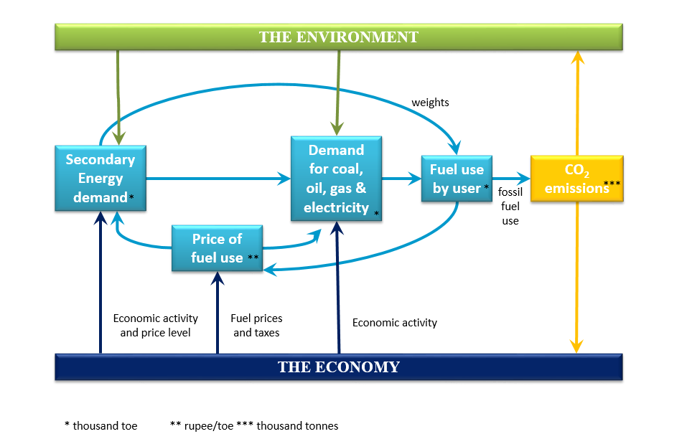

Figure .: Inputs to the energy module

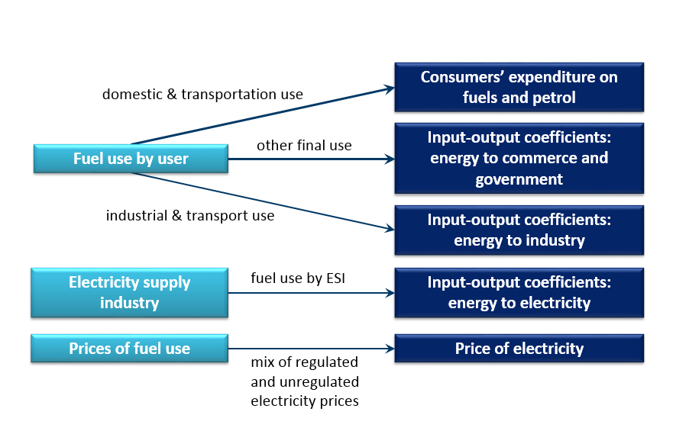

Figure .: Feedback from the energy module

Price elasticities

It should be noted that the long-run price elasticities of demand for energy are the only model parameters that are not derived from the time-series data[5]. The reason for this is that the past data may not be a good guide to future responses.

Typically changes in energy prices in the historical data have been due to fluctuations in commodity prices and have been temporary in nature. However, the changes in energy prices that are modelled using E3-India tend to be based on permanent changes in policy and are therefore more likely to lead to behavioural change. Estimating elasticities based on the time-series data could thus lead to a downward bias.

Instead the long-run price elasticities used are taken from a combination of cross-section estimation and reviewed literature. For most sectors the values range from -0.2 to -0.3, meaning that a 1% increase in price leads to a 0.2-0.3% reduction in consumption. For the transport sector, a higher value of -0.45 is used, taken from Franzen and Sterner (1995) and Johansson and Schipper (1997, p.289) and confirmed by CE’s own analysis. Short-run elasticities are based on the time-series data and are usually close to zero. The exact values of the price elasticities will be tested further in future.

Fuel substitution

Fuel use equations are estimated for four energy carriers (coal, oils, gas and electricity) with four sets of equations estimated for the fuel users in each region. These equations are intended to allow substitution between the four energy carriers by users on the basis of relative prices, although overall fuel use and the technological variables can affect the choice.

Due to limitations in biomass prices, biomass consumption in E3-India is treated as a residual fuel demand and is modelled as a fixed ratio to aggregate energy use (final use only). Biomass used in power generation comes from FTT results.

One point to note is that the current version of E3-India includes only existing fuel types for road transport. The econometric equations are not able to consider electrification of the transport system as there is no historical precedent for this. These developments must therefore be entered by assumption by the model user.

Feedbacks to the economy

The economic feedbacks are based on the fact that the same transactions appear in the energy data and in the economic data, albeit in different units. For example, the iron and steel sector’s purchases of coal appear as:

* coal consumption in the energy balances (as time series), measured in toe
* an input-output flow in the National Accounts (for the base year), measured in m rupees

The feedbacks from the energy module assume a one-to-one relationship between these two measures, once price changes are considered.

This places quite a strong reliance on consistency between the two data sets. Theoretically the energy balances multiplied by the fuel costs (excluding taxes) should match against the flows in the input-output table, once distribution costs are taken into account. However, this is often not the case (for example due to differences in definition and a lack of state-level input-output data) and the mismatch in data can lead to apparently non-important uses of fuel having large economic consequences.

The team at Cambridge Econometrics therefore works to ensure consistency in the data sets where reasonably possible. Adjustments are made to the base-year input-output tables to ensure accuracy in the modelling.

There are also feedbacks from the energy module to household final demand. In the same way that an input-output flow provides an economic representation of industry purchases of energy, consumer expenditure on energy in the national accounts is equivalent to the energy balances for household purchases. In E3-India, the approach is to set the economic variables so that they maintain consistency with physical energy flows. The same issues about consistency of data described above apply here.

E3-India's emission submodel

The emissions module calculates carbon dioxide emissions generated from end-use of different fuels and from primary use of fuels in the energy industries themselves, particularly electricity generation. The current E3-India version does not cover other non-CO2 atmospheric emissions due to data limitations at state-level.

CO2 emissions

Emissions data for CO2 from energy consumption are available for each of the energy users in the model. Coefficients (tonnes of carbon in CO2 emitted per toe) are implicitly derived using historical data (and sometimes also baseline projections) and so the source for the emissions factors is a combination of the sources for energy and emissions data (see Chapter 3). This forms the relationship between energy consumption and emissions.

## The power sector model

Overview

The power sector in E3-India is represented using a novel framework for the dynamic selection and diffusion of innovations, initially developed by J.-F. Mercure (Mercure, 2012), called FTT: Power (Future Technology Transformations for the Power sector)[6]. This is the first member of the FTT family of technology diffusion models. FTT uses a decision-making core for investors wanting to build new electrical capacity, facing several options. The resulting diffusion of competing technologies is constrained by a global database of renewable and non-renewable resources (Mercure & Salas, 2012, 2013; adapted for the states of India, see below). The decision-making core takes place by pairwise levelised cost (LCOE) comparisons, conceptually equivalent to a binary logit model, parameterised by measured technology cost distributions. Costs include reductions originating from learning curves, as well as increasing marginal costs of renewable natural resources (for renewable technologies) using cost-supply curves. The diffusion of technology follows a set of coupled non-linear differential equations, sometimes called ‘Lotka-Volterra’ or ‘replicator dynamics’, which represent the better ability of larger or well established industries to capture the market, and the life expectancy of technologies. Due to learning-by-doing and increasing returns to adoption, it results in path-dependent technology scenarios that arise from electricity sector policies.

Chapter 7 provides a detailed description of the FTT:Power model in E3-India.

Natural resource constraints

The representation of FTT:Power in the global E3ME model includes constraints on the supply of both renewable and non-renewable resources (Mercure & Salas, 2012, 2013, e.g. barrels of oil, or suitable sites for wind farms).

The supply of non-renewable resources is treated as exogenous in E3-India since the rest of the world is not included. The working assumption is that India can continue to produce coal with extraction costs similar to the current ones (allowing for inflation) over the period to 2035. Due to data restrictions, it is only possible to introduce state-level constraints for some renewable technologies:

* for wind and solar, using information from MapRE[7], we introduce cost-curves to include diminishing capacity factors
* for hydro, state level maximum potentials are added using information from Energy Alternative India (EAI)[8]
* landlocked states have zero potentials for wave, tidal and offshore wind

## Innovation and endogenous technological progress

E3-India's technology indices

In the past, technological progress has often been represented as exogenous in macroeconomic models (e.g. via a time trend) or as a residual in a neoclassical production function. Both methods have their drawbacks. The neoclassical approach is somewhat circular in its logic, i.e. to know a firm's production possibilities one needs to model technological progress, but in modelling technological progress one is already making an assumption about the production process. The time trend approach is also unappealing given its theoretical background.

Specification

The approach to constructing the measure of technological progress in E3-India is adapted from that of Lee et al (1990). It adopts a direct measure of technological progress by using cumulative gross investment, but this is altered by using data on R&D expenditure, thus forming a quality adjusted measure of investment. The equation for Tt is written as:

$T_{t}=c+αdt(τ1)$

where $dt\left(τ1\right)$ satisfies the following recursive formula

$dt\left(τ1\right)=τ1d_{t-1}\left(τ1\right)+\left(1-τ1\right)log⁡(GI_{t}+τ2RD_{t})$

where

$GI_{t}=$ the level of gross investment

$RD_{t}=$ constant-price research and development expenditure

τ1 = a measure of the impact of past-quality adjusted investment on the current state of technical advance, while

τ2 = a measure of the weight attached to the level of R&D expenditure.

To initialise the recursive process for $d_{t}$, the assumption is made that in the pre-data period the process generating $\log\left(GI_{t}\right)$ is characterised by a random walk. Under this assumption, the first value of $d_{t}$ can be written as

$d_{t}=log⁡(GI)$

where the right-hand side represents the average of gross investment over the first five-year sample period. The series dt(τ1) is then calculated by working the recursive procedure forward given the initial value, $d_{0}$.

$τ1$ is set at 0.3 following an estimate of impacts based on the economic literature (Cambridge Econometrics, 2005). $τ2$ is set to 1 for the R&D expenditure.

E3-India investment and R&D data

Data availability for state-level investment is poor and there are no data for R&D. For this reason, R&D is set to zero in the technological progress indicator equation. In the future, R&D could be incorporated when data become available. Overall, the indicator is constructed using investment data of variable quality and users should exercise caution when using the indicator.

Feedbacks

The measures of technological progress include both product and process innovation and this is represented in the various feedbacks to other parts of the model: a higher quality product could lead to higher levels of demand or command a higher price, so the technology indices feature in the model’s trade and price equations. Additionally, the term is included in the model’s energy demand equations to represent efficiencies.

## E3-India compared to other macroeconomic models

E3-India in comparison to CGE models

The macro-econometric modelling approach is often compared to other macroeconomic models. The Computable General Equilibrium (CGE) model has become the standard tool for long-term macroeconomic and energy-environment-economy (E3) analysis. The use of CGE models is widespread all over the world; notable examples include GTAP (Hertel, 1999), the Monash model (Dixon and Rimmer, 2002) and GEM-E3 (Capros et al, 2012). Many of these models are based on the GTAP database that is maintained by Purdue University in the US.

In terms of basic structure, purpose and coverage, there are many similarities between E3-India and comparable CGE models. Each is a computer-based economic model that considers E3 interactions, broken down into sectors and regions. Both modelling approaches are based on a consistent national accounting framework and make use of similar national accounts data.

Key differences

However, beneath the surface there are substantial differences in modelling approach and it is important to be aware of this when interpreting model results. The two types of model come from distinct economic backgrounds; while they are in general consistent in their accounting, identity balances, they differ substantially in their treatment of behavioural relationships.

Ultimately this comes down to assumptions about optimisation. The CGE model favours fixing behaviour in line with economic theory, for example by assuming that individuals act rationally in their own self-interest and that prices adjust to market clearing rates; in this way aggregate demand automatically adjusts to meet potential supply and output levels are determined by available capacity.

In contrast, econometric models like E3-India interrogate historical data sets to try to determine behavioural factors on an empirical basis and do not assume optimal behaviour. The model is demand-driven, with the assumption that supply adjusts to meet demand (subject to any constraints), but at a level that is likely to be below maximum capacity.

This has important practical implications for scenario analysis. While the assumptions of optimisation in CGE models mean that all resources are fully utilised, it is not possible to increase output and employment by adding regulation. However, E3-India allows for the possibility of unused capital and labour resources that may be utilised under the right policy conditions; it is therefore possible (although certainly not guaranteed) that additional regulation could lead to increases in investment, output and employment.

Many of the assumptions that underpin CGE (and DSGE) models have been increasingly questioned as to whether they provide an adequate representation of complex real-world behaviour[9]. Examples include perfect competition, perfect knowledge and foresight, and optimal rational behaviour and expectations. Some CGE models have been adapted to relax certain assumptions but the underlying philosophy has not changed.

The main drawback of the E3-India approach in comparison is its reliance on having high-quality time-series data. Constructing state-level data was thus a key part of the model-building exercise but there remains substantial room for improvement.

Jansen and Klaassen (2000) and Bosetti et al (2009) describe some of the differences between modelling approaches in the context of environmental tax reform.

Comparing E3-India to econometric forecasting models

E3-India could also be compared to short-term econometric forecasting models. These models, which are typically operational in government, describe short and medium-term economic consequences of policies but with a limited treatment of longer-term effects. This limits their ability to analyse long-term policies and they often lack a detailed sectoral disaggregation.

These models are usually used for short-term forecasting exercises, often with a quarterly or even monthly resolution.

Where E3-India fits in…

E3-India combines the features of an annual short- and medium-term sectoral model estimated by formal econometric methods with the detail and some of the methods of CGE models, providing analysis of the movement of the long-term outcomes for key E3 indicators in response to policy changes. It is essentially a dynamic simulation model that is estimated by econometric methods.

The method: long-term equations and short-term dynamic estimation

E3-India has a complete specification of the long-term solution in the form of an estimated equation which has long-term restrictions imposed on its parameters. Economic theory informs the specification of the long-term equations and hence properties of the model; dynamic equations which embody these long-term properties are estimated by econometric methods to allow the model to provide forecasts. The method utilises developments in time-series econometrics, with the specification of dynamic relationships in terms of error correction models (ECM) which allow dynamic convergence to a long-term outcome (see Section 5.3).

E3-India is therefore the result of an ambitious modelling project which expands the methodology of long-term modelling to incorporate developments both in economic theory and in applied econometrics, all applied at the state level in India.

Comparative advantages of E3-India

To summarise, compared to the other macroeconomic models in operation currently across the world (both CGE and otherwise), E3-India has advantages in the following four important areas:

Geographical coverage

The current version of E3-India provides state-level coverage, with explicit representation of each state and territory in India.

Sectoral disaggregation

The sectoral disaggregation of the model allows the representation of fairly complex scenarios at state level, especially those that are differentiated by sector. Similarly, the impact of any policy measure can be represented in a detailed way, for example showing the winners and losers from a particular policy.

Econometric pedigree

The econometric and empirical grounding of the model makes it better able to represent performance in the short to medium terms, as well as providing long-term assessment. It also means that the model is not reliant on the rigid assumptions common to other modelling approaches.

E3 linkages

E3-India is a hybrid model. A non-linear interaction (two-way feedback) between the economy, energy demand/supply and environmental emissions is an undoubted advantage over models that may either ignore the interaction completely or only assume a one-way causation.

# The FTT:Power model in E3-India

## Introduction

This chapter provides an introduction to the power sector sub-model in E3-India, which is called FTT:Power. Further information about FTT:Power can be found in the references at the end of this document. Further information about the E3-India model can be found at the model web page

<https://www.camecon.com/how/E3-India-model/>

## Background to the model

FTT:Power is a bottom-up model of technology diffusion across 24 power sector technologies. The model was originally built by Dr Jean-Francois Mercure in Cambridge and is a core feature in Cambridge Econometrics’ macroeconomic models.

The model provides a framework for the dynamic selection and diffusion of innovations, which in E3-India is applied to the power sector in each Indian state. It is based on two key curves: the S-shaped curve of technology diffusion and the logistic curve of reduced production costs due to learning (see Figure 7.1).

Figure . Diffusion and learning curves 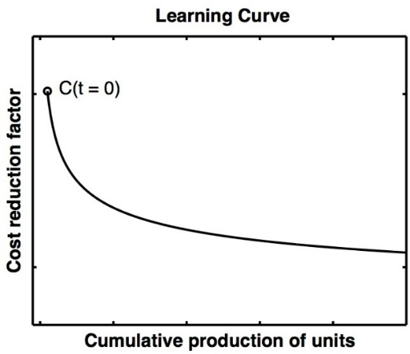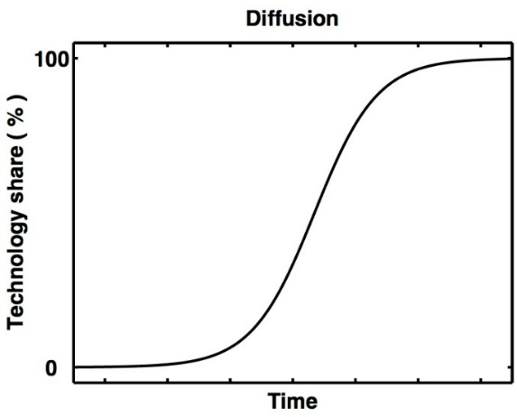

The diffusion curve describes the rates of take-up for new technologies. Initial take-up of new technologies may be slow because it takes time for products to become established in the marketplace. Following the initial period, however, there may be a sudden increase in adoption, until saturation point is reached. At the same time, the costs of producing new equipment gradually fall over time due to scale and learning effects. The result may be a sudden shift in technology preferences, as described in the next section.

## Technical specification

Dimensions of the model and plant lifetimes

FTT:Power includes 24 technologies, which are listed inTable 7.1. The starting point for the model simulation is the final year of historical data. Beyond the final year of data[10], it is assumed that capacity closes at the rate *(1/τ)* where τ is the expected lifetime of the plants in each technology. For example, if, the expected lifetime of a gas plant is 40 years then 2.5% of capacity must be replaced each year.

Table . Technologies in the FTT:Power model

|  |  |  |
| --- | --- | --- |
|  |  |  |
| Nuclear | Solid Biomass | Wind onshore |
| Oil | Solid Biomass + CCS | Wind offshore |
| Coal PC | Biomass IGCC | Solar Photovoltaic |
| Coal IGCC | Biomass IGCC + CCS | Concentrated Solar Power |
| Coal PC + CCS | Biogas | Geothermal |
| Coal IGCC + CCS | Biogas + CCS | Wave |
| Gas CCGT | Tidal | Fuel Cells |
| Gas CCGT + CCS | Large Hydro | CHP |
|  |  |  |

The levelized cost calculation

Starting values for the data series are based on the global mean and standard deviation of different types of power plants, taken from Projected Costs of Generating Electricity 2015 Edition[11] (IEA).

During the solution period, for each technology in each state, a levelized cost (LCOE) is estimated. The LCOE accounts for:

* capital costs
* operations and maintenance costs
* fuel costs
* taxation costs (e.g. carbon tax)
* expected revenues from selling electricity

A discount rate (currently set at 10%) is applied to the differences between costs and revenues over time. Each technology also has an associated build time before it can produce electricity.

An important feature of the costs is the distribution. It is assumed that each cost is normally distributed, with a specified mean and variance. A distribution for the LCOEs is therefore generated.

The pairwise comparisons

Each year new capacity must be built either to replace retired plants or to meet a growing demand. FTT:Power determines the choice of technologies that is used.

The main input to the calculations is the LCOE. A comparison is made between the LCOEs for each pair of technologies. Using the distributions, the share in which the cost of technology j is less than that of technology i gives a probability of switching from technology i to technology j. This is defined as Fij. The matrix F gives the full set of probabilities of switching between technologies for a given set of LCOEs.

A separate matrix, A, provides estimates of the ease of moving between two technologies. For example, it is easier to replace a coal plant with a gas plant than with a windfarm, because much of the necessary infrastructure is already in place. Aij determines how easy it is to move from technology i to technology j. The default values for Aij depend on the expected lifetimes and build times for each technology.

Movements between technologies

Equation 1 forms the core of the FTT:Power model. It determines the change in technology share (S) from technology i to technology j over the time frame Δt . Importantly, the existing shares of technologies i and j are part of the equation. This means that if technology j is well established, it will capture a larger share of any substitution away from technology i.

As the equation suggests, the shifts will also happen faster if they are easy (Aij) or more incentivised by cost (Fij). It is possible to have reverse substitutions at the same time (i.e. Aji and Fji); the model tracks the net changes.

Equation 1: Changes in technology shares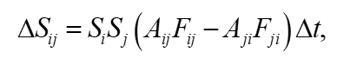

The total changes in the shares of each technology are estimated by summing the movements between all the different pairs. For example, ΔSi is equal to the sum of ΔSij over all j.

Investment in new capacity and electricity prices

Each year the changes in the shares are converted into new power sector capacity, with estimates for the costs of new construction. The values for capacity and generation are updated in the model and a new wholesale electricity price is calculated based on a weighted average of the LCOEs for each technology.

Limits to the shares

In some cases it is necessary to limit individual technology shares. For example, there may be absolute limits on hydro power imposed by natural resources, and inland states cannot use wave or tidal power. Most importantly, there is a limit on the share of electricity that may be generated by intermittent technologies in each state. The model thus ensures that grid stability is maintained against baseline levels.

## Linkages to the rest of the model

Figure 7.2 summarises the links between FTT:Power and the wider E3-India model. The main inputs from E3-India are:

* demand for electricity
* policies that affect technology choices (e.g. taxes, regulations)

The main feedbacks to E3-India are:

* electricity prices
* fuel demand from the power sector
* investment in new capacity

FTT:Power is fully integrated with E3-India so that consistency is ensured between the different models.

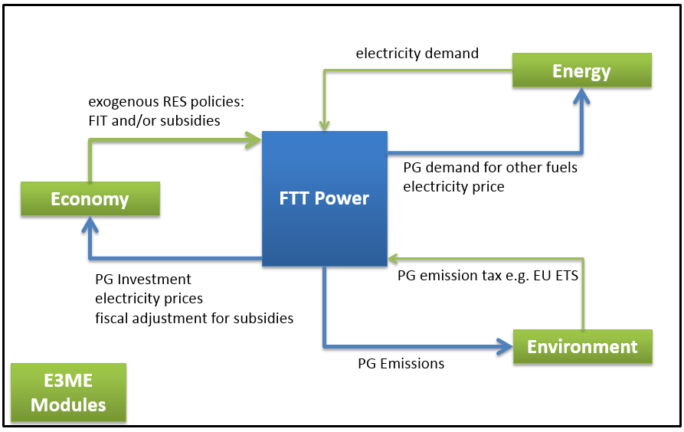Figure . Linkages between FTT:Power and the rest of E3-India

# Example policy scenarios

## Introduction

In this section we consider two common types of scenarios, building on the links described above:

* a carbon/energy tax
* policies to improve energy efficiency

The aim of this section is not to present specific results, but to show how these policies are represented in the E3-India modelling framework, and the necessary assumptions involved.

## A carbon or energy tax

One of the most common uses of the model is to provide a consistent and coherent treatment of fiscal policy in relation to greenhouse gas emissions. Some form of carbon/energy tax is an important component of such policy and E3-India can explore scenarios involving such a tax, as well as other fiscal policies and alternative means of reducing emissions. Figure 8.1 shows how the tax affects prices and wage rates in the model.

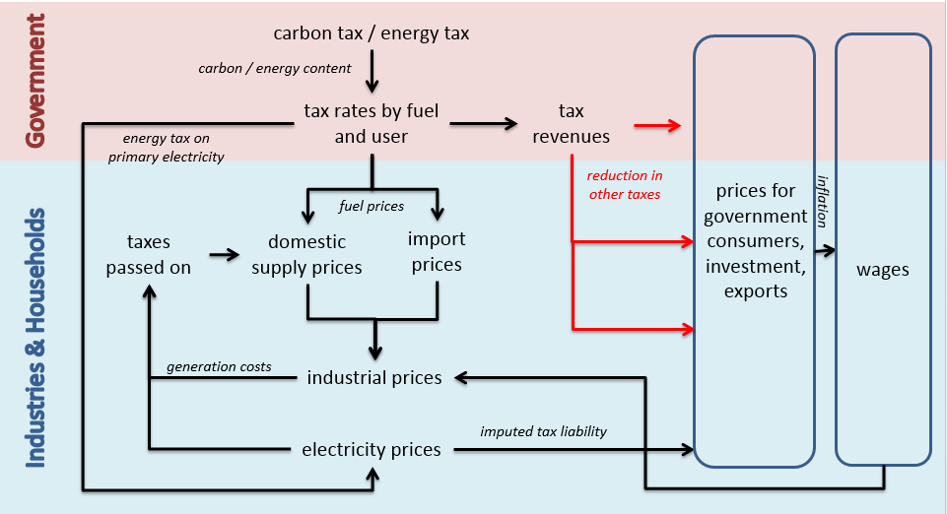Figure .: The impact of the carbon/energy tax on prices and wage rates

Assumptions and price effects

There are inevitably certain simplifying assumptions made in modelling a carbon/energy tax.

The first assumption is that the effects of the tax in the model are derived entirely through the impact of the tax on fuel prices, and through any use of the subsequent revenues from the tax in reducing other tax rates (i.e. revenue recycling). Other effects, including awareness or announcement effects, are not modelled. For example, if the introduction of a high carbon tax caused the electricity industry to scrap coal plants in advance of the tax being levied, this effect would have to be imposed on the model results[12].

The two components of the tax are treated separately. The carbon component of the tax is given as a rate in rupees per tonne of carbon (rupee/tC) emitted in the form of CO2. The carbon tax liability of all fuels is calculated on the basis of their CO2 emissions, and converted into rupees per tonne of oil equivalent (rupee/toe). The energy component of the tax is expressed in terms of rupee/toe directly. A matrix of total energy tax rates (in rupee/toe), by energy user, fuel and region may then be calculated for each year. Tax revenues can be calculated from fuel use.

The second assumption is that imports and domestic production of fuels will be taxed in the same manner, with exports exempt from the tax coverage. The treatment is assumed to correspond to that presently adopted by the authorities for excise duties imposed on hydrocarbon oils.

The third assumption is that any increase in fuel prices due to carbon/energy taxes are treated as the same as changes in fuel prices for any other reason. This means that the same price elasticities may be applied to determine the behavioural response (see Section 5.4). A share of cost increases will be passed on to final users through the estimated pass-through rates in the model (see Section 5.10).

The net effect on industrial and import prices feeds through to consumer prices and will affect relative consumption of goods and services depending on the carbon/energy content and on their price elasticities. Higher consumer prices will then lead to higher wage claims.

Real effects

Figure 8.2 shows the consequent effects of these price and wage rate changes. Energy consumption and fuel mixes will adjust, depending on price and substitution elasticities. The energy price increases will be passed on to more general increases in prices, which will cause substitution in consumers' expenditure, in exports and between imports and domestic production. These changes will feed back to fuel use.

CO2 emissions are derived directly from the use of different fuels.

Revenue recycling

Depending on how the tax revenues are used, they may also affect real outcomes; standard options for revenue recycling include:

* reductions in standard income tax rates
* reductions to employees’ national insurance contributions
* reductions to employers’ national insurance contributions (labour taxes)
* reductions in sale taxes or VAT rates
* increases in social benefits
* increases in public investment or R&D spending
* paying for renewable energy subsidies
* increases in government consumption, e.g. of education or health

The macroeconomic outcome may be highly dependent on the option chosen (see e.g. Barker et al, 2009). In the past, the results from E3ME modelling have shown that a small positive effect on output and employment at the macroeconomic level is possible when other tax rates are reduced in response (see e.g. Ekins et al, 2012).

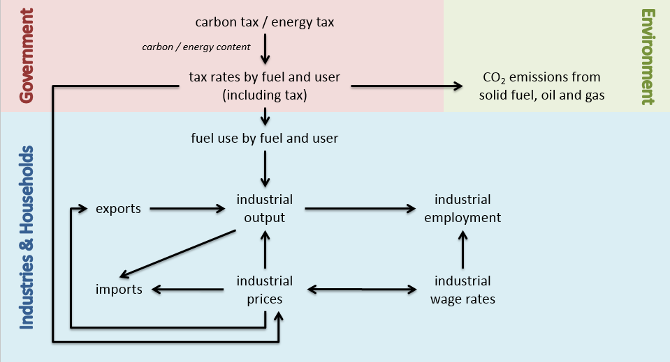

Figure .: The impact of the carbon/energy tax on fuel use, CO2 emissions and industrial employment

## Investment in energy efficiency

Energy efficiency is a key component of decarbonisation strategies and has further advantages in terms of competitiveness and energy security. The global E3ME model has been used several times to model energy efficiency scenarios, including input to the Impact Assessment of the EU’s Energy Efficiency Directive. As it is based on similar principles, E3-India can be applied in the same way.

The level of detail in the modelling is determined by the available data. At a most basic level, E3-India needs as inputs:

* potential energy savings
* the investment cost of these savings
* the sector and the fuel that is displaced

In the past, figures from *World Energy Outlook* published by the IEA have been used to estimate potential savings, and the unit investment costs associated with these savings. However, it is also possible to consider specific technologies if the necessary data are available. This could, for example, be the results of a bottom-up sectoral model.

The energy savings are entered into the model as exogenous reductions in fuel consumption (FRGH, FREH, etc), possibly with a correction for direct rebound effect. The investment is added as an exogenous increase in investment in the relevant sector (KRX). The cost of the investment can then be recouped by higher prices in the sector making the investment, or through higher tax rates if the investment is publicly funded.

Scenarios that assess energy efficiency therefore typically show gains in investment and output of the sectors that supply investment goods. The sectors that supply energy lose out. Investment in household energy efficiency allows a shift in consumer spending patterns. In some states, there is a reduction in fossil fuel imports, which leads to a modest increase in GDP. Figure 7.3 summarises the main economic interactions.

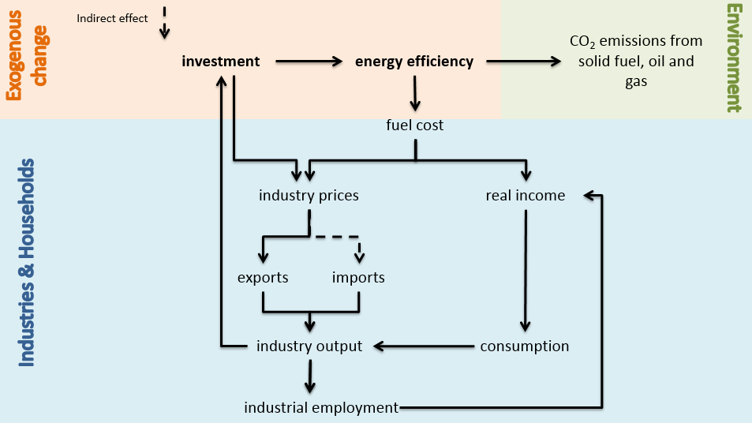

Figure .: The main economic interactions of energy efficiency

# The E3-India Test Scenarios

## Introduction

We provide a set of pre-loaded model input files that were used in testing the E3-India. Table 9.1 provides an overview.

Table .: Overview of example scenarios

| Run | Description | Instruction file | Assumptions file | Scenario file |
| --- | --- | --- | --- | --- |
| Baseline | E3-India baseline | EnForecast | Assumptions | BaseScen |
| S1 | Exogenous investment | EnTest1 | Assumptions | BaseScen |
| S2 | Income tax | EnForecast | Assump1 | BaseScen |
| S3 | Energy tax | EnForecast | Assumptions | Scen1 |
| S4 | Carbon tax | EnForecast | Assumptions | Scen2 |
| S5 | S4+ revenue recycling (employers’ SSC) | EnForecast | Assumptions | Scen3 |
| S6 | S4+ revenue recycling (income tax) | EnForecast | Assumptions | Scen4 |
| S7 | S4+ revenue recycling (VAT) | EnForecast | Assumptions | Scen5 |
| S8 | Energy efficiency | EnTest4 | Assumptions | BaseScen |
| S9 | Feeds-in-Tariff | EnTest2 | Assumptions | BaseScen |
| S10 | Renewable subsidies | EnTest3 | Assumptions | BaseScen |
| S11 | Exogenous oil price | EnForecast | Assump2 | BaseScen |
| S12 | Removing Electricity Price Subsidies to households | EnForecast | Assumptions | Scen6 |

To run the scenarios, select the pre-loaded input files accordingly in the options in **Running the model** tab. Then give the output file names for each run (e.g. S1,S2,… S11,S12). Click the run model button.

Please refer to main E3-India -Testing Scenarios document for more information.

Note making use of text editors

The input files that appear in the E3-India Manager software are text files that can be edited outside the E3-India Manager software environment using any text editor software. This may be preferred if the input requirements are complex. Another useful tip is to use some text editor software to highlight the differences of the two input files.

However it must be noted that, if editing these files outside the Manager software, the model input.idiom files require text formatting to be exactly the same as the default file provided.

## Test scenario 1: Investment

Scenario description

Exogenous investment in 18.Other business Services sector from 2016 onward (10% of existing investment)

Model inputs

|  |  |  |  |
| --- | --- | --- | --- |
| Variable | Description | Unit | Input file |
| KRX(18,all) | Exogenous investment by sector and by region | 2011 million rupees | EnTest1 (Idiom instruction file) |

Scenario main impacts

|  |  |  |
| --- | --- | --- |
| Variable | Description | Impacts (compared to BAU) |
| RSK (KR*) | Investment | Increase |
| RSQ (QR*) | Industry output | Increase |
| REMP (YRE*) | Industry employment | Increase overall but some decrease (substitution effect between capital and labour) |
| RSX (QRX*) | Industry export | Increase (demand from other regions + technology impacts) |
| RSM (QRM*) | Industry import | Increase (demand for other region goods/services) |
| * denotes sectoral variable | | |

## Test scenario 2: Income tax

Scenario description

Increase average income tax rate in region 1 Andhra Paresh from 23% to 30% from 2017 onward (note further income tax testing for all regions are included in another test scenario – using revenues from carbon tax to reduce income tax in all regions).

Model inputs

|  |  |  |  |
| --- | --- | --- | --- |
| Variable | Description | Unit | Input file |
| RDTX  (11 TAX_DIRECT) | Average direct income tax rate | % of wages and salaries | Assump1 (assumption file) |

Scenario main impacts

|  |  |  |
| --- | --- | --- |
| Variable | Description | Impacts (compared to BAU) |
| RRPD | Gross real disposable income (i.e. income after tax) | Decrease |
| RSC | Consumer spending | Decrease |
| GDP | GDP | Decrease |
| REMP (YRE*) | Employment | Decrease |
| RSQ (QR*) | Industry output | Decrease (especially services sector which are highly related to consumer spending) |
| * denotes sectoral variable | | |

## Test scenario 3: Energy tax

Scenario description

Tax of 400 rupees per tonne of oil equivalent to all energy users of all fuels.

Model inputs

|  |  |  |  |
| --- | --- | --- | --- |
| Variable | Description | Unit | Input file |
| RTEA | Energy tax rate 2001-2035 | Rupees/toe | Scen1 (scenario) |
| FEDS | Switch for fuel user coverage | 1 = full coverage | Scen1 (scenario) |
| JEDS | Switch for fuel type coverage | 1 = full coverage | Scen1 (scenario) |

Scenario main impacts

|  |  |  |
| --- | --- | --- |
| Variable | Description | Impacts (compared to BAU) |
| RFU (FR0*) | Total fuel demand | Decrease |
| FRET* | Electricity demand | Decrease (substitution with other fuels) |
| FRCT* | Coal demand | Decrease (substitution with other fuels) |
| FROT* | Oil demand | Decrease (substitution with other fuels) |
| FRGT* | Gas demand | Decrease (substitution with other fuels) |
| RCO2 (FCO2) | CO2 emissions | Decrease |
| PRSC (PCR*) | Average consumer price index | Increase (due to tax) |
| RSC (CR*) | Consumer spending | Decrease (less disposable income) |
| RSX (QRX*) | Export | Mostly decrease (from higher energy price but relative to other states so there are competitiveness effects from internal trade) |
| RSM (QRM*) | Import | Mostly decrease from lowered domestic demand and imports of energy |
| RGDP | GDP | +/- depending on scale of import reduction (improvement to GDP) |
| * denotes sectoral variable | | |

## Test scenario 4: Carbon tax

Scenario description

Tax of 400 rupees per tonne of carbon (note not CO2) to all energy users of all fuels. Note assuming no revenue recycling. All revenues are used to reduce government deficit.

Model inputs

|  |  |  |  |
| --- | --- | --- | --- |
| Variable | Description | Unit | Input file |
| RTCA | Carbon tax rate, 2001-2035 | Rupees/tonne of carbon | Scen2 (scenario) |
| FEDS | Switch for fuel user coverage | 1 = full coverage | Scen2 (scenario) |
| JEDS | Switch for fuel type coverage | 1 = full coverage | Scen2 (scenario) |

Scenario main impacts

|  |  |  |
| --- | --- | --- |
| Variable | Description | Impacts (compared to BAU) |
| RCO2 (FCO2) | CO2 emissions | Decrease |
| RFU (FR0*) | Total fuel demand | Decrease |
| FRET* | Electricity demand | +/- (substitution with other fuels) |
| FRCT* | Coal demand | Decrease (substitution with other fuels) |
| FROT* | Oil demand | Decrease (substitution with other fuels) |
| FRGT* | Gas demand | Decrease (substitution with other fuels e.g. coal to gas) |
| MJEF* | Fuels demand by PG | Fossil fuels decrease |
| MEWG* | Power sector generation by technologies | Fossil fuels decrease/ possibly small increase in renewable shares but not drastic due to small CO2 tax |
| METC* | Localised costs of electricity as seen by investors by technologies (including carbon costs + policies) | Fossil fuels costs increase |
| PYH(9,all)* | Electricity price (sector 9) | Increase |
| PRSC (PCR*) | Average consumer price index | Increase (due to tax and higher electricity price) |
| RSC (CR*) | Consumer spending | Decrease (less disposable income) |
| RSX (QRX*) | Export | Mostly decrease (from higher energy price but relative to other states so there are competitiveness effects from internal trade) |
| RSM (QRM*) | Import | Mostly decrease from lowered domestic demand and imports of energy |
| RGDP | GDP | +/- depending on scale of import reduction (improvement to GDP) |
| * denotes sectoral variable | | |

Figure .: The impact of the carbon/energy tax on prices and wage rates



Figure .: The impact of the carbon/energy tax on fuel use, CO2 emissions and industrial employment

## 9.5 Test scenario 5: Carbon tax+revenue recycling (employers’ social security contribution)

Scenario description

Same tax as previously (400 rupees per tonne of carbon) to all energy users of all fuels. All revenues from carbon tax used to reduce employers’ social security contribution within the region.

Model inputs

|  |  |  |  |
| --- | --- | --- | --- |
| Variable | Description | Unit | Input file |
| RTCA | Carbon tax rate, 2001-2035 | Rupees/tonne of carbon | Scen3(scenario) |
| FEDS | Switch for fuel user coverage | 1 = full coverage | Scen3 (scenario) |
| JEDS | Switch for fuel type coverage | 1 = full coverage | Scen3 (scenario) |
| RRTE | Proportion of energy tax and carbon tax to reduce employers’SSC by | 1 = 100% | Scen3 (scenario) |

Scenario main impacts

In addition to the carbon tax scenario.

|  |  |  |
| --- | --- | --- |
| Variable | Description | Impacts (compared to the carbon tax with no revenue recycling scenario) |
| RCTT | Total revenues from carbon tax (m rupees) | Increase (tax rate x CO2 emissions) |
| RERR | Employers social security contribution rates | Decrease |
| REMP (YRE*) | Employment | Increase (direct impact from lowering labour costs to firms) |
| RGDP | GDP | Increase |
| RSC (CR*) | Consumer spending | Increase |
| RWS (YRWS*) | Total wages and salaries | Increase |
| RRDP | Real disposable income | Increase |
| PYH | Industry prices | Decrease (reduction in labour unit cost) but not all costs will pass through to final price |
| * denotes sectoral variable | | |

## Test scenario 6: Carbon tax+revenue recycling (income tax)

Scenario description

Same tax as previously (400 rupees per tonne of carbon) to all energy users of all fuels. All revenues from carbon tax used to reduce direct tax (income tax) within the region.

Model inputs

|  |  |  |  |
| --- | --- | --- | --- |
| Variable | Description | Unit | Input file |
| RTCA | Carbon tax rate, 2001-2035 | Rupees/tonne of carbon | Scen4(scenario) |
| FEDS | Switch for fuel user coverage | 1 = full coverage | Scen4 (scenario) |
| JEDS | Switch for fuel type coverage | 1 = full coverage | Scen4 (scenario) |
| RRTR | Proportion of energy tax and carbon tax to reduce direct tax by | 1 = 100% | Scen4 (scenario) |

Scenario main impacts

In addition to the carbon tax scenario.

|  |  |  |
| --- | --- | --- |
| Variable | Description | Impacts (compared to the carbon tax with no revenue recycling scenario) |
| RCTT | Total revenues from carbon tax (m rupees) | Increase (tax rate x CO2 emissions) |
| RDTR | Direct tax rates | Decrease |
| RRDP | Real disposable income (income after tax) | Increase |
| RSC (CR*) | Consumer spending | Increase |
| RGDP | GDP | Increase |
| REMP (YRE*) | Employment | Increase (secondary impact from higher GDP) |
| * denotes sectoral variable | | |

## Test scenario 7: Carbon tax+revenue recycling (VAT)

Scenario description

Same tax as previously (400 rupees per tonne of carbon) to all energy users of all fuels. All revenues from carbon tax used to reduce VAT within the region.

Model inputs

|  |  |  |  |
| --- | --- | --- | --- |
| Variable | Description | Unit | Input file |
| RTCA | Carbon tax rate, 2001-2035 | Rupees/tonne of carbon | Scen5(scenario) |
| FEDS | Switch for fuel user coverage | 1 = full coverage | Scen5 (scenario) |
| JEDS | Switch for fuel type coverage | 1 = full coverage | Scen5 (scenario) |
| RRVT | Proportion of energy tax and carbon tax to reduce VAT by | 1 = 100% | Scen5 (scenario) |

Scenario main impacts

In addition to the carbon tax scenario.

|  |  |  |
| --- | --- | --- |
| Variable | Description | Impacts (compared to the carbon tax with no revenue recycling scenario) |
| RCTT | Total revenues from carbon tax (m rupees) | Increase (tax rate x CO2 emissions) |
| RSVT | VAT rates | Decrease |
| PRSC (PCR*) | Consumer price index | Decrease |
| RSC (CR*) | Consumer spending | Increase |
| RGDP | GDP | Increase |
| REMP (YRE*) | Employment | Increase (secondary impact from higher GDP) |
| * denotes sectoral variable | | |

## Test scenario 8: Energy efficiency (savings + investment)

Scenario description

10% energy savings in the use of coal by manufacturing sector in all regions. Manufacturing investment increase approximately $1m (60 m rupees) per 6,000 toe (source: estimated from IEA WEIO and WEO publications). Investment paid for by manufacturing (increase in cost to the sector).

Model inputs

|  |  |  |  |
| --- | --- | --- | --- |
| Variable | Description | Unit | Input file |
| FRCH(3,all) | Exogenous change in coal demand by manufacturing (fuel user 3) | Thousand TOE | EnTest4.idiom (IDIOM Instruction file) |
| KRX(8,all) | Exogenous change in investment by manufacturing sector (industry 8) | 2011 m rupees | EnTest4.idiom (IDIOM Instruction file) |
| YRUX(8,all) | Exogenous increase in costs to manufacturing (get added to total unit cost) | Entered as m rupees and get converted to unit cost in model | EnTest4.idiom (IDIOM Instruction file) |

Scenario main impacts

|  |  |  |
| --- | --- | --- |
| Variable | Description | Impacts (compared to BAU) |
| FRCT | Coal demand | Decrease |
| FR0 | Total energy demand | Decrease |
| FCO2 | CO2 | Decrease |
| RSK (KR*) | Investment | Increase |
| RGDP | GDP | Increase |
| YRUC* | Unit costs of industry | Increase |
| PYH* | Industry price | Increase by less than costs |
| Other++ |  |  |
| * denotes sectoral variable | | |



Figure .: The main economic interactions of energy efficiency

## Test scenario 9: Feeds-in-tariff

Scenario description

Feed-in-tariff for renewables technologies in FTT-power: -110% difference between levelised costs and electricity price.

Technology included: Tidal (15), Large Hydro(16), Onshore(17) , Offshore(18), CSP(20) note Solar PV (19) already have FIT in the baseline.

Example

LCOE of solar is $140/MWh, Electricity price is around $50/MWh

FIT is (140-50) *-1.1 = - $99/MWh

Cost to investor become 140-99 = $41/MWh

making small profit ($50-$41 = $9/MWh).

Note that FIT rate of -110% doesn’t make all technologies profitable depending on difference between costs and price of that technology

Model inputs

|  |  |  |  |
| --- | --- | --- | --- |
| Variable | Description | Unit | Input file |
| MEFI | Feed-in-tariff by power technology by region | % difference between levelised cost and electricity price | EnTest2.idiom (IDIOM Instruction file) |

Scenario main impacts

|  |  |  |
| --- | --- | --- |
| Variable | Description | Impacts (compared to BAU) |
| METC* | Localised costs of electricity as seen by investors by technologies (including carbon costs + policies) | Decrease in technologies with FIT |
| MEWK* | Power sector capacities by technologies by region | Renewable shares increase (but there will be substitution due to differences in final LCOE) |
| MEWG* | Power sector generations by technologies by region | Renewable shares increase (but there will be substitution due to differences in final LCOE) |
| MWIY | Power sector investment in new capacity | Renewable increase (but fossil fuels could decrease) |
| MJEP*/PFRE* | Price of energy/Price of electricity | Electricity price increase to pay for FIT |
| FRET* | Electricity demand | Reduce from higher electricity price |
| PRSC | Consumer price index | Increase from higher electricity price |
| RSC (CR*) | Consumer spending | Decrease |
| RSK (KR*) | Investment | Higher investment by electricity sector (feedback from FTT) |
| RGDP | GDP | +/- depending on scale of RSC and RSK impacts |
| Other++ |  |  |
| * denotes sectoral variable | | |

## Test scenario 10: Renewable subsidies

Scenario description

Subsidies for renewables technologies in FTT-power: 50% of investment costs of technologies

Technology included: Tidal (15), Large Hydro(16), Onshore(17) , Offshore(18), Geothermal(21)

Note(s): we assumed government paid for the subsidies but not raise taxes in response (i.e. through bigger budget deficit). This assumption can easily be change to achieve revenue neutrality.

Model inputs

|  |  |  |  |
| --- | --- | --- | --- |
| Variable | Description | Unit | Input file |
| MEWT | FTT subsidies by power technology by region | % of investment cost of technology | EnTest3.idiom (IDIOM Instruction file) |

Scenario main impacts

|  |  |  |
| --- | --- | --- |
| Variable | Description | Impacts (compared to BAU) |
| METC* | Localised costs of electricity as seen by investors by technologies (including carbon costs + policies) | Decrease in technologies with subsidies |
| MEWK* | Power sector capacities by technologies by region | Renewable shares increase (but there will be substitution due to differences in final LCOE) |
| MEWG* | Power sector generations by technologies by region | Renewable shares increase (but there will be substitution due to differences in final LCOE) |
| MWIY | Power sector investment in new capacity | Renewable increase (but fossil fuels could decrease) |
| MJEP*/ PFRE* | Price of energy /Price of electricity | Electricity price decrease because of subsidies |
| FRET* | Electricity demand | Higher from lower electricity price |
| PRSC (PCR*) | Consumer price index | Decrease from lower electricity price (although average could be positive due to higher economic activity) |
| RSC (CR*) | Consumer spending | Increase |
| RSK (KR*) | Investment | Higher investment by electricity sector (feedback from FTT) |
| RGDP | GDP | Increase from investment and possibly lower price (but could be negative once we start changing assumption about revenue neutrality) |
| * denotes sectoral variable | | |

## Test scenario 11: Exogenous oil price

Scenario description

Increase exogenous global oil price assumption – instead of growing at 3% pa between 2016-2020 let assume it is growing at 4% pa instead.

Note(s): Global energy price assumptions are in pa growth rate and derived from the latest IEA World Energy Outlook publication (current policies scenario).

Model inputs

|  |  |  |  |
| --- | --- | --- | --- |
| Variable | Description | Unit | Input file |
| PMF  (CPRICE_BRENT_OIL) | Price of import groups in $ (2005 =1.00) | Index | Assump2.idiom (assumption file) |

Scenario main impacts

|  |  |  |
| --- | --- | --- |
| Variable | Description | Impacts (compared to BAU) |
| PFRO* | Oil price by fuel users | Increase from higher Brent oil price assumption |
| PFR0* | Average price of energy by users | Increase as oil price increases |
| RFU (FR0*) | Total fuel demand | Decrease |
| FROT* | Oil demand | Decrease |
| RCO2 (FCO2*) | CO2 emissions | Decrease |
| RGDP | GDP | Increase or decrease depending on which impacts are larger – reduction in oil imports or impacts from higher price on consumption |
| RSM (QRM) | Imports | Oil import decrease |
| RSC (CR) | Consumer spending | Decrease due to higher price lead to reduction in real disposable income |
| * denotes sectoral variable | | |

## Test scenario 12: Removing Electricity Price Subsidies to households

Scenario description

Removing electricity price subsidies for each State to look at impacts on various types of households.

Note- subsidy is treated as negative tax in E3_India so a scenario to remove electricity subsidies implies a positive electricity tax on household’s consumption of electricity.

The E3_India’s energy users classification are

* 1 Power generation
* 2 Other transformation
* 3 Manufacturing
* 4 Transport
* 5 Households
* 6 Services
* 7 Agriculture
* 8 Non-energy used

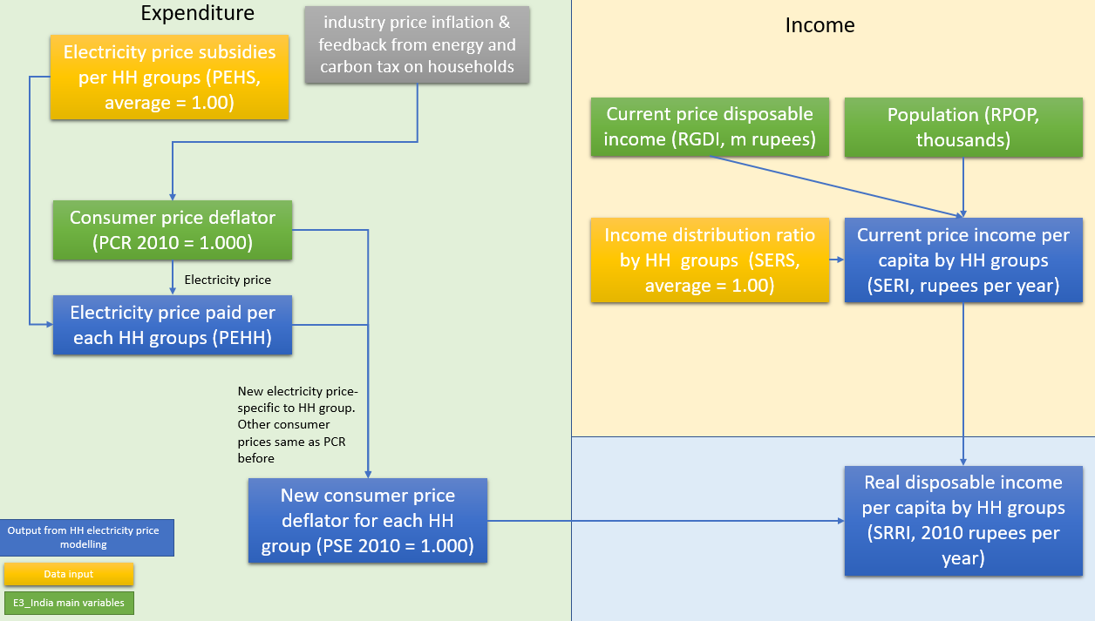For electricity use, the model includes modelling of electricity price subsidies to different household types. This provides results on household’s income distribution from changes in electricity taxation and subsidies. The figure below demonstrates how income distributions, measured by changes in real disposable income by household groups, are affected from changes in electricity prices.

It should be noted that due to lack of time series data, the model doesn’t include price-elasticity of electricity demand for each group types of households. Users need to work out the equivalent average electricity price increase for the whole households group and use these values as electricity tax on the household groups. The variable PEHS[13], electricity price subsidies by households, enables users to adjust the subsidy rates to provide distributional impacts (no feedback to the rest of the model).

Model inputs

|  |  |  |  |
| --- | --- | --- | --- |
| Variable | Description | Unit | Input file |
| RTEA | Energy tax rate 2001-2035 (5000 rupees/toe) | Rupees/toe | Scen6 (scenario) |
| FEDS | Switch for fuel user coverage (only households) | 1 = full coverage | Scen6 (scenario) |
| JEDS | Switch for fuel type coverage (only electricity) | 1 = full coverage | Scen6 (scenario) |
| PESH | Households implied price of electricity subsidies (removed all subsidies in the baseline – set to 1 for all groups) | 1.00 = no subsidies, 0.8 = 20% subsidies | Scen6 (scenario) |

Scenario main impacts

|  |  |  |
| --- | --- | --- |
| Variable | Description | Impacts (compared to BAU) |
| FRET* | Electricity demand from households | Decrease |
| RFU (FR0*) | Total fuel demand | Decrease or there might be substitution between fuels |
| PRSC (PCR*) | Average consumer price index | Increase (due to electricity tax) |
| RSC (CR*) | Consumer spending | Decrease (less disposable income) |
| RGDP | GDP | Small decrease from reduction in consumer demand |
| SRRI* | Real disposable income by households | Household groups that are more vulnerable (e.g. low income) are worse off than other groups |
| * denotes sectoral variable | | |

# Top-Down and Bottom-Up Modelling Approaches

## Overview

The terms ‘top-down’ and ‘bottom-up’ are often used in economic and energy modelling. Unfortunately, they have more than one meaning which can lead to confusion. This appendix aims to clarify the position of E3-India with regards to top-down and bottom-up modelling, and discusses the issues in the context of energy modelling more generally.

## Top-down and bottom-up in the economic context

For E3 modelling the terms top-down and bottom-up in general refer to the approach used for the energy sector, as discussed in the next section. However, the labels are still sometimes applied to economic sectoral models.

A top-down economic model is one where macro-level indicators are determined first and then the sectoral outputs are estimated by sharing out the macro results. In contrast, a bottom-up economic model is one where output is determined at the sectoral level, and then the macro impacts are derived as the sum of the sectoral results.

In economic terms, E3-India is a bottom-up model. It consists of 20 sectors in and outcomes of macro-level indicators, such as GDP, are determined by taking the sum of the sectors.

The one exception to this is the model’s consumption equations, where a top-down approach is applied for theoretical reasons. First, total household expenditure is estimated based on available incomes; this is then shared between different consumption categories. These equations are described in more detail in Section 5.6.

## Top-down and bottom-up in the energy-environment context

E3ME, and the E3-India model, are both intended to be integrated top-down, bottom-up models of E3 interaction. The current model can be summarised as:

* including a bottom-up model of the electricity supply industry
* being otherwise top-down in approach

Future bottom-up submodels are being planned for the domestic and transport sectors but are not included in the current model version.

Top-down economic analyses and bottom-up engineering analyses of changes in the pattern of energy consumption possess distinct intellectual origins and distinct strengths and weaknesses (see Table 9.1).

Similarly the mechanisms which represent the driving forces in the respective analyses are very different. In economic models change is usually modelled using elasticities, such as substitution between factors, or price and income elasticities. In bottom-up modelling the determinant force is captured by the relationship between technological options and usually by some notion of the discount rate employed by economic agents (households, firms and the government). In some sense, the discount rate employed in bottom-up models is the mirror image of an elasticity employed in top-down models. Both factors will determine the extent to which agents react to changes in the conditions associated with the energy supply chain (see Barker, Ekins and Johnstone, 1995).

Perhaps the most significant difference is in the treatment of capital and technology. In top-down models capital is usually treated as a homogeneous input, which is related to energy only insofar as it is assumed to possess a degree of substitutability with energy inputs in production. Technological change (i.e. qualitative change in the characteristics of capital) is usually represented as an exogenous trend, sometimes explicitly related to energy consumption, affecting the productivity of the homogeneous capital input.

Conversely, in bottom-up models capital is given an explicit empirical content and is related to energy in a very specific way, either in terms of generating equipment, other energy-related capital, or public infrastructure. Technological change is represented as a menu of options presently available or soon-to-be available which enjoy increasing market penetration.

Table .: Comparison of top-down and bottom-up modelling methodology

|  |  |  |
| --- | --- | --- |
|  | **Bottom-up** | **Top-down** |
| Classifications employed | Engineering-based | Economics-based |
| Treatment of capital | Precise description of capital equipment | Homogenous and abstract concept |
| Motive force | Discount rate employed by agents | Income and price elasticities |
| Perception of market | Market imperfections and barriers | Perfect markets (usually) |
| Potential efficiency improvements | Usually high with options for costless improvements | Usually low due to economic assumptions |
|  |  |  |

The two approaches also start from different conceptions of the nature of markets. Most top-down models, although not E3ME or E3-India, do not admit to the possibility of market imperfections (e.g. imperfect competition). Most importantly, the existence of costless (i.e. economically preferable) opportunities is often assumed away (except at the margin). Energy consumption (and thus carbon dioxide emissions) are a reflection of revealed preferences and thus any alternative technological scenarios which have not been taken up in the economy are left unexploited for sound economic reasons, such as agent uncertainty (with respect to supply and demand factors) or 'hidden' factors (such as disruption or management costs). Conversely, in bottom-up models the inability of the economy to reach a technologically efficient supply chain in terms of the provision of energy services is attributed to market imperfections (e.g. credit constraints, information asymmetries, transaction costs). The relationship between such imperfections and decision-making is, however, left unexplored.

As noted, both types of analysis possess important strengths, but both have weaknesses when used to address long-term issues. On the one hand in top-down models, the notion that an elasticity of substitution between capital and other factors (estimated on the basis of 30-40 years of data, or imposed on the basis of intuition or the requirements of functional form) can be used to make useful comments about the world over the next 50 or 100 years from now is suspect. Indeed, beyond a certain number of years it is the engineering characteristics of the 'back-stop' technology, and not the behavioural relations themselves, around which the carbon-energy-output relationship revolves.

On the other hand the depiction of the long-run in bottom-up models as a menu of technological options is clearly unsatisfactory as well. At best, the technological options can be presented in chronological form (commercially available, in development stages, technologically feasible), coming on line progressively. By defining capital precisely the models cannot be made dynamic in a satisfactory manner unless the path of technological change is known, and as such are restricted in their relevance to short and medium-term analysis.

In addition, the characteristics of the two approaches limit the relevance of the respective analyses. For instance, top-down models are not able to analyse the effects of non-price based policies which affect the nature of the market itself and not just prices within the market. Institutions and regulations are (implicitly) not subject to change. Given the prevalence of imperfections in the market for energy services, such an omission is significant.

Conversely, bottom-up models are not able to analyse the price effects of the introduction of the options enumerated, or associated feedback effects. For instance, an analysis which examines the technological options available to the electricity supply industry misses important feedback effects unless it examines the effects of such a programme on the construction industry which undertakes the conversion, on the energy sector which is faced with significant dislocation, and on those sectors which use electricity and other energy carriers intensively as inputs in production.

# Linking E3-India to other models

## Why link to other models?

E3-India provides an integrated representation of the economy and energy systems in India. The analysis in the model is carried out at a relatively high level of detail, with 20 sectors covered in the 32 states and territories. E3-India is already linked to the FTT power sector model (see Section 6.6), which provides a representation of the key technologies in the power sector at state level.

However, as with all modelling tools, E3-India has clear limitations and boundaries and there are some policy-related questions that the model is not suitable to address. But the other existing modelling tools that could address these questions may not be able to provide insights to e.g. jobs and GDP that E3-India is designed to assess. There may therefore be benefits to using a combined modelling approach.

Issues to be aware of

There are both theoretical and practical considerations to bear in mind when linking models. For example, as a simulation model, E3-India does not make any assumptions about optimisation and thus there could be difficulties in interpretation when linking to other optimisation tools. At a more practical level, other models may use different classifications, units or definitions of key indicators.

One-way model linkages, where the results from one model are fed into another are reasonably common. Two-way linkages, where the models interact with each other iteratively, are less common and much more complicated to build.

This section of the manual provides two examples of how E3-India could be linked to other tools. In both cases the linkages are one-way. The links can be described as ‘soft’ in that they are in the form of data transfers. ‘Hard’ links involve integrating software, which is a much more resource-intensive exercise.

## Linking E3-India to an energy systems model

Energy systems models are commonly used in academia and in analysis for the IPCC (for example as part of Integrated Assessment Models). The [TIMES](https://iea-etsap.org/index.php/etsap-tools/model-generators/times) model, maintained by IEA ETSAP, is a commonly used example.

Energy systems models are ‘bottom-up’ in design; they cover the energy system from an engineering perspective at a high level of detail. They do not usually include links to the rest of the economy, however.

There are therefore potential advantages in combining energy systems models with E3-India. Most energy systems models are optimisation tools and results must be interpreted carefully – essentially E3-India suggests what might happen to GDP and jobs if the energy path determined by the energy model was realised.

The procedure for linking is as follows:

* Run the scenario in the energy systems model.
* Convert the results from the model into categories consistent with E3-India, for example in terms of fuels and sectors, and on an annual basis.
* Set the fuel equations in E3-India to exogenous. The easiest way to do this is to insert the line ‘CALIB FR0,FRET,FRGT,FROT,FRCT ON’ into the instructions file beneath the other calibration (CALIB) statements.
* Set the values of FR0A (total fuel consumption), FR01 (coal), FR02 (oil), FR03 (gas), FR04 (electricity) to be consistent with the results from the energy model – either by entering in the instructions file or writing to the model databank.
* Check to see if there are any other scenario inputs (e.g. carbon prices) that should be entered to E3-India.
* Run the scenario in E3-India.

## Linking E3-India to micro-simulation model

Micro-simulation models provide breakdowns of impact by detailed social group. They are based on very detailed survey results that give indications of the structure of the population in terms of incomes and social condidtions. They thus address one of the limitations of E3-India, which, due to data requirements, does not include such a detailed aggregation.

The procedure for linking E3-India to a micro-simulation model is quite different to the one described above for energy modelling. Usually it would be the outputs from E3-India that are used in the micro-simulation model, rather than the other way round.

The key steps are:

* Define the key inputs that the micro-simulation requires – e.g. household incomes, unemployment rates.
* Run the scenario in E3-India, in the usual way.
* Convert the results from E3-India into the dimensions required by the micro-simulation model.
* Provide the inputs required by the micro-simulation model.

# Different Macroeconomic Modelling Approaches

## Modelling for policy assessment

Macroeconomic modelling is playing an ever-increasing role in the policy making process but the strengths and limitations of different models remains rather a niche topic. While it is well known that economists frequently disagree with each other, it is less well known that the models they develop reflect these disagreements. The users of model results (e.g. policy makers) are rarely aware of the underlying assumptions in the models, or how they relate to the conclusions from the analysis.

In energy and climate policy

In the area of climate policy, a notable example is the use of different policy instruments to meet emission reduction targets. Many economists have applied Computable General Equilibrium (CGE) modelling approaches that are based on neoclassical economics to answer the question about what the best policy instruments should be. They find that a carbon pricing measure (i.e. tax or emission trading scheme) outperforms all other policy instruments in terms of efficiency in reducing emissions. However, this finding to some extent just reflects the assumptions of the model, that perfect markets are best suited to the efficient allocation of scarce resources and therefore a carbon market will automatically outperform any regulatory measures.

To agree with the conclusion that carbon markets produce the best outcome, one would have to accept the assumptions of the modelling that is applied. To name a few of these assumptions:

* Markets are always perfect, with prices adjusting freely to balance supply and demand. No firms have monopoly positions or can set product prices beyond what the market dictates. Wage rates are also fully flexible and move to rates at which there is no involuntary unemployment.
* All individuals and companies have a complete ‘perfect’ knowledge about all the potential ways that they can spend their resources.
* All individuals are identical and behave in the same way. All individuals and companies act in a fully rational manner and use their resources in the way that optimises their welfare or profit.
* There is a limited amount of money in the economic system.
* Technology develops independently from policy developments and developments in the wider economy.

All these assumptions have been contested by researchers in other fields.

## The E3ME and E3-India models

The sections of this chapter are based on insights from the global E3ME macroeconomic model and the state-level E3-India model. Both of these models are macro-econometric in design and are based on post-Keynesian economic foundations. It is possible to obtain results that differ in both direction and magnitude from other modelling approaches.

## Theoretical Background

Introduction to post-Keynesian economics

Post-Keynesian economics builds on the original work of Keynes in the mid-20th century to reflect the structure of the modern economy, particularly the importance of finance. Most of the core principles of post-Keynesian economics remain consistent with the original work of Keynes, for example that the economy is ‘demand-driven’ and unemployment is an important feature of the economy. An introduction to post-Keynesian economics is provided in King (2015) and a more complete description in Lavoie (2015).

Post-Keynesian macroeconomic models generally fall into two groups:

* Stock-Flow-Consistent (SFC) modelling
* Macro-econometric modelling

SFC modelling (Berg et al, 2016) is generally carried out at an aggregate level. Although there are SFC models that can be used to assess climate interactions (e.g. Dafermos et al, 2016), these models usually operate at a macro level, i.e. without the sectoral (and state) disaggregation of the E3-India model.

The term macro-econometric model is used here to refer specifically to post-Keynesian models and does not, for example, include CGE models in which the parameters are estimated using econometric techniques. The most well-known macro-econometric model is Cambridge Econometrics’ E3ME (Environment-Energy-Economy Macro-Econometric) model (Cambridge Econometrics, 2014). E3ME was originally developed through the European research programmes and is now maintained by Cambridge Econometrics in the UK. The paragraphs below describe how E3ME relates to the underlying post-Keynesian theory.

Modelling post-Keynesian economics

The basic starting point in a macro-econometric model is Keynes’ *Treatise on Probability* (Keynes, 1921). Keynes defines fundamental uncertainty as what is today often referred to as ‘unknown unknowns’, i.e. things that cannot be envisaged, let alone predicted. There are therefore no assumptions of perfect knowledge or foresight in the model.

Gaps in knowledge mean that it is not possible for individuals or companies to optimise their decision making. If it is not possible to optimise decision making, an alternative way of modelling human behaviour is required. The econometric approach in the model fills this gap; the assumption is that behaviour in the model is based on that which may be observed in the historical data. Or, to put it another way, that past behaviour does not change in the future.

This assumption has been criticised in the past (notably in Lucas, 1976), and it must be acknowledged that future behaviour cannot be predicted (otherwise we would not need modelling). The counter-argument is that this approach provides the best unbiased guess of future behavioural patterns, and is more consistent with insights from behavioural economics about non-optimising behaviour (e.g. Kahneman, 2012). It has also recently been noted that the critique by Lucas and others is applicable to CGE models and all other modelling approaches that use elasticities to project into the future (Haldane and Turrell, 2018).

Leaving aside questions of model parameterisation, the relaxation of the assumption of optimal behaviour changes the modelling paradigm. If, as in neoclassical economics and CGE models, all decisions are optimised and markets adjust freely, the economics is a question of how to allocate the limited labour and capital resources in the economy. However, in the absence of optimal decision making, as in post-Keynesian economics, there is no guarantee that all available resources will be used. For example, if wage rates are set too high (e.g. if it is not possible to reduce workers’ salaries), then the demand for labour will be less than the available supply of labour.

The result is that, according to the writing of Keynes, the level of output in the economy is determined by the level of aggregate demand. While constraints on the availability of resources are respected (e.g. it is not possible to increase the number of jobs beyond ‘full employment’), there is no guarantee that these limits will be reached.

These observations are backed by empirical evidence (European Commission, 2017a). For example, persistent unemployment is a feature of the modern economy. Eurostat reports that manufacturing companies typically operate at around 80% capacity. As discussed below, central banks now recognise that the money supply is not fixed.

Money and aggregate demand

One of the most important findings in Keynes’ *General Theory* (Keynes, 1936) was that unemployment is a natural outcome of the economy. Contrary to the beliefs of many economists, this finding is not only due to the ‘stickiness’ of wages that is described in the example above. It reflects the role of money and the financial system in the modern economy.

Again, the post-Keynesian treatment of money is a key distinction from neoclassical economics (Pollitt and Mercure, 2017). In a standard CGE model, there is a fixed supply of money and any money that is saved is automatically balanced by investment, with the rate of interest adjusting to ensure parity between the two. Keynes did not believe that this market structure worked in reality and followed an approach that will be familiar to economists today as more similar to economic ‘multiplier’ analysis (see Figure 1).

In the figure, a clockwise flow of resources is observed; aggregate demand is calculated by summing across the top row and supply is adjusted to match. This in turn creates further intermediate demands and the cycle starts again. The model solves iteratively until the addition in each loop becomes small; the process is similar to how economic multipliers may be calculated through repeated matrix multiplication. Typically, the model cycles through the loop 30-40 times in each year of solution.

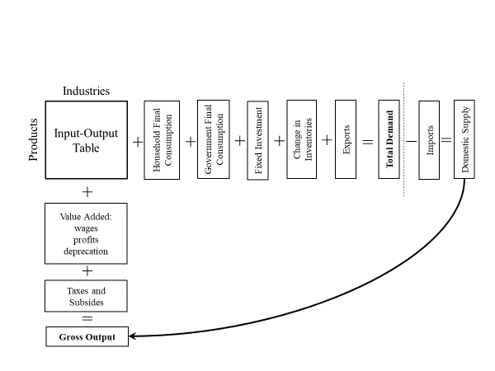Source: Cambridge Econometrics.

Figure . Structure of the National Accounts in E3ME

Changes to the money supply and changes to the level of aggregate demand are closely linked and both relate to uncertainty (Keen, 2011). If individuals and companies face an uncertain future then they will save money as a precaution for unexpected shocks. For example, if a worker faces a risk of being unemployed, then he/she will try to create a cushion in the form of higher savings. Any money that is saved is not used to purchase goods or services and therefore does not help to maintain output and employment in other sectors of the economy.

In contrast, if there are high expectations of future profits, then companies may borrow to invest in building future capacity. The result is an increase in demand for construction and other services that would not have happened without the higher borrowing.

The representation of the financial system in E3ME reflects these findings (Pollitt and Mercure, 2017). There is no automatic balancing between investment and savings. Instead, when a bank issues a loan, money is ‘created’ and the spending from that loan adds to aggregate demand (and therefore employment). When money is saved, it does not contribute to aggregate demand and is therefore ‘destroyed’. There is no automatic balancing of interest rates; instead central banks create reserves to support the commercial banks who make the loans. Crucially, this is how central banks recognise that the modern economy works (e.g. McLeay et al, 2014).

Policy implications

While discussion about optimal behaviour and how the financial system works may sound overly technical in nature, it has a strong bearing on the model results. For example, consider the following three statements:

* If decision making is not optimal, then there may be a role for policy making to improve outcomes for social welfare.
* If individuals’ optimal decisions do not lead to the best outcome for society as a whole, then there again is a potential role for policy making to improve outcomes.
* If not all available economic resources are used, then it is possible to increase output by finding policy that uses them.

Under a standard CGE model that is based on neoclassical economics, none of these statements is relevant as the conditions are not met. Under the post-Keynesian modelling framework offered by E3-India or E3ME, however, each one may be true, although the final outcome of the modelling depends on the policies that are being suggested. The important point is that potential positive net impacts of policy making (including both price-based measures and regulation) are not ruled out by assumption.

Further information

Further information about E3-India is available at this web page: <https://www.camecon.com/how/e3-india-model/>

Further information about the E3ME model can be found in the model manual (Cambridge Econometrics, 2014), which is available on the model website [www.e3me.com](http://www.e3me.com). A full list of E3ME equations is provided in the appendix to Mercure et al (2018b).

Further discussion of the modelling approach more generally in the context of sustainability is provided in Mercure et al (2016).

## Comparison to CGE: 3 Examples

In this section we demonstrate the differences between a macro-econometric model and a standard CGE model using three policy examples.

Carbon tax

The first example is a carbon tax. In a standard CGE model a tax is a distortion to an already optimised economy, where demand equals supply and prices are set at market-clearing equilibrium levels. Because of perfect competition, when a carbon tax is imposed, it is assumed that 100% of the tax costs get passed on to final product prices. The new equilibrium leads to reductions in both consumer and producer surplus.

In contrast, a macro-econometric model views a carbon tax as an instrument that influences behaviour while shrinking the money supply (if revenues are not recycled, see below). Firms may choose to pass on the carbon tax or to absorb the additional costs depending on their pricing strategy. These factors are captured in a macro-econometric model with behaviour determined through the parameters in the econometric equations. The demand response depends on final product prices as well as product quality and other indirect effects. Unless there are supply constraints, it is assumed that the level of supply adjusts to meet the level of demand, but this is likely to be below the level of potential supply.

Figure .: Carbon tax example

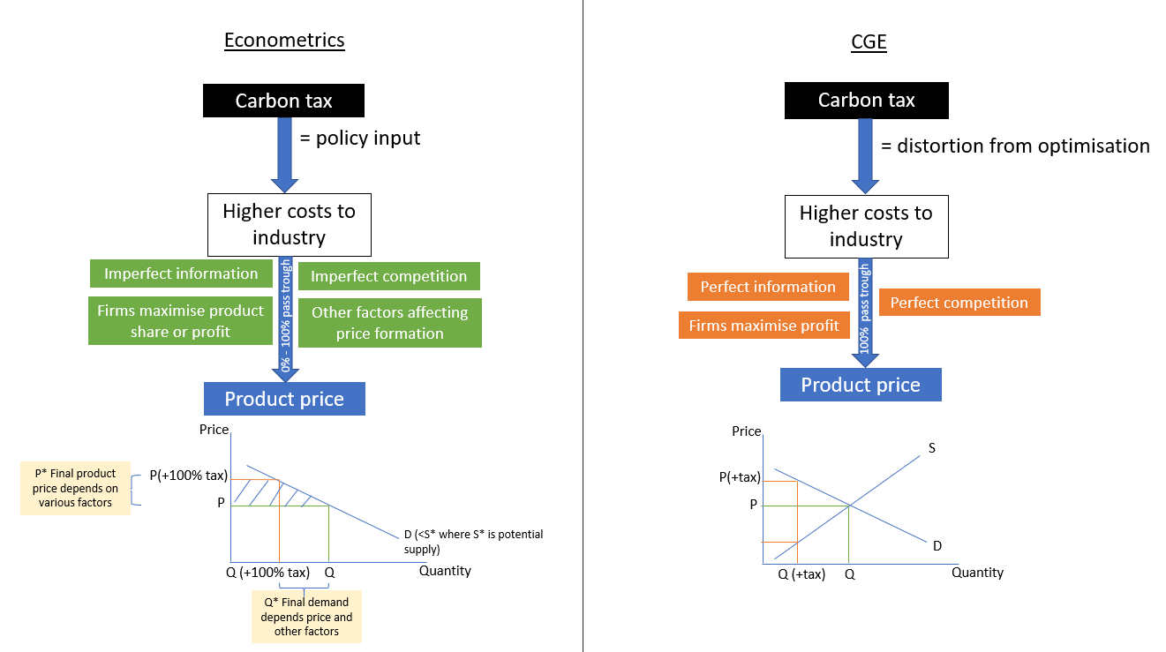Source: Cambridge Econometrics.

Environmental Tax Reform and green jobs

Both CGE and macro-econometric models have been used to assess Environmental Tax Reform (ETR) in which an environmental tax is levied and the revenues are used to reduce an existing tax. There has been particular interest in the possibility of ‘double dividend’ effects, where both economic and environmental outcomes are improved compared to a baseline case (Goulder, 1994).

Within the CGE modelling framework, double dividends are only obtained if the increased distortion from the environmental tax is more than offset by a reduction in distortions from the tax that is reduced (e.g. labour taxes). In the published literature such a finding is a relatively rare outcome because of the specific uses of energy in economic production.

The simulation approach offered by E3-India and other macro-econometric models treats ETR quite differently. Financial balances, trade balances and the development of new technologies are key to determining outcomes. Notably, if ETR stimulates additional private sector investment, then this will create additional demand and could lead to a double dividend effect, at least in the short run (although debt repayments may reduce long-run growth rates). Similarly, if fuel-importing countries can replace consumption of fuel with consumption of domestically-produced goods, they may benefit overall.

In summary, the CGE model can only find a double dividend outcome if the ETR leads to a more efficient allocation of resources. In the macro-econometric model, there is the potential for previously unused resources to be drawn into production. There is therefore much more potential to see an increase in output and a double dividend result.

Modelling the labour market

In a standard CGE modelling framework, a starting point in any analysis is one of full employment in which any unemployment is described as voluntary. This follows from the assumption of full utilisation of resources described above. In contrast, unemployment in macro-econometric models is determined by the difference between labour supply and demand (both of which are determined by econometric equations); unemployment in the macro-econometric model therefore includes both voluntary and involuntary unemployment.

Following the same logic as laid out above, it is possible for employment to increase substantially in an ETR scenario, if the tax shift leads to higher levels of domestic production and jobs. It is thus possible to generate ‘green jobs’ scenarios through Environmental Tax Reform.

A carbon tax example of ETR

The discussion above can be illustrated by a case where an energy-importing country imposes a carbon tax and uses the revenues to reduce VAT (or sales tax) rates on all products.

In a standard CGE model, the carbon tax is likely to be much more distortionary than VAT and therefore the reallocation of resources caused by the tax will have a negative effect. To put it another way, in the ETR scenario, the optimisation in the CGE model becomes increasingly constrained, leading to a loss of production. Employment levels will not change but wage rates will fall in response to lower output.

In E3-India, it is more likely that there will be positive impacts on output and employment. Companies that pay the carbon tax may not pass on all the costs (in the short run at least), meaning that there is an effective transfer of real income from firms to households (who benefit from lower VAT rates). As households typically have lower savings rates than companies, total expenditure in the economy increases, creating a stimulus effect. In addition, the carbon tax may lead to investment that is financed by borrowing, which also has a stimulus effect. Finally, domestic firms may benefit if expenditure on imported fuels is displaced.

It is possible that some or all of these channels will not yield a positive effect (e.g. if spending on imported fuels is replaced with spending on other imports) but the modelling framework allows for the possibility that such a taxation shift may draw on available production capacity. Park et al (2015) showed that positive outcomes are possible for this example in four countries in East Asia.

Energy efficiency

The debate around energy efficiency measures tends to focus on the ‘no regrets’ options, where cost-effective energy savings can be made. It is difficult to assess these options in an optimisation modelling framework, however, because they are either ruled out by assumption or only justified through very high private discount rates.

Much of the policy analysis on energy efficiency has therefore used either a simulation-based macro-econometric model such as E3-India, or a CGE approach that has been modified to allow for sub-optimal behaviour (European Commission, 2017b).

The second issue relates to the ‘crowding out’ of investment, which is particularly important to investment-intensive policies like energy efficiency. In a standard CGE model with a fixed money supply, energy efficiency must compete for scarce financial resources with other investment goods. If savings remain unchanged, higher investment in energy efficiency will lead to lower investment elsewhere; and a diversion from the optimal pathway of investment will lead to lower levels of output overall.

In macro-econometric models, however, the constraints on production are in the real economy. The banking system can provide the necessary financing for investment in energy efficiency by expanding the money supply and not crowding out other investment. As long as there is enough production capacity (e.g. available workers) to build and install the equipment, output and employment will therefore increase in the short run. Multiplier effects will yield further economic benefits unless capacity constraints are breached.

## E3-India and the wider suite of models

The E3ME model was originally developed through the European framework research programmes in the 1990s. Originally it covered western European countries but this was expanded to cover an enlarged European Union in 2007 and eventually to provide global coverage in 2012.

E3ME itself is derived from a macro-econometric model of the UK, MDM-E3, which splits the UK up into twelve government office regions. The fundamental underpinnings of the models remain the same, however.

E3-India and the other E3 models operated by Cambridge Econometrics have all been developed from the E3ME source code. The current suite of models includes one other tool with sub-national disaggregation:

* E3-US (50 states plus DC)

Two other national models have been developed:

* E3-Brazil
* E3-Thailand

In addition, the MDM-E3 model for the UK is still maintained.

Descriptions of all the models can be found at the main E3ME website, [www.e3me.com](http://www.e3me.com)

## Previous Applications of E3ME

The E3-India model is relatively new and therefore has limited previous applications. However, the E3ME model is now widely used in Europe and beyond for policy assessment, for forecasting and for research purposes. This section describes some of the main applications of the model.

Carbon taxes and tax reform

Initial applications and European assessments

The original E3ME model was developed in the 1990s, building on the UK MDM-E3 model that can be traced back to the 1970s. In its early days, E3ME was applied to assess macroeconomic impacts of carbon tax and carbon tax reform in Europe (Barker et al, 1998a; 1998b, 1998c; 1998d; Barker, 1999). One of the most notable applications of the E3ME model was the COMETR research project (Andersen and Ekins, 2009), in which E3ME was used for ex-post assessments of the first examples of real-world ETR in Europe. The modelling results are described in Barker et al (2007, 2009), Ekins et al (2012), Pollitt et al (2012) and Pollitt et al (2014a) and elaborated further in the context of households in Ekins et al (2011). The results suggest that a double dividend effect is possible in Europe.

E3ME has been selected to provide technical inputs to the official EU Impact Assessments including options for moving beyond 20% GHG reduction target for 2020 (European Commission, 2010), the revised Energy Taxation Directive (European Commission,2011a), the Energy Efficiency Directive (European Commission, 2011b; 2011c) and the EU’s 2030 environmental targets (European Commission, 2014). More recently E3ME has been used to assess elements of the ‘Clean Energy Package’ and ‘Long-term strategy’ on decarbonisation (e.g. European Commission, 2017b).

Global use of the model

Over the past decade, E3ME has been used widely to analyse environmental policy across the world. The model has also been used repeatedly to assess decarbonisation pathways at different international levels (Barker et al, 2005; 2006; 2008; 2016; Barker and Scrieciu, 2009) and in the UK (Dagoumas and Barker, 2010). E3ME has been applied as described by Barker et al (2012) to provide an economic assessment of the IEA’s 450ppm scenario (IEA, 2010) and climate change mitigation in Latin America (Kober et al, 2016). In all of these studies, taxation has been a key policy input, with assumptions about revenue neutrality included in the scenarios.

In East Asia, E3ME has been applied for an assessment of meeting voluntary Copenhagen 2020 targets for four countries/regions: China, Japan, Korea and Taiwan and the possibility of double dividend through ETR (Lee et al, 2015). The findings confirm that double dividends are possible.

In Japan, E3ME has been applied for an assessment of the economic costs of meeting Japan’s Copenhagen pledge (3.8% below 2005 in 2020) and NDC target (26% below 2013 in 2030) of reducing GHG emissions (see Lee et al, 2012 and Lee et al, 2017). The model results showed this to incur a modest economic cost that could be turned into a modest benefit if efficient revenue recycling methods were used. The interaction between the share of nuclear power in Japan’s energy mix and its carbon targets were discussed alongside Environmental Tax Reform in Pollitt et al (2014b) and Lee et al (2017).

In these modelling exercises, results from the E3ME model are often compared to those from CGE models. Examples of such exercises include Lee et al (2015), European Commission (2015) and Jansen and Klaassen (2000). Increasingly, the model is used alongside CGE models for policy analysis so as to provide a range of possible different outcome (e.g. European Commission, 2013; 2015).

Assessing long-term climate goals (various policies)

Linkages to bottom-up models

Another key distinction of the E3ME model is its linkages to the bottom-up Future Technologies Transformation (FTT) modules. The success of a low-carbon, sustainable transition will be determined by the technologies that are adopted around the world. Any attempt to model this transition therefore requires a detailed treatment of technology development and adoption. The simulation-based nature of E3ME sits well alongside the FTT models of technology diffusion, which draw on evolutionary economics and share elements of complexity science (Mercure et al, 2016).

The current version of E3ME contains FTT modules for power generation (Mercure, 2012; Mercure et al, 2014), road transport (Mercure et al, 2018a), steel (new, not yet formally published) and residential heating (Knobloch et al, 2018). There is a land-use module currently under development.

An ambitious long-term climate goal to limit temperature rise below 1.5°C above pre-industrial levels requires ambitious climate policies. Results from E3ME-FTT with linkages to a climate model found that a high carbon tax alone will not be sufficient to achieve this target. Instead a combination of equally ambitious energy efficiency, regulations, renewable subsidies and feed-in-tariff policies are required; the climate results from this scenario are published in Holden et al (2018).

At global level, recent high-profile applications of the model have been presented in New Climate Economy (2018) and IRENA (2018), which confirm that a portfolio of policies are required and that they could benefit both the environment and the economy.

As a global model, E3ME is able to identify winners and losers across the world regions as a result of the low carbon transition. The winners are typically regions with large renewable potentials who are currently net importers of energy, and those who export energy efficiency and renewable equipment. Energy exporters are likely to lose out from reduced export revenues and could be stuck with stranded fossil fuel assets. Even under a business as usual scenario, a recent high-profile publication (Mercure et al, 2018c) that used the linked E3ME-FTT models suggested that over $1 trillion of value could be lost from fossil fuel assets under existing technological trends.

All references used in this chapter are given in Section 16.2.

# Case studies

## Initial testing

Overview

This section highlights three exercises that were carried out by Surabhi Joshi and Riley Allen in 2016/17. The scenarios were used as part of the testing for the original version of E3-India, and presented at several workshops in India.

Three themes were tested, these are described below. The following paragraphs introduce the exercise.

Introduction

The E3-India is a macroeconomic policy impact model developed by Cambridge Econometrics to help foster effective engagement around policy at the state level in India. The model is being developed as a tool and at present is at an advanced stage of development, sufficient for us to demonstrate its potential for simulation and analysis of policy impacts. Data gaps will be filled, and we hope that as local knowledge grows over time, that will help the model realize its full potential.

The analysis presented below helps to demonstrate the flexibility and use of the model in three ways. First, the model is flexible with respect to geographic scale. It can be used to demonstrate policy impacts at different geographic resolutions (regions) that span one or more states and territories. Second, the model is flexible with respect to technology. It can be used to reveal the impacts of policy scenarios that are differentiated by energy technology (like feed-in tariffs, or FiTs, for example, to demonstrate impacts on GHG emissions) by region. Third, the model is tightly woven among energy, environment, and the economy (the Es in “E3”). Consequently, the model permits its users to understand impacts of policy both within the sector and beyond. We can, for example, use the model to understand the impacts of technology transition scenarios with key economic parameters such as state-level GDP, investments, and consumer expenditure for state-level or economy-wide E3 simulations.

The latest version of the E3-India model, the Beta 3 (B3) version, is now available. This version of the model incorporates certain default “scenario” and “assumption” files along with “idiom” files that provide users flexible tools to run policy simulations. All three of these text file groupings are in text files that can be manipulated by the model user. The scenario and assumption files are preconstructed tables to allow for relatively simple policy simulations by users. The idiom files represent a tool for advanced users to simulate policies using a fairly basic programming language developed by Cambridge Econometrics for the model.

The modeling framework provides considerable flexibility for users to modify model input variables and then to view the impacts of those modifications on an extensive list of outputs. In order to manage the long list of variables, CE has created a high-level organizational structure that can be viewed through the model interface. There are three major groups of simulation variables: i) energy, environmental, and economic (E3) variables available by region, ii) E3 variables available by sector(within each region), and iii) energy technologies, referred to as future technology transition(FTT) variables. The requisite regional resolution for analysis is selected using either individual states or union territory or aggregates as demonstrated in Theme I.

Theme I: Applying the E3-India Model in Different Geographic Regions

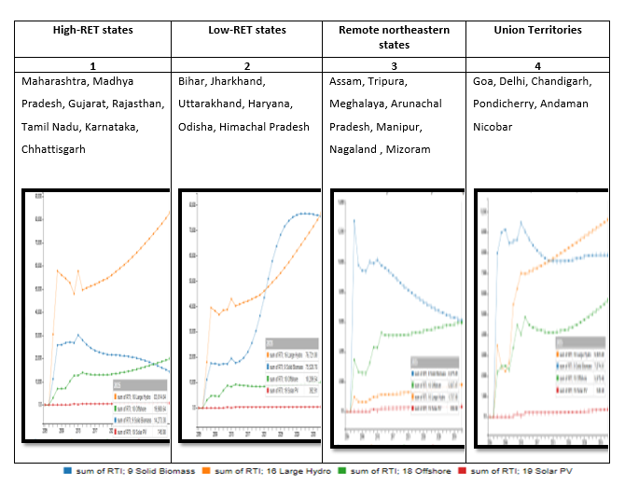The Renewable Energy Technology (RET) transition scenario is based on existing renewable capacities associated with individual states and trajectory of renewable growth as forecasted by the model. The RET transition scenario was studied among four different groups of Indian states categorized and aggregated as follows: i) high RET (i.e., “high” with respect to installed capacity) states; ii) low-RET states; iii) remote northeastern states; and iv) Union Territories. The growth trends for four renewable energy technologies (solid biomass, large hydro, onshore wind and solar photovoltaic technology (PV) from 2005 to 2035 were analyzed in terms of annual electricity generation (GWh/year). The results indicate that states with high RET capacity would be the forerunners in solar and wind installations until 2035. Solid biomass and large hydro would have significant share in renewables for all the categories. The promotion of solar PV would be more aggressive in Union Territories than in northeastern states or low-RET states. Thus, within the same national boundaries, the pathway of the Renewable Energy Transition would be significantly different for the four regional categories analyzed. The simulated trajectory of renewable generation for either individual states or aggregated groups can effectively inform policy choices, regulatory actions, and utility decisions for better management and infrastructure planning for energy capacity addition in each region. The vertical axis shows the trend of electricity generation by technology represented in Gwh/year.

Figure .: Renewable penetration in different groups of states

Theme II: Feed-in tariffs and assessment of low-GHG pathways

FiTs are wholesale price or “standard offer” prices that are awarded to technologies that meet the eligibility requirements for any given generation technology. FiTs typically include a price premium (above market-base or cost-based prices) to encourage the development of newer technologies.

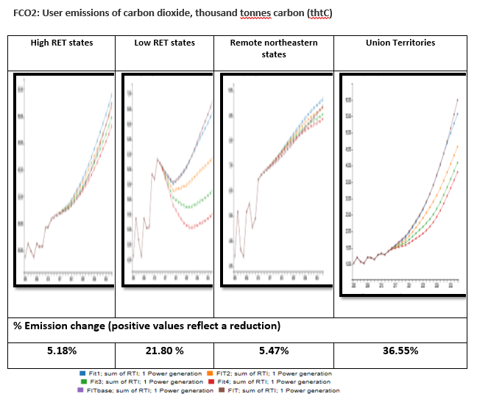The analysis performed required modifications to the “idiom” files described earlier. The code in the file was modified to establish greater FiT-based incentives for solid biomass, large hydro, offshore wind and solar PV. The analysis includes four different levels of FiTs in terms of the percentage premium above the electricity price to establish a new levelized wholesale FiT-base price available to the technologies listed. The baseline scenario (9) has FiT levels set at 1.1 (meaning that the FiT is 110 percent of the base price). New idiom scenario files named with changes to the code were modified and given new text file names: F1, F2, F3 and F4.The FiTs were setat1.6, 2.1, 2.6, and 3.1(to establish price premiums of 60 percent, 110 percent, 160 percent and 210 percent, respectively). An assessment of carbon emissions associated with above energy pathways of RETs for the four categories of Indian states was performed. The results are illustrated below.

Figure .: CO2 emissions in groups of states (thtC)

The above analysis demonstrates that higher FiT rates in high RET states or remote northeastern states do not show a significant reduction in CO2 emissions. However, similar incentives for low-RET states or Union Territories such as Delhi and Chandigarh lead to a fairly large reduction in carbon intensity of 21.8 percent and 36.55 percent, respectively. This analysis is indicative of the role that RET policies for union territories or late movers states can play in GHG reductions for India. This type of analysis becomes critically important with India’s ratification of the Paris climate agreement, in which India has proactively committed to reductions in carbon emission intensity of its GDP of 33-35 percent below 2005 levels by 2030.

Of course, other dimensions of the impacts, including impacts on electric rates and the economy, should also be considered in such an analysis. Such analysis would allow policymakers to consider the alternative pathways and their respective impacts on carbon reduction, consumers, and the economy. The E3-India modeling framework provides a closed (self-consistent) framework for evaluating such the potential impacts. The third theme helps to demonstrate these capabilities within the E3-India model.

Theme III: Integration of the technology transition scenarios with key economic state level parameters

This section deals with using theE3-India model for analyzing some key state-level parameters, such as power sector investments, consumer spending, and total investments, and ascertaining their impact on key economic outcomes such as changes in GDP. The first set of graphics shows the investment categories and levels that are needed to meet the RET targets in different regions. The second set of graphics shows the impacts of these investments on key economic outputs, including GDP and consumer expenditures.

Figure .: Investment and economic impacts

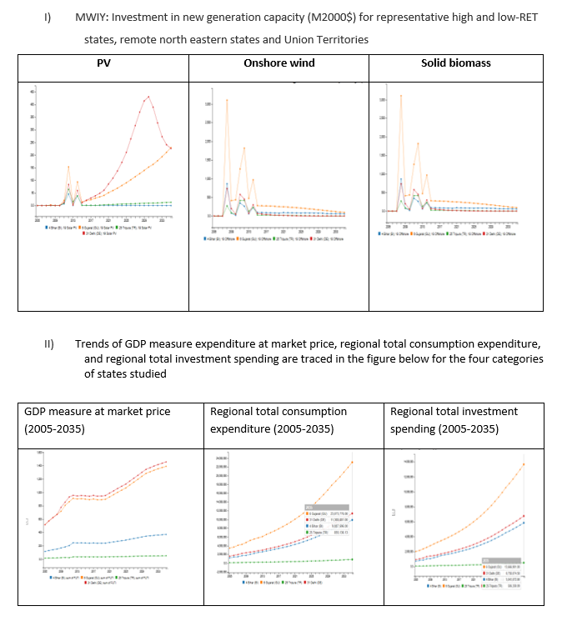

The trend indicates high investments in earlier years, followed by constant low investments for onshore wind and solid biomass. Investments for solar PV show a greater positive investment trajectory over time. The GDP trends for the four categories of states show higher GDP generation for high-RET states and Union Territories, followed by low-RET states and remote northeastern states. The regional consumption expenditure and investments increase with time but the trajectory differs among the categories of states, with high-RET states and Union Territories being the leaders.

## Ongoing case studies

The following case studies are currently being assessed.

**Towards Healthy Discoms: Mapping impacts of power sector efficiency improvement, subsidy phase out and tariff rationalisation articulated through UDAY across Indian states**

Financial health of state DISCOMs in India have been snafued with huge accumulated debt (approximately Rs. 4.3 lakh crore as on March 2015). The financially stressed DISCOMs are not been able to supply adequate power at affordable rates, hampering quality of life and overall economic growth and development of many Indian states. A unique scheme launched by government of India’s i.e Ujjwaal Discom Yojana (UDAY) aims at improving Discom performance plurilaterally through four initiatives (i) Improving operational efficiencies of DISCOMs; (ii) Reduction of cost of power; (iii) Reduction in interest cost of DISCOMs; (iv) Enforcing financial discipline on DISCOMs through alignment with State finances. This study simulates impacts associated with a synchronous effort to improve performance of DISCOM and shift of debt from dejure to defacto borrowing by states.

The study generates scenarios using information from state level tripariate MoUs executed under UDAY and uses E3-India modelling tool to simulate individual and combined impacts on indicators like state electricity tariff across consumption categories, GDP, employment , electricity price and emissions.

**Evaluating green grid scenarios for triple bottom line of Economic, Social and environmental efficiencies**

The feasibility of integrating targeted 175 GW of solar and wind capacities to the existing Indian grid have been recently established using production coast based modelling. This study provides an extension and wider dimension to existing studies by evaluating impacts of various probable scenarios for state level RE targets in India from a development perspective. This involves use of an array of economic, social and environmental performance indicators using E3-India model. The study maps energy transition impacts on state level sectoral multipliers along with employment and environmental impacts in terms of CO2, SOx and NOx. The five prominent scenarios for RE integration i.e. 1) No new renewable 2) 20 GW wind (W) – 50 GW solar (S) 3) 100S-60W 4) 60S-100W 5) 150S-100W are analysed. This study provides an initial probe into possibility of structural change mediated in Indian economy by unprecedented renewable integration and its economy wide impacts for the economy.

# How the model solves

## The basic solution process

This section describes in detail the solution process within the compiled model code. In most instances the user will not need to understand the solution process, but some basic knowledge would be helpful on occasions when the model fails to solve. An outline is therefore provided.

Iteration loops in the solution

As described in Chapter 6, there are several simultaneous loops and interactions in E3-India. While theoretically it might be possible to solve all the equations as a system, in practice the model is far too complex and an iterative approach is required.

The method of solution is [Gauss-Seidel](https://en.wikipedia.org/wiki/Gauss%E2%80%93Seidel_method), in which the different equation sets are solved in a predetermined order[14], starting with the values of the previous year's solution. The equations are solved, then the whole process is repeated (the 'iteration') and the differences in the values of selected variables from one iteration to the next are calculated; they will usually decrease quite quickly between iterations. When these differences are small enough, the solution is deemed to be ‘converged’.

Reports are written to a text file[15] during the solution on (1) any very large absolute differences in solutions between iterations, (2) any non-converged values at the end of the solution, (3) the 30 items with the largest absolute differences between iterations at two different points in the solution, and (4) possible multiple solutions.

Problems in the solution

A large, complex, non-linear model such as E3-India inevitably can sometimes have problems of convergence and stability in model solution. Generally, there are two reasons that the model may fail to solve:

* explosive behaviour where a model variable keeps on increasing until it breaches a pre-specified limit
* non-convergence, where the model becomes trapped between two different solutions and is unable to move to a single point

When a model variable goes out of bounds, an error message is displayed telling the user which variable, state and sector has breached its limit (this is also recorded in the output diagnostics file). This is designed to help the user identify the source of the problem as easily as possible, although it should be noted that the error message may identify a symptom rather than a cause.

Cases of non-convergence are shown when the model reaches a maximum limit on the number of iterations (usually set at 50) without reaching a unique solution.

Common types of error pre-solution

Expertise has been developed to identify reasons for both causes and to remove the sources wherever possible. Although not necessarily the case, failures in solution often come from errors in the data or in the estimation. The first response is to check for errors and remove any. Indeed, a set of procedures should be followed before any solution of the model is undertaken to ensure that the data, the parameters and the programming is free of certain types of error:

* Data errors: e.g. zero prices, disaggregated energy demand does not add up to aggregated energy demand value, wage payments when employment is zero, current non-zero values when constant-priced values are zero so that implicit unit-prices are infinite.
* Parameter errors: where there are discrepancies between the model variables and the variables used for parameter estimation.

Alternative model specifications

When all these checks have been done, certain extreme values of parameters or combinations of parameter values in different equations may still cause problems in solution. These must be identified and removed.

The approach for doing this is usually by changing the specification from the default econometric equation (as specified in Chapter 5), to a simpler specification. Common alternatives are:

* SHAR – The specified model variable changes in line with the same variable for other sectors in the state.
* RATE – The specified model variable changes in line with the same variable for the same sector in other states.
* EXOG – The specified model variable is not allowed to change and is fixed at the value on the databank.

The function specifications are set early in an Excel spreadsheet which gets exported to csv files for the model to read. The Excel file can usually be found in the C:\E3-india\In\Switches directory.

In general, considerable care should be used when changing specifications. For example, the RATE specification would not be appropriate when running the model for a single state. Unless there is a theoretical reason, model variables should usually only be held as exogenous for model testing.

Other alternative specifications are available for the individual equation sets.

Common problems in the solution – when output becomes zero

Many problems in the solution relate to model variables approaching zero. In particular, when output (QR) for a sector approaches zero, certain ratios (e.g. industry prices, labour productivity) can become unstable:

QR = QRY + QRC + QRK + QRG + QRX – QRM + QRR

where the terms on the right-hand side relate to intermediate demand and the components of final demand, plus imports as a negative demand and the calibration residual QRR. It is quite obvious that fast-growing imports could result in zero or negative output (the model software will not allow negative output).

This can lead to both model collapse and non-convergence. Any one sector can cause problems in the solution so, with a large number of sectors and states, it is not difficult to see how this could lead to instability.

Other solution problems – zero unemployment

Another important reason for non-convergence is when the economy of a state in the model approaches full employment. In this case the effect of the unemployment rate (the log of the rate is used) can change dramatically in several of the equations, leading to sudden changes in solution from one iteration to another. This effect is compounded by a check in the solution to prevent unemployment going negative by forcing a floor on the unemployment rate: the solution can bounce off this floor from one iteration to the next.

user is warned that they are liable to enter such areas if changes are made to the model or its assumptions which increase employment. The modelling problem has its roots in the actual performance of economies, which become more unstable at very low levels of unemployment. A similar warning is also applicable for when output of a sector is heading toward zero.

## Model software

There are now several well-established packages that can be used for model building, each with its own advantages and disadvantages. However, there is no one single package that fits the requirements of the E3-India model, so a combination of software packages is used.

The following software is used:

* Fortran: E3-India source code is written in the Fortran95 programming language. It is compiled using the Intel Fortran compiler. The standard development environment is Microsoft Visual Studio. Users do not interact with the Fortran code.
* IDIOM: This is a programming language which is itself a pre-compiled set of Fortran commands. It provides a user interface for the modeller, for example allowing the user to make certain changes without recompiling the source code. The IDIOM manual (Cambridge Econometrics, 2007) provides further details and is available on request to advanced model users.
* DOS: The model is run from the command line, using cmd batch files. However, the Manager software hides this from the user.
* Python and HTML: The model manager and front end, which allows the model to be run without requiring any programming expertise, is programmed in Python and HTML.
* Ox: The Ox programming language (Doornik, 2007) is used for data processing, parameter estimation and manipulation of results.

# Frequently asked questions

Practical questions

|  |  |  |  |
| --- | --- | --- | --- |
| # | Question | Answer | More information |
| **1** | Are there some basic precautions to be aware of during the setup of the baseline? |  | Chapter 2 |
| **2** | How do I export my E3-India results? |  | Section 2.2 |
| **3** | When running the model, where do I read a possible error message? |  | Chapter 12 |
| **4** | How are model variables named? |  | Chapter 4 |
| **5** | How is coal treated in the model? |  | Section 6.5 |
|  |  |  |  |

Theoretical questions

|  |  |  |
| --- | --- | --- |
|  |  |  |
| **6** | What are the underlying assumptions used in the construction of a CGE and E3-India?  Are there any empirical studies that can confirm the relevance of these assumptions? | E3-India is a macro-econometric model based on post-Keynesian economics. The model is a simulation tool that attempts to reproduce real-world behaviour and does not make assumptions about optimising behaviour. Instead, behaviour is assumed to reflect past trends, as derived in the econometric equations that are based on historical time-series data.  This means that many features of the economy that cannot always be represented in the CGE model (e.g. the role of institutions and the existence of unemployment, fixed exchange rates. The main weakness of the approach is the reliance on historical data for assessing future behaviour (i.e. Lucas Critique) but our view is that this still gives us a best guess of real-world relationships. |
| **7** | One of the major difficulties of the general equilibrium models is the modelling of the labour market. How do you model this market? Are there any (empirical) studies that can justify your choice? | E3-India is not an equilibrium model and therefore doesn’t suffer from many of the limitations of CGE models. There are econometric equations for labour demand and supply, wage rates and average working hours. There is no assumption that wages adjust so that labour markets ‘clear’ either in the long or short run. Involuntary unemployment therefore exists as part of the difference between labour supply and demand. Changes in unemployment rates in turn affect decisions made on consumption.  The main limitation of E3-Indias the absence of a detailed treatment of skills, so the model cannot say which workers can fill which jobs. This is due to data limitations and is something we are looking to improve in future. In general, however, any scenarios with large shifts in labour between sectors needs a separate more qualitative assessment to ensure that workers are able to make the transition. |
| **8** | Can you summarise the expected long-term impacts on GDP, the employment and the environment?  Can you define the notion of "long term"? | Unlike a standard CGE model, time in E3-India is defined explicitly. The model solves on an annual basis and provides results for both short and long-term outcomes. The dynamic part of the econometric equations provides annual changes, gradually moving towards a long-term steady state outcome. The speed with which the model moves towards a long-term outcome is also determined by the error-correction specification of the equations. Typically, most equations are most of the way to long-term outcomes within 3-5 years.  GDP is an accounting identity and the model results reflect changes in the sum of consumption, investment and net trade. Impacts on GDP will therefore depend on what happens to these. Labour is a derived demand, which depends on demand for final products. Typically wages adjust slowly at best, so impacts on labour largely depend on impacts on production levels (although usually a smaller magnitude).  Energy is also a derived demand so the level of energy consumption depends on production levels. Economies of scale are accounted for however so the relationship is not one-to-one. |
| **9** | What period to the historical data cover? | The historical time series start in 1993 and 1995 is the first year for parameter estimation and full solution. The time series are annual and use the most recent data available. The future baseline projections go out to 2035. |
| **10** | What are the units for the output variables? | Most monetary values are expressed as millions of rupees at constant prices (2011 price base). Price indices (2011 = 1.0) are also given to convert to current prices.  Employment is measured in thousands of people. Energy consumption is measured in thousands of tonnes of oil equivalent and emissions in thousands of tonnes of carbon. |

# References

## References for the E3-India model manual

Agnolucci, P, Barker T and Ekins, P (2004), ‘Hysteresis and energy demand: the Announcement Effects and the effects of the UK Climate Change Levy’, Working Paper No. 51, Tyndall Centre for Climate Change Research. <http://www.tyndall.ac.uk/sites/default/files/wp51.pdf>

Anderson, D and S Winne (2004), 'Modelling innovation and threshold effects in climate change mitigation', Working Paper No. 59, Tyndall Centre for Climate Change Research. [www.tyndall.ac.uk/publications/pub_list_2004.shtml](http://www.tyndall.ac.uk/publications/pub_list_2004.shtml)

Armington, P (1969), ‘A Theory of Demand for Products Distinguished by Place of Production’, IMF Staff Papers, XVI, pp159-178.

Barker, T S (1977), 'International trade and economic growth: an alternative to the neoclassical approach', Cambridge Journal of Economics, 1, pp153-172.

Barker, T S and A W A Peterson (1987), ‘The Cambridge Multisectoral Dynamic Model of the British Economy’, Cambridge University Press.

Barker, T S, R van der Putten and I Stern (1993), 'HERMES: a macrosectoral model for the UK economy', in CEC (eds), HERMES: Harmonised Econometric Research for Modelling Economic Systems, North Holland

Barker, T S, Ekins, P and N Johnstone (1995), ‘Global Warming and Energy Demand’, Routledge, London.

Barker, T S and B Gardiner (1996), 'Employment, wage formation and pricing in the European Union: empirical modelling of environment tax reform', in C Carraro and D Siniscalco (eds), Environmental Fiscal Reform and Unemployment, pp. 229-272, Kluwer.

Barker, T S (1998), 'The effects on competitiveness of coordinated versus unilateral fiscal policies reducing GHG emissions in the EU: an assessment of a 10% reduction by 2010 using the E3ME model', Energy Policy, vol. 26, no. 14, pp. 1083-1098.

Barker, T S (1998), 'Use of energy-environment-economy models to inform greenhouse gas mitigation policy', Impact Assessment and Project Appraisal, vol. 16, no. 2, pp. 123-131.

Barker, T S (1998), 'Large-scale energy-environment-economy modelling of the European Union', in Iain Begg and Brian Henry (eds), Applied Economics and Public Policy, Cambridge University Press.

Barker, T S and K E Rosendahl (2000), ‘Ancillary Benefits of GHG Mitigation in Europe: SO2, NOx and PM10 reductions from policies to meet Kyoto targets using the E3ME model and EXTERNE valuations’, Ancillary Benefits and Costs of Greenhouse Gas Mitigation, Proceedings of an IPCC Co-Sponsored Workshop, March, 2000, OECD, Paris.

Barker, T S, A W A Peterson and A Winters (1984), 'IDIOM: an international dynamic input-output model', pp. 183-192 in UNIDO (ed.) Proceedings of the Seventh International Conference on Input-Output Techniques, United Nations, New York.

Barker, T S, S De-Ramon and H Pollitt (2009), 'Revenue recycling and labour markets: effects on costs of policies for sustainability', in (eds) V. Bosetti, R. Gerlagh and S. Schleicher, Modelling Transitions to Sustainable Development, Elgar, Cheltenham, UK.

Barrell, R and P Davis (2007), ‘Financial liberalisation, consumption and wealth effects in seven OECD countries’, Scottish Journal of Political Economy, 54(2) 254-67.

Beinhocker, E (2007) ‘The Origin of Wealth: Evolution, Complexity, and the Radical Remaking of Economics’, Random House Business.

Bentzen, J and T Engsted, (1993), 'Short- and long-run elasticities in energy demand: a cointegration approach', Energy Economics, 15(1) 9-16.

Blackaby D H and N Manning (1990), 'Earnings, unemployment and the regional employment structure in Britain', Regional Studies, Vol. 24, pp. 529-36.

Blackaby D H and N Manning (1992), 'Regional earnings and unemployment - a simultaneous approach', Oxford Bulletin of Economics and Statistics, Vol. 54, pp. 481-502.

Booth, R R (1971), 'Optimal Generation Planning Considering Uncertainty,' IEEE Transactions on Power Apparatus and Systems.

Bosetti, V, R Gerlagh and S P Schleicher (2009), ‘Modelling Sustainable Development: Transitions to a Sustainable Future’, Edward Elgar.

Bracke, I and T Brechet (1994), 'The Estimation of an Allocation System for Consumption: Progress Report and First Simulations for Belgium', E3ME Working Paper No 38.

Briscoe, G and R Wilson (1992), 'Forecasting economic activity rates', International Journal of Forecasting, 8, pp201-217.

Bryden, C (1993), 'Modelling the UK Electricity Supply Industry', E3ME Working Paper No 21.

Cambridge Econometrics (2007), ‘IDIOM International Dynamic Input-Output Modelling Language User's Guide’, available on request.

Cambridge Econometrics and Université Libre de Bruxelles (2005), ‘Simulation of R&D investment scenarios and calibration of the impact on a set of multi-country models’, Final Report.

Cambridge Systematics, Inc. (1982), ‘Residential End-Use Energy Planning Model System (REEPS), Electric Power Research Institute’, Report EA-2512, Palo Alto, California.

Capros, P, D Van Regemorter, L Paroussos and P Karkatsoulis (2012), ‘The GEM-E3 model’, IPTS Scientific and Technical report.

Davidson, J, D Hendry, F Srba and S Yeo (1978), 'Economic modelling of the aggregate time series relationship between consumers' expenditure and income in the UK', Economic Journal, Vol 80, pp899-910.

de Bruyn, S, A Markowska, F de Jong and M Bles (2010), ‘Does the energy intensive industry obtain windfall profits through the EU ETS? An econometric analysis for products from the refineries, iron and steel and chemical sectors’, CE Delft.

Dixon, P B and M T Rimmer (2002), ‘Dynamic, General Equilibrium Modelling for Forecasting and Policy: a Practical Guide and Documentation of MONASH’, North-Holland.

Doornik, J A (2007), ‘Ox: An Object-Oriented Matrix Language’, London: Timberlake Consultants Press.

DRI (1991), ‘The Economic Impact of a Package of EC Measures to Control CO2 Emissions’, Final Report prepared for the CEC, November.

DRI (1992), ‘Impact of a Package of EC Measures to Control CO2 Emissions on European Industry’, Final Report prepared for the CEC, January.

Ekins, P, H Pollitt, J Barton and D Blobel (2011), ‘The Implications for Households of Environmental Tax Reform (ETR) in Europe’, Ecological Economics, Volume 70, Issue 12, pp2472-2485, Elsevier.

Ekins, P, H Pollitt, P Summerton and U Chewpreecha (2012), ‘Increasing carbon and material productivity through environmental tax reform’, Energy Policy, 42, 365-376.

Engle, R F and C W J Granger (1987), 'Cointegration and error correction: representation, estimation and testing', Econometrica, 55, 251-76.

Engle, R F and C W J Granger (1991), ‘Long-Run Economic Relationships (Readings in Cointegration)’, Oxford University Press.

Eurostat (1996) ‘European System of Accounts (ESA95)’, Eurostat, European Commission.

Franzén, M and T Sterner (1995), ‘Long-run Demand Elasticities for Gasoline’, in Barker, T., N. Johnstone and P. Ekins (eds.), Global Warming and Energy Elasticities, Routledge.

Gateley, D (1993), 'The imperfect price-reversibility of world oil demand', The Energy Journal, Vol. 14, No. 4, pp. 163-181.

Grubb, M (1995), 'Asymmetrical price elasticities of energy demand', pp. 305-310 in Barker, T S, Ekins, P and N Johnstone (1995) Global Warming and Energy Demand, Routledge, London.

Grubb, M (2014), ‘Planetary Economics’, Routledge.

Hargreaves, C (1991, eds), ‘Macroeconomic Modelling of the Long Run’, Edward Elgar, Aldershot, UK.

Hendry, D F (1994), ‘Dynamic Econometrics’, Oxford: Oxford University Press.

Hendry, D F and M P Clements (1994), 'On a theory of intercept corrections in macro-economic forecasting', in S. Holly (eds) Money, Inflation and Employment: Essays in Honour of Sir James Ball, Edward Elgar.

Hendry, D F, Pagan, A and J D Sargan (1984), ‘Dynamic specification, in Handbook of Econometrics’, Vol II, Griliches, Z and M D Intriligator (eds), Amsterdam, North Holland.

Hertel, T (1999), ‘Global Trade Analysis: Modeling and Applications’, Cambridge University Press.

Hunt, L and N Manning (1989), 'Energy price- and income-elasticities of demand: some estimates for the UK using the cointegration procedure', Scottish Journal of Political Economy, 36(2) pp183-193.

Jackson, J.R., et. al. (1982), 'Conservation Policy Analysis and End-Use Models: A Commercial Sector Example' in Proceedings: End-Use Models and Conservation Analysis, Electric Power Research Institute, Report EPRI EA 2509, Palo Alto, CA.

Jansen, H and G Klaassen (2000), ‘Economic Impacts of the 1997 EU Energy Tax: Simulations with Three EU-Wide Models’ Environmental and Resource Economics, Volume 15, Number 2, pp.179-197.

Jenkins, R T (1979), 'Production Costing Using The Cumulant Method of Representing the Equivalent Load Duration Curve,' IEEE Transaction on Power System Engineering.

Jensen, V (1990), 'Least-Cost Planning: The Illinois Experience', Public Utilities Fortnightly.

Johansson, O and L Schipper (1997), 'Measuring the long-run fuel demand of cars', Journal of Transport Economics and Policy, Vol XXXI, No 3, pp 277-292.

Kahneman, D (2012), ‘Thinking, Fast and Slow’, Penguin.

Keeney, R L and H Raiffa (1976), ‘Decisions with Multiple Objectives’, John Wiley & Sons, New York NY.

Kerdrain, C (2011), ‘How important is wealth for explaining household consumption over the recent crisis: An empirical study for the United States, Japan and the Euro Area’, OECD Department Working Papers.

Layard, P R G and S J Nickell (1986), 'Unemployment in Britain', Economica, Vol. 53, No. 210(S).

Layard, R, Nickell, S and R Jackman (1991), ‘Unemployment’, Oxford University Press, Oxford, UK.

Lee, K, M H Pesaran and R G Pierse (1990), 'Aggregation Bias in Labour Demand Equations for the UK Economy', Chapter 6 in Barker, T and M H Pesaran (eds) Disaggregation in Econometric Modelling, Routledge.

Lee, K & K Shields (1997), 'Modelling sectoral output growth in the EU economies', Workpackage 4.1: Supply-side Specification for Output, University of Leicester.

Lee, K C and M H Pesaran (1993), 'The Role of Sectoral Interactions in Wage Determination in the UK Economy', The Economic Journal, January 1993.

Lee K and K Shields (1997), 'Modelling Sectoral Output Growth in the EC Economies', E3ME Working Paper No 15, Workpackage 4.1: Supply-Side Specification for Output.

Lee K (1988), 'Labour Market Adjustment in a Disaggregated Model of the UK Supply Side', DAE Working Paper No. 8810.

Linden, J A van der, and Jan Oosterhaven (1995), 'European Community intercountry input-output relations: construction method and main results for 1965-85', Economic Systems Research, Vol. 7, No. 3, pp. 249-269.

Marchesi M C and P Zagamé (1998), 'Un compromis entre exigences académiques et besoins des utilisateurs: le modèle E3ME', CCIP.

Mercure, J-F (2012), 'FTT:Power A global model of the power sector with induced technological change and natural resource depletion', Energy Policy, 48, 799–811.

Mercure, J-F and P Salas (2012), 'An assessment of global energy resource economic potentials', Energy, 46(1), 322–336.

Mercure, J-F, and P Salas (2013), 'On the global economic potentials and marginal costs of non-renewable resources and the price of energy commodities', Energy Policy, (63), 469–483.

Naill, R, S Belanger, A Klinger and E Petersen (1990), ‘Analysis of the Cost Effectiveness of U.S. Energy Policies to Mitigate Global Warming’, 1990 International System Dynamics Conference, Boston MA, July 10-13, 1990.

Neal, A J and R A Wilson (1987), 'Average Weekly Hours of Work in the United Kingdom, 1948-80: A Disaggregated Analysis', Chapter 9 in D L Bosworth and D F Heathfield (1987) Working Below Capacity, London: Macmillan.

Pesaran, M H (1988), 'Costly Adjustment Under Rational Expectations: A Generalisation', UCLA Working Paper No 480.

Pesaran, M H and R J Smith (1994), 'A Generalised R2 for Regression Models Estimated by the Instrumental Variables Method', Econometrica, pp705-710.

Pesaran, M H and R Smith (1992), ‘Estimating Long-Run Relationships from Dynamic Heterogenous Panels’, presented at Fourth conference on Panel Data, Budapest, June 18-19th 1992.

Peterson, A W A, T S Barker and R van der Ploeg (1983), 'Software support for multisectoral dynamic models of national economies', Journal of Economics Dynamics and Control, Vol. 5, l983, pp. l09-l30.

Pindyck, R and D L Rubenfeld (1981), ‘Econometric Models & Econometric Forecasts’, McGraw-Hill.

Pollitt, H (2007), ‘Extending E3ME to Include Analysis of Material Flows’, scoping report for the Anglo-German Foundation, Cambridge Econometrics. <http://94.76.226.154/Libraries/Downloadable_Files/Material_Flows.sflb.ashx>

Pollitt, H (2008), ‘Combining Economic and Material Flows Analysis at the Sectoral level: Development of the E3ME Model and Application in the MATISSE Case Studies’, MATISSE project deliverable 8.6.1, April 2008.

Pollitt, H and Chewpreecha, U (2008), ‘Development of Labour Supply Projections with the E3ME Framework’, Cambridge Econometrics Working Paper.

Pollitt, H and Chewpreecha, U (2009), ‘Extending the E3ME Model to 2050: An Introduction to E3ME Version 4.7’, Cambridge Econometrics Working Paper. <http://www.camecon.com/Libraries/Downloadable_Files/2050.sflb.ashx>

Pollitt, H and Mercure, J-F (2017) ‘The role of money and the financial sector in energy-economy models used for assessing climate and energy policy’, Climate Policy, <http://dx.doi.org/10.1080/14693062.2016.1277685>

Ragot L (1994), 'Le commerce extérieur dans MEGEVE. Rapport d'etape 1: les séries disponibles dans CRONOS Sec 2', ERASME.

RBI (2018) ‘STATE FINANCES : A STUDY OF BUDGETS’, see <https://rbi.org.in/Scripts/AnnualPublications.aspx?head=State%20Finances%20:%20A%20Study%20of%20Budgets>

Reister, D (1992), 'The Oak Ridge Industrial Model: An Introduction', in Proceedings: End-Use Models and Conservation Analysis, Electric Power Research Institute, Report EPRI EA 2509, Palo Alto, CA.

Scott, M F G (1989), ‘A New View of Economic Growth’, Oxford: Clarendon Press.

Serletis, A (1992), 'Unit root behaviour in energy future prices', The Economic Journal, 13(2), pp119-128.

Sutherland, H, H Immervoll and C O’Donoghue (1999), ‘An Introduction to Euromod’, Euromod working paper series EM0/99.

Sutherland, H and HX Jara (2013) ‘Baseline results from the new EU27 EUROMOD (2007-2010)’, Euromod working paper EM3/2013.

Tzemos, S (1981), ‘Evaluation of Probabilistic Simulation Methods and Development of Optimization Techniques for Capacity Expansion Planning of Electric Power Generation Systems’, PhD Dissertation, Ohio State University.

United Nations, Department of Economic and Social Affairs, Population Division (2013). World Population Prospects: The 2012 Revision, Volume II, Demographic Profiles (ST/ESA/SER.A/345).

U.S. Department of Energy (1983), ‘Energy Projections to the Year 2010’, NTIS Document DOE/PE-0029/2, Washington, D.C.

Walker, I O and F Wirl (1993), 'Irreversible price-induced efficiency improvements: theory and empirical application to road transportation', The Energy Journal, Vol. 14, No. 4, pp. 183-205.

Wallis, K F (1984, 1985, 1986, and 1987, eds), ‘Models of the UK Economy’, Four Annual Reviews by the ESRC Macroeconomic Modelling Bureau published in 1984, 1985, 1986, 1987. Oxford University

## Specific references in Chapter 12

Journal articles and book chapters based on E3ME

Barker, T. (1998a), ‘The Effects on Competitiveness of Co-ordinated versus Unilateral Fiscal Policies Reducing GHG Emissions in the EU: An Assessment of a 10% Reduction by 2010 Using the E3ME Model’, *Energy Policy*, 26 (14), pp 1083-1098.

Barker, T. (1998b), ‘The Use of Energy-Environment-Economy Models to Inform Greenhouse Gas Mitigation Policy’, *Impact Assessment and Project Appraisal*, 16 (2), pp 123-131.

Barker, T. (1998c), ‘Large-scale Energy-Environment-Economy Modelling of the European Union’, In I. Begg and B. Henry (Eds.) *Applied Economics and Public Policy*, Cambridge: Cambridge University Press.

Barker, T. and Köhler, J. (1998d), ‘Equity and Ecotax Reform in the EU: Achieving a 10% Reduction in CO2 Emissions Using Excise Duties’, *Fiscal Studies*, 19 (4), pp 375-402.

Barker, T. (1999), ‘Achieving a 10% Cut in Europe’s Carbon Dioxide Emissions Using Additional Excise Duties: Coordinated, Uncoordinated and Unilateral Action Using the Econometric Model E3ME’, *Economic Systems Research*, 11 (4), pp 401-421.

Barker, T., Pan, H., Köhler, J., Warren, R. and Winne, S. (2005), ‘Avoiding Dangerous Climate Change by Inducing Technological Progress: Scenarios Using a Large-scale Econometric Model’, In H.J. Schellnhuber, W. Cramer, N. Nakicenovic, T. Wigley and G. Yohe, (Eds.) *Avoiding Dangerous Climate Change*, Cambridge: Cambridge University Press, 2005.

Barker, T., Pan, H., Köhler, J., Warren, R. and Winne, S. (2006), ‘Decarbonizing the Global Economy with Induced Technological Change: Scenarios to 2100 using E3MG’, *Energy Journal*, 27 (S1), pp 241-258.

Barker, T., Junankar, S., Pollitt, H. and Summerton, P (2007), 'Carbon leakage from unilateral environmental tax reforms in Europe, 1995-2005', *Energy Policy* 35 (2007), pp 6281–6292.

Barker, T., Ekins, P., Junankar, S., Pollitt, H. and Summerton, P. (2009), ‘The competitiveness effects of European environmental tax reforms', *European Review of Energy Markets*, Energy Policy Volume 3, Issue 1, April 2009.

Barker, T., Anger, A., Chewpreecha, U. and Pollitt, H. (2012), ‘A new economics approach to modelling policies to achieve global 2020 targets for climate stabilisation’, *International Review of Applied Economics*, Volume 26 Issue 2, pp 205-221.

Barker, T., Alexandri, E., Mercure, J-F., Ogawa, Y. and Pollitt, H. (2016), ‘GDP and Employment Effects of Policies to Close the 2020 Emissions Gap’, *Climate Policy*, Volume 16, Issue 4, pp 393-414.

Dagoumas, A. and Barker, T. (2010) ‘Pathways to a low-carbon economy for the UK with the macro-econometric E3MG model’, *Energy Policy*, Volume 38, Issue 6, pp.3067-3077.

Ekins, P., Pollitt, H., Barton, J. and Blobel, D. (2011) ‘The Implications for Households of Environmental Tax Reform (ETR) in Europe’, *Ecological Economics*, Volume 70, Issue 12, pp2472-2485.

Ekins, P., Pollitt, H., Summerton, P. and Chewpreecha, U. (2012) ‘Increasing Carbon and Material Productivity through Environmental Tax Reform’*, Energy Policy*, Volume 42, pp 365–376.

Holden, P.B., Edwards, N.R., Ridgwell, A., Wilkinson, R.D., Fraedrich, K., Lunkeit, F., Pollitt, H., Mercure, J.-F., Salas, P., Lam, A., Knobloch, F., Chewpreecha, U. and Viñuales, J.E. (2018) ‘Climate–carbon cycle uncertainties and the Paris Agreement’, *Nature Climate Change*, Volume 8, pp 609-613 (2018).

Knobloch, F., Pollitt, H., Chewpreecha, U., Daioglou, V. and Mercure, J.-F. (2018) ‘Simulating the deep decarbonisation of residential heating for limiting global warming to 1.5°C’, *Energy Efficiency*, Volume 12, Issue 2, pp 521–550.

Jansen, H. and Klaassen, G. (2000), ‘Economic Impacts of the 1997 EU Energy Tax: Simulations with Three EU-Wide Models’, *Environmental and Resource Economics*, Volume 15, Number 2, pp 179-197.

Kober, T., Summerton, P., Pollitt, H., Chewpreecha, U., Ren, X., Wills, W., Octaviano, C., McFarland, J., Beach, R., Cai, Y., Calderon, S., Fisher-Vanden, K., Loboguerrero Rodriguez, A.M. (2016) ‘Macroeconomic impacts of climate change mitigation in Latin America: A cross-model comparison’, *Energy Economics*, Volume 56, pp 625-636.

Lee, S, Pollitt, H. and Ueta, K. (2012) ‘A Model-Based Econometric Assessment of Japanese Environmental Tax Reform’, *The Scientific World Journal*, Volume 2012 (2012), Article ID 835917.

Lee, S., Chewpreecha, U., Pollitt, H. and Kojima, S. (2017) ‘An economic assessment of carbon tax reform to meet Japan’s NDC target under different nuclear assumptions using the E3ME model’, *Environmental Economics and Policy Studies*, Society for Environmental Economics and Policy Studies - SEEPS, vol. 20(2), pp 411-429, April.

Mercure, J.-F. (2012), 'FTT:Power A global model of the power sector with induced technological change and natural resource depletion', *Energy Policy*, 48, pp 799–811.

Mercure, J.-F., Salas, P., Foley, A., Chewpreecha, U., Pollitt, H., Holden, P.B. and Edwards, N.R. (2014) ‘The dynamics of technology diffusion and the impacts of climate policy instruments in the decarbonisation of the global electricity sector’, *Energy Policy*, 73, pp 686–700.

Mercure, J.-F., Pollitt, H.,Bassi, A.M., Viñuales, J.E. and Edwards, N.R. (2016) ‘Modelling complex systems of heterogeneous agents to better design sustainability transitions policy’, *Global Environmental Change*, Volume 37, March 2016, pp 102–115.

Mercure, J.-F., Lam, A, Billington, S. and Pollitt, H. (2018a) ‘Integrated assessment modelling as a positive science: private passenger road transport policies to meet a climate target well below 2°C’, *Climatic Change*, November 2018, Volume 151, Issue 2, pp 109–129.

Mercure, J.-F., Pollitt, H., Edwards, N.R., Holden, P.B., Chewpreecha, U., Salas, P., Lam, A., Knobloch, F. and Viñuales, J.E. (2018b) ‘Environmental impact assessment for climate change policy with the simulation-based integrated assessment model E3ME-FTT-GENIE’, *Energy Strategy Reviews*, Volume 20, April 2018, Pp 195–208.

Mercure, J.-F., Pollitt, H., Viñuales, J.E., Edwards, N.R., Holden, P.B., Chewpreecha, U., Salas, P., Sognnaes, I., Lam A. and Knobloch, F. (2018c) ‘Macroeconomic impact of stranded fossil fuel assets’, *Nature Climate Change*, Volume 8, pp 588–593 (2018).

Pollitt, H., Zhao, Y., Ward, J., Smale, R., Krahe, M. and Jacobs, M. (2012) ‘The Potential Role for Carbon Pricing in Reducing European Deficits’, *Global Policy Essay*, September 2012.

Pollitt, H., Alexandri, E., Chewpreecha, U. and Klaassen, G. (2014a) ‘Macroeconomic analysis of the employment impacts of future EU climate policies’, *Climate Policy*, Volume 15, Issue 5, pp 604-625.

Pollitt, H., Lee, S., Park, S.-J. and Ueta, K. (2014b) ‘An Economic and Environmental Assessment of Future Electricity Generation Mixes in Japan - An assessment using the E3MG macro-econometric model’, *Energy Policy*, Volume 67 (2014), pp 243-254.

Pollitt, H. and Mercure, J.-F. (2017) ‘The role of money and the financial sector in energy-economy models used for assessing climate and energy policy’, *Climate Policy*, Volume 18, Issue 2, pp 184-197.

Books based on E3ME

Andersen, M.S. and Ekins, P. (2009) ‘Carbon-Energy Taxation: Lessons from Europe’. Oxford, IEA.

Lee, S., Pollitt, H. and Park, S.J. (2015) ‘Low-Carbon, Sustainable Future in East Asia’, Routledge.

Official EU Impact Assessments and reports using E3ME

European Commission (2010) ‘Analysis of options to move beyond 20% greenhouse gas emission reductions and assessing the risk of carbon leakage’, European Commission’s official communication, DG CLIMATE, see <https://ec.europa.eu/clima/sites/clima/files/strategies/2020/docs/sec_2010_650_part2_en.pdf>

European Commission (2011a) ‘Smarter energy taxation for the EU: proposal for a revision of the Energy Taxation Directive’, official Impact Assessment, DG TAXUD, see <https://ec.europa.eu/taxation_customs/sites/taxation/files/docs/body/com_2011_168_en.pdf>

European Commission (2011b) ‘Assessing the impact of changes to horizontal issues concerning energy savings in the EU’, official Impact Assessment, DG ENER, see <https://ec.europa.eu/energy/sites/ener/files/documents/sec_2011_0779_impact_assessment.pdf>

European Commission (2011c) ‘Assessing the Impact of Changes to the European Energy Supply-Side Efficiency Framework’, official Impact Assessment, DG ENER, see <https://ec.europa.eu/energy/sites/ener/files/documents/sec_2011_0779_ia_annexes.pdf>

European Commission (2013) ‘Employment effects of selected scenarios of the Energy Roadmap 2050’, final report for European Commission, DG ENER, see <https://ec.europa.eu/energy/sites/ener/files/documents/2013_report_employment_effects_roadmap_2050_2.pdf>

European Commission (2014) ‘A policy framework for climate and energy in the period from 2020 up to 2030’, official Impact Assessment, DG CLIMATE, see <https://eur-lex.europa.eu/legal-content/EN/TXT/PDF/?uri=CELEX:52014SC0015&from=EN>

European Commission (2015) ‘Assessing the Employment and Social Impact of Energy Efficiency’, final report for European Commission, DG ENER, see <https://ec.europa.eu/energy/sites/ener/files/documents/CE_EE_Jobs_appendices%2018Nov2015.pdf>

European Commission (2017a) ‘Case study – technical analysis on capacity constraints and macroeconomic performance’, see <https://ec.europa.eu/energy/sites/ener/files/documents/case_study_2_capacity_constraints_and_macro_performance.pdf>

European Commission (2017b) ‘The macro-level and sectoral impacts of Energy Efficiency policies’, see <https://ec.europa.eu/energy/sites/ener/files/documents/the_macro-level_and_sectoral_impacts_of_energy_efficiency_policies.pdf>

Other international reports based on E3ME results

IRENA (2018), ‘Global Energy Transformation: A roadmap to 2050’, International Renewable Energy Agency, Abu Dhabi

New Climate Economy (2018) ‘Unlocking the Inclusive Growth Story of the 21st Century’, New Climate Economy, Washington DC.

Model manuals

Cambridge Econometrics (2017) ‘E3-India Manual’, available at <https://www.camecon.com/how/e3-india-model/>

Other references in Chapter 12

Berg, M., Hartley, B. and Richters, O. (2015) ‘A stock-flow consistent input-output model with applications to energy price shocks, interest rates and heat emissions’, *New Journal of Physics*, 17(2015) 015011.

Dafermos, Y., Nikolaidi, M. and Galanis, G. (2016) ‘A stock-flow-fund ecological macroeconomic model’, *Ecological Economics*, 131 (2017) pp 191–207.

Goulder, L.H. (1994) ‘Environmental Taxation and the "Double Dividend:" A Reader's Guide’, NBER Working Paper No. 4896.

Haldane, A.G. and Turrell, A.E. (2018) ‘An interdisciplinary model for macroeconomics’, *Oxford Review of Economic Policy*, Volume 34, Issue 1-2, pp 219–251.

IEA (2010) ‘World Energy Outlook 2010’, International Energy Agency, OECD.

Kahneman, D. (2012), ‘Thinking, Fast and Slow’, Penguin.

Keen, S (2011) ‘Debunking Economics - Revised and Expanded Edition: The Naked Emperor Dethroned?’, second revised & enlarged edition, Zed books ltd.

Keynes, J.M. (1921) ‘Treatise on Probability’, London: Macmillan & Co.

Keynes, J.M. (1936) ‘The General Theory of Employment, Interest and Money’, Palgrave Macmillan.

King, J.E. (2015) ‘Advanced Introduction to Post Keynesian Economics’, Cheltenham, UK and Northampton, MA: Edward Elgar.

Lavoie, M. (2015) ‘Post-Keynesian Economics: New Foundations’, Cheltenham, UK and Northampton, MA: Edward Elgar.

Lucas, R. (1976) ‘Econometric Policy Evaluation: A Critique’, in Brunner, K and A Meltzer ‘The Phillips Curve and Labor Markets’, Carnegie-Rochester Conference Series on Public Policy, New York: American Elsevier, pp 19-46.

McLeay, M., Radia, A. and Thomas, R. (2014) ‘Money creation in the modern economy’, *Bank of England quarterly bulletin*, 2014Q1.

Park, S.J., Ogawa, Y., Kawakatsu, T. and Pollitt, H. (2015) ‘The double dividend of Environmental Tax Reform in East Asian economies’, Chapter 10 in Lee, S, H Pollitt and Park SJ (eds.) ‘*Low-carbon, sustainable future in East Asia’*, Routledge.

Model Classifications

|  |  |  |
| --- | --- | --- |
| **Regions**  1 Andhra Pradesh (AD)  2 Arunachal Pradesh (AR)  3 Assam (AS)  4 Bihar (BR)  5 Chhattisgarh (CG)  6 Gujarat (GJ)  7 Haryana (HR)  8 Himachal Pradesh (HP)  9 Goa (GA)  10 Jammu & Kashmir (JK)  11 Jharkhand (JH)  12 Karnataka (KA)  13 Kerala (KL)  14 Madhya Pradesh (MP)  15 Maharashtra (MH)  16 Manipur (MN)  17 Meghalaya (ML)  18 Mizoram (MZ)  19 Nagaland (NL)  20 Odisha (OD)  21 Punjab (PB)  22 Rajasthan (RJ)  23 Sikkim (SK)  24 Tamil Nadu (TN)  25 Tripura (TR)  26 Uttar Pradesh (UP)  27 Uttarakhand (UK)  28 West Bengal (WB)  29 Andaman & Nicobar (AN)  30 Chandigarh (CH)  31 Delhi (DL)  32 Pondicherry (PY)  **Fuel Users**  1 Power own use & trans.  2 Other energy own use & transformation  3 Basic metal  4 Metal goods  5 Chemicals  6 Non-metallic minerals  7 Food, drink & tobacco  8 Textile, leather & clothing  9 Rubber and plastics  10 Paper & publishing  11 Engineering etc  12 Other industry  13 Construction  14 Rail transport  15 Road transport  16 Air transport  17 Water transport  18 Households  19 Services  20 Agriculture & fishing  21 Non-energy use | **E3-India Classifications**  **Sectors**  1 Agriculture etc  2 Forestry  3 Coal  4 Oil & Gas etc  5 Other Mining  6 Food, Drink & Tobacco  7 Textiles & Clothing  8 Leather  9 Wood  10 Paper, Print. & Pub.  11 Manuf. Fuels  12 Pharmaceuticals  13 Chemicals  14 Rubber & Plastics  15 Non-Met. Min. Prods.  16 Basic Metals  17 Metal Goods  18 Electronics  19 Electrical Engineer & Inst  20 Motor Vehicles  21 Other Transport Equip.  22 Other Manufacturing  23 Electricity Supply  24 Gas Supply  25 Water Supply  26 Construction  27 Trade and logistics  28 Hotels & Catering  29 Land Transport etc  30 Water Transport  31 Air Transport  32 Communications  33 Banking & insurance  34 Other Business Services  35 Public Admin. & Defence  36 Education  37 Health & Social Work  38 Misc. Services  39 Unallocated | **Fuels**  1 Coal  2 Oil  3 Natural Gas  4 Electricity  5 Biomass  **Power sector Technologies**  1 Nuclear  2 Oil  3 Coal  4 Coal + CCS  5 IGCC  6 IGCC + CCS  7 CCGT  8 CCGT + CCS  9 Solid Biomass  10 S Biomass CCS  11 BIGCC  12 BIGCC + CCS  13 Biogas  14 Biogas + CCS  15 Tidal  16 Large Hydro  17 Onshore  18 Offshore  19 Solar PV  20 CSP  21 Geothermal  22 Wave  23 Fuel Cells  24 CHP |

|  |  |  |
| --- | --- | --- |
| **Consumers’ Expenditure**  1 Food  2 Drink  3 Tobacco  4 Clothing etc.  5 Rent  6 Water etc.  7 Electricity  8 Gas  9 Liquid fuels  10 Other fuels  11 Durable goods  12 Other consumables  13 Medical  14 Transport services  15 Other services  16 Recreational  17 Unallocated  **Government sectors**  1 Defence  2 Education  3 Health  4 Other  5 Unallocated | **E3-India Classifications**  **Labour Groups**  1 Male 15-19  2 Male 20-24  3 Male 25-29  4 Male 30-34  5 Male 35-39  6 Male 40-44  7 Male 44-49  8 Male 50-54  9 Male 55-59  10 Male 60-64  11 Male 65+  12 Female 15-19  13 Female 20-24  14 Female 25-29  15 Female 30-34  16 Female 35-39  17 Female 40-44  18 Female 45-49  19 Female 50-54  20 Female 55-59  21 Female 60-64  22 Female 65+  23 Total 15-19  24 Total 20-24  25 Total 25-29  26 Total 30-34  27 Total 35-39  28 Total 40-44  29 Total 45-49  30 Total 50-54  31 Total 55-59  32 Total 60-64  33 Total 65+ | **Population groups**  1 Male Children  2 Male 15-19  3 Male 20-24  4 Male 25-29  5 Male 30-34  6 Male 35-39  7 Male 40-44  8 Male 44-49  9 Male 50-54  10 Male 55-59  11 Male 60-64  12 Male OAPs  13 Female Children  14 Female 15-19  15 Female 20-24  16 Female 25-29  17 Female 30-34  18 Female 35-39  19 Female 40-44  20 Female 45-49  21 Female 50-54  22 Female 55-59  23 Female 60-64  24 Female OAPs |



Model Assumption and Scenario Inputs

Assumption file

In the assumptions file there are two types of inputs, commodity prices and GDP in other parts of the world. Both are expressed as annual growth rates. The categories are:

* 02 CPRICE_FOOD_FEED – prices for food and animal feed
* 03 CPRICE_WOOD – prices for wood as a raw material
* 04 CPRICE_CONS_MIN – prices for aggregates and other construction minerals
* 05 CPRICE_IND_MIN – prices for minerals used for industrial purposes
* 06 CPRICE_FER_ORES – prices for ferrous ores
* 07 CPRICE_NFER_ORES – prices for non-ferrous ores
* 08 CPRICE_COAL – coal prices
* 09 CPRICE_BRENT_OIL – oil prices
* 10 CPRICE_GAS – natural gas prices
* 11 CPRICE_OTHERS – prices for other commodities

The countries for which GDP growth can be adjusted are India’s main trading partners. Other countries are included in the final rest of world category.

Scenario file

The inputs in the scenarios file are:

|  |  |  |  |
| --- | --- | --- | --- |
| Input | Units | Dimensions | Definition |
| RTEA | Rup/toe | State x Year | Energy tax levied on energy consumption |
| RTCA | Rup/tC | State x Year | Carbon tax levied on CO2 emissions |
| FEDS | Share | Fuel User x State | Exemptions from RTCA and RTEA, 0 = exempt |
| JEDS | Share | Fuel x State | Exemptions from RTCA and RTEA, 0 = exempt |
| RRTE | % | State x Year | Carbon/energy tax revenues used to reduce employers’ social contributions |
| RRTR | % | State x Year | Carbon/energy tax revenues used to reduce income taxes |
| RRVT | % | State x Year | Carbon/energy tax revenues used to reduce VAT |
| PESH | Share | Income Group x State | Implied subsidies to each group (1 = none) |

Other inputs (through the instructions files)

Additional flexibility is added when using the instructions files. Some of the most commonly used inputs here are shown below.

* FRCH (fuel user by state) – exogenous reduction in coal consumption, in thousands of tonnes of oil equivalent.
* FROH, FRGH, FREH – exogenous reductions in oil, gas and electricity consumptions (same dimensions and units).
* KRX (sector by state) – exogenous increase in investment, millions of rupees at 2011 prices.

Almost all the variables in E3-India can be shocked exogenously. For further information on this please contact the modelling team.

1. [www.e3me.com](http://www.e3me.com)
2. Most of the testing has been carried out using Windows 10.
3. These are also referred to as ‘fuels’ for brevity.
4. Due to data constraints, E3-India only includes a limited treatment of income distribution across different household groups (see social indicators later in this section).
5. There are also some parameters that are fixed by theory, such as the assumption that in the long run household expenditure is equal to household income.
6. A pre-print is available online here: <https://arxiv.org/abs/1205.4868>
7. <http://mapre.lbl.gov/rez/irez/> MapRE (Berkeley University)
8. <http://www.eai.in/ref/ae/hyd/hyd.html>
9. Beinhocker (2007) provides a good overview, see also the ever-growing field of behavioural economics (e.g. Kahnemann, 2012).
10. Data taken from Central Electricity Authority, Ministry of Power, India and <http://indiaenergy.gov.in/>
11. <https://www.oecd-nea.org/ndd/pubs/2015/7057-proj-costs-electricity-2015.pdf>
12. A separate study of this ‘Announcement Effect’ in the UK is described in Agnolucci et al (2004).
13. Baseline PEHS is estimated from a) electricity price per consumption unit by state <https://www.bijlibachao.com/news/domestic-electricity-lt-tariff-slabs-and-rates-for-all-states-in-india-in-2016.html> and b) household electricity consumption by states, quintiles and rural/urban <https://openknowledge.worldbank.org/bitstream/handle/10986/20538/926480PUB0978100Box385381B00PUBLIC0.pdf?sequence=1&isAllowed=y>
14. The order is not important in determining results; it was chosen on the basis of solution speed and stability and largely follows the order of the functions shown in Chapter 5.
15. This text file (called the ‘verification’ file) contains a set of diagnostic outputs that can be relayed back to Cambridge Econometrics when support is required.